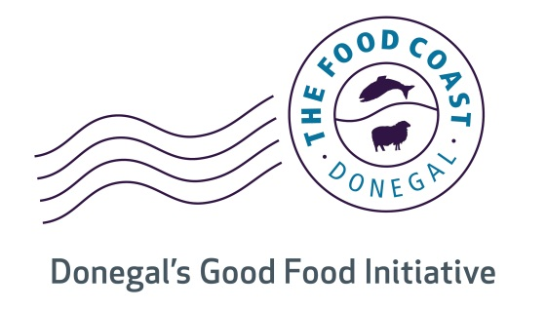
Donegal Chowder Cook Off 2016
24th September 2016
Competitor Details:
Name:
Contact Name:
Address:
Contact No:
Mobile No:
Email:
Company/Restaurant Details:
Business Description:

Registered with EHO?
Note Information to be submitted on day of competition | Temperature Records as per terms & conditions  Chill Chain Records
Please complete and return to Eve – Anne McCarron:
Donegal Local Enterprise Office Tel: 074-91630735
Donegal County Council
Enterprise Fund Business Centre,
Ballyraine, Letterkenny, Co. Donegal.

Email: eveanne.mccarron@leo.donegalcoco.ie

