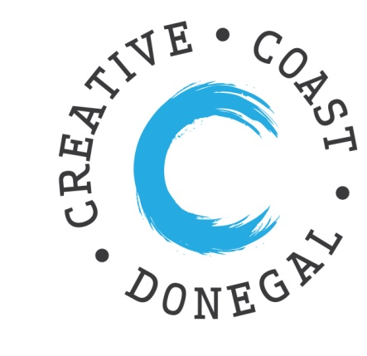 This event provides an ideal opportunity for you to showcase your craft and design business to a group of North American buyers.
Expression of Interest – Meet the Buyer
Creative Coast Donegal
Date: Thursday 22nd October 2020
Venue: TBC

Name:

Position in the company:

Address:

Website:

Social Media:

Tel. No. (Landline) (Mobile):

Email:

Is your business listed on www.creativecoastdonegal.ie? Yes □ No □

Business Description: (Date established, Turnover, Staff numbers, Product/Service Description)

Closing Date for Expressions of Interest 31st March 2020. Please complete and return to:
Grace Korbel
Local Enterprise Office, Donegal County Council, Enterprise Fund Business Centre, Ballyraine, Letterkenny Co. Donegal.
Email: grace.korbel@leo.donegalcoco.ie Tel: 074 91 60735

