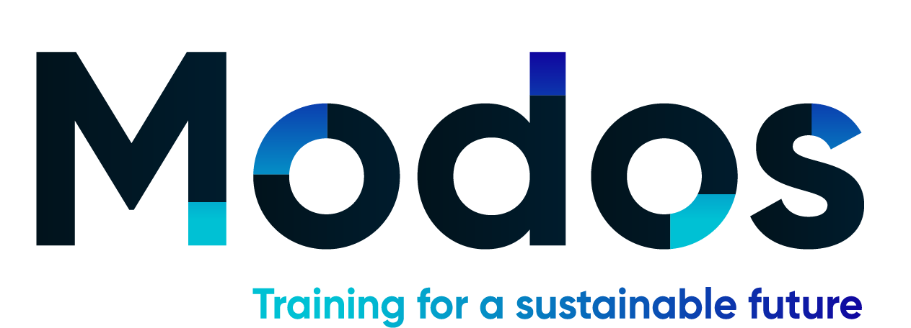

Application Form
By completing this application form you are applying to the Dublin City Council and Dún Laoghaire-Rathdown County Council MODOS Programme: Circular Economy Training for SMEs. We look forward to working with a group of businesses committed to learning about the Circular Economy and effecting positive change in their businesses.
This programme is supported by the Environmental Protection Agency (EPA).
Application deadline: 25th February 2022

Enterprise details
Contact name: __________________________________________
Role within the company: __________________________________________
Company name: __________________________________________
Company Address (Line 1): __________________________________________
Address (Line 2): __________________________________________
City: ___________________________________________
Telephone: ___________________________________________
Email: ___________________________________________
Website: ___________________________________________
If not you, who will be attending the training on behalf of your company?
Please state his/her role and provide an e-mail contact for them:
Email: __________________________________________
Role within the company: __________________________________________

Business information
- How many employees does your business employ? _________________

- How long is your business trading?
Less than 6 months
Between 6 months and 3 years
More than 3 years

- Please state in what sector your company operates in and what does your company do (i.e. food industry – producer):
food and drink industry
craft and design/ textiles
retail
agriculture
services
cosmetics
hospitality
tourism
ICT/ electronics
healthcare
manufacturing e.g. plastics/ packaging
construction
other:
In what capacity do you operate in the selected sector?

- Have your customers asked for information on your sustainability (environmental, social or governance) practices?
Yes
No
Don’t know
MODOS course selection
All modules will take place online
MODOS Spring Programme Modules
Module 1: Circular Economy – Introduction & Overview

Module 2: Circular Economy – Applied A: Carbon Footprint and your Supply Chain

Module 3: Circular Economy – Applied B: Operations & Resources

Module 4: Circular economy - Engagement

MODOS Course dates:
Each course covers the same material, please select one course.
Course 1 | Course 2
2nd March 2022 | 9th March 2022
9th March 2022 | 23rd March 2022
23rd March 2022 | 30th March 2022
30 March 2022 | 6th April 2022

☐I would like to attend Course 1
☐I would like to attend Course 2
☐I do not have a preference; am happy to attend either Course 1 or Course 2
*While we cannot guarantee your chosen preference of course dates, we will try our best to accommodate you.

Thank you for your application.

As there are limited places available on this programme, we will review all applications and successful applicant businesses will be sent a payment link.

Applicant Signature: _______________________

Date: ___________________

Please email the completed form to modos@dublincity.ie

