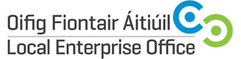
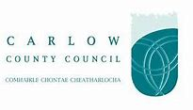
BUILDING A REVENUE GENERATING EXPERIENCE FROM YOUR AGRI-FOOD TOURISM ENTERPRISE.
Duration | 1 evening
Time: | 6.30pm – 9.30pm
Date: | 5th November 2018 (Monday)
Fee | Free of Charge
Trainer | Julie O’Brien, Runda

Course Overview:
The tourism sector’s best prospects for growth lie in generating increased levels of revenue from new and enhanced Tourism Experiences. Tourists are looking for the opportunity to book unique food experiences directly with local farmers, food producers, artisan producers, supper clubs, food and culture destinations, home cooks, craft brewers or passionate foodies who are happy to share their local knowledge. The aim of this briefing is to assist companies both to think about the design of their agri-food tourism experience and to learn what is required to sell and promote the experience to domestic and international visitors.

The briefing will be facilitated by Julie O’Brien and following the briefing 5 companies will be selected for mentoring in order to develop a clear roadmap in order to either enhance or develop their agri-food tourism experience. This briefing is for County Carlow companies and start-ups only.

Julie O’ Brien

Owned and managed by Julie O’Brien, Runda offers sales, marketing and revenue management solutions for hospitality and tourism businesses, including accommodation providers, visitor attractions, festivals, event management companies, adventure tourism, culture and heritage bodies throughout Ireland.

With more than twenty years hands-on, senior level experience, Julie has worked in commercial roles as a tour operator, DMC, conference organiser and hotelier across leisure and corporate sales channels in both domestic and international markets with responsibility for the generation of multi-million euro revenue targets. Currently, Julie works on a contract basis for private clients. Moreover, she is a registered trainer and mentor with Fáilte Ireland’s Brexit Response programme.

Carlow County Council – Local Enterprise Offices
Enterprise House
O'Brien Road
Carlow

Phone: 059 9129 783
E-mail: enterprise@carlowcoco.ie
Web: www.localenterprise.ie/carlow

