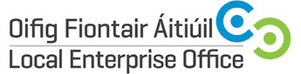
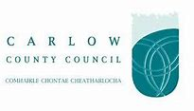
SOCIAL MEDIA MARKETING ESSENTIALS - LINKEDIN, INSTAGRAM & SNAPCHAT
Duration | 1 day
Date(s) | 15th October 2018 (Monday)
Time | 9.30am – 4.30pm
Location | Enterprise House, O’Brien Road, Carlow
Fee | €30.00
Trainer | ASPIRE Online Services Ltd.

Course Overview:
The purpose of the Social Media Marketing Essentials for Linkedin , Instagram & Snapchat is to examine the world of social media opportunities for your business. Social media gives every business the chance to make real connections with current and potential customers at a low cost. Whether it’s a start-up business, or a growing business that is trying to move from bricks to clicks, these chances can bring challenges.
Course Objective:
The objective of this workshop is a group led process where businesses will learn technical skills and receive support and guidance to achieve specific, measurable Social Media Marketing business goals.
Course Content:
- Optimising your personal and company brand-how to set up your profile correctly
- Review key areas of Linkedin
- A marketing framework for Linkedin
- How to generate leads
- Instagram for business
- Taking a photo
- Developing a posting schedule
- How to interact with other Snapchat users
- How to get followers on Snapchat
- How to tell stories on Snapchat that will keep your audience coming back for more

