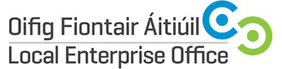
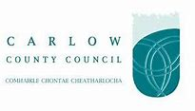
SOCIAL MEDIA MARKETING ESSENTIALS – FACEBOOK, TWITTER & GRAPHICS

Duration | 1 day
Date(s) | 10th October 2018 (Wednesday)
Time | 9.30am – 4.30pm
Location | Enterprise House, O’Brien Road, Carlow
Fee | €30.00
Trainer | ASPIRE Online Services Ltd.

Course Overview:
The purpose of the Social Media Marketing Essentials is to examine the world of Facebook, Twitter & Graphics. Social media gives every business the chance to make real connections with current and potential customers at a low cost. Whether it’s a start-up business, or a growing business that is trying to move from bricks to clicks, these chances can bring challenges.
Course Objective:
The objective of this workshop is a group led process where businesses will learn technical skills and receive support and guidance to achieve specific, measurable Social Media Marketing business goals.
Course Content:

The Following Content will be covered.

- Design Graphics for Social Media Platforms
- How to create creative branding for a Facebook Business page
- Planning a Facebook Advertising Campaign
- How to use basic and advanced Facebook/Twitter marketing tactics
- Building a community of followers on Twitter
- How to use free image editing tool
- How to use MS Powerpoint for Image Creation

Carlow County Council – Local Enterprise Offices
Enterprise House
O'Brien Road
Carlow

Phone: 059 9129 783
E-mail: enterprise@carlowcoco.ie
Web: www.localenterprise.ie/carlow

