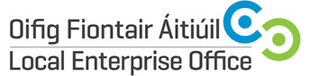
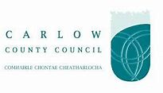
START YOUR OWN BUSINESS COURSE DAY COMMENCING 22nd NOVEMBER 2018
Duration | 3 days
Date(s) | November22nd & 29th; December 6th 2018 (Thursdays)
Time | 9.30am – 4.30pm
Location | Enterprise House, O’Brien Road, Carlow
Fee | €50.00
Trainer | Mentor Consultants Limited

Course Overview:
The Start Your Own Business Programme has been designed to address the needs of those wishing to start their own business, or those who have recently started trading. It is aimed at providing practical support, advice and guidance in a broad range of business areas. This programme will enable participants to gain a working knowledge of how to set up a business and / or to manage an existing business.
Course Objective:

- How suited are you to run your own business?
- Help you develop a business plan for your own business.
- Introduction to a broad range of business issues facing all those who start and run their own business
How to use a Business Advisory Service, which provides one to one support to assist you in the development of your business idea.
- How to utilise a financial planning service which will highlight potential sources of funding and eligibility towards further assistance, such as grants, low interest loans and equity.

The following content will be covered:
- Enterprise & Self Employment
- Market Research
- Who wants to be an Entrepreneur
- Taxation
- Finance & Book-keeping
- Marketing
- Sales and Sales Plan
- Cash Flow Projections
- Legal Implications
- Business Plan Preparation

Carlow County Council – Local Enterprise Offices
Enterprise House
O'Brien Road
Carlow
Phone: 059 9129 783
E-mail: enterprise@carlowcoco.ie
Web: www.localenterprise.ie/carlow
