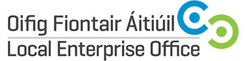
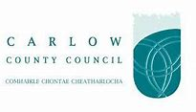
MAKING YOUR WEBSITE WORK

Duration | Half Day
Date(s) | 7th November 2018 (Wednesday)
Time | 9.30am – 1.00pm
Location | Enterprise House, O’Brien Road, Carlow
Fee | €20.00
Trainer | Aspire Online Services Limited

Course Overview
The aim of Making Your Website Work course is to enable individuals involved in Small to Medium Enterprises to get answers to questions and make it easier for users to engage with their website and get results.

Course Objective:
The objective of the Making Your Website Work course is to enable the participants to more effectively market and promote their businesses online through use of Search Engine Optimisation techniques learned, and to extract the most benefit from their web presence.
The following Course Content will be covered:
- What is Search Engine Optimisation?
- Why apply SEO to a website
- Social SEO
- The SEO checklist – how to audit your website
- Understanding your competition
- Keywords research best practice
- Understanding how to attain higher search engine rankings for a business’s identified keywords/phrases
- Understanding Google updates
- Building links professionally
- How to Stay Out of Trouble with the Search Engines
- What Google Tools should your business be using to assist with SEO tactics?

Carlow County Council – Local Enterprise Offices
Enterprise House
O'Brien Road
Carlow

Phone: 059 9129 783
E-mail: enterprise@carlowcoco.ie
Web: www.localenterprise.ie/carlow

