National Enterprise Awards 2016 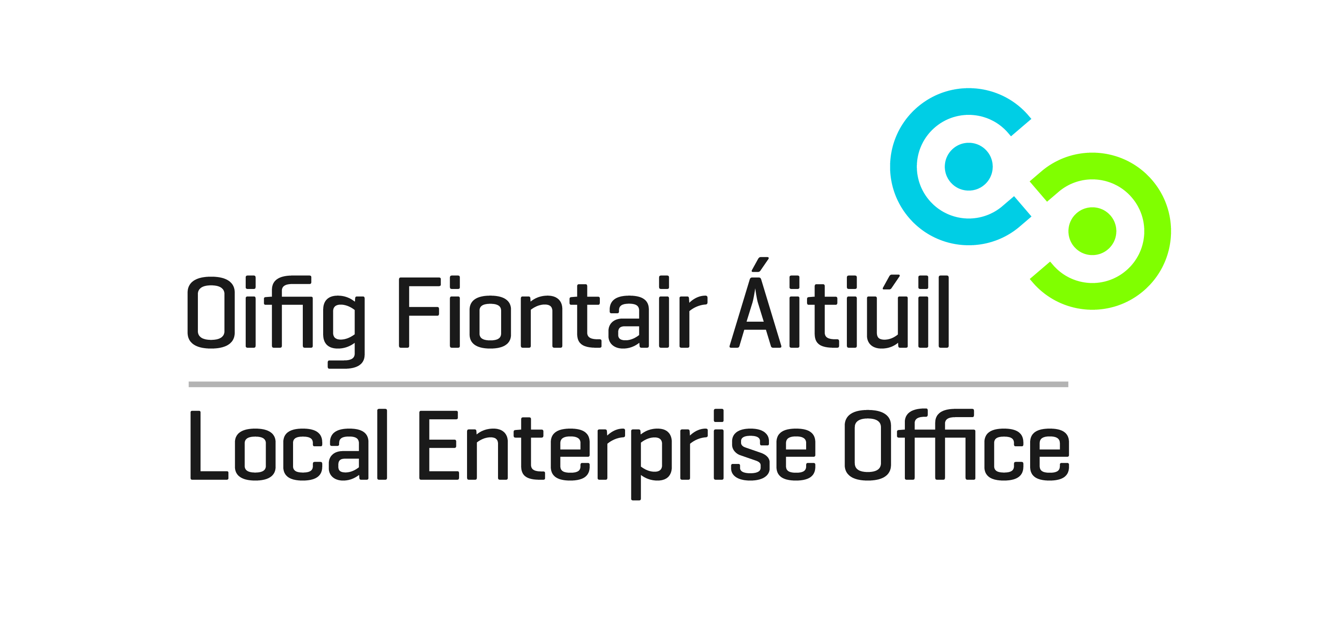#NEAwards16
LIST OF NATIONAL FINALISTS FOR 2016 (by order of Local Enterprise Office)
Carlow EquiRatings: Data analytics for the sport of Eventing
Nominee: Diarmuid Byrne
EquiRatings Limited is a sports data and analytics company bringing performance, safety and entertainment services to the equestrian sports of eventing, jumping, dressage and endurance. In its first year, EquiRatings has already secured major clients in six countries. www.equiratings.com

Cavan Ualto Ltd: Electrical process and plant automation
Nominee: Clinton Pratt
Ualto Ltd is an industry leading electrical engineering and process control automation company, specialising in providing a complete turnkey solution. Its client base, in Ireland and the UK, are in the food production, pharmaceutical and mining sectors. www.ualto.com
Clare Titan Logistics: Fourth party logistics
Nominee: Paul Collins
Titan Logistics based in Shannon, Co Clare has earned a reputation for its unique consultative approach in providing bespoke supply chain management solutions to a growing client base across the pharmaceutical, medical, garment manufacturing and other industries. Titan Logistics (Titan) has rapidly evolved into a leading supply chain integrator specialising in Fourth Party Logistics (4PL) services. www.titanlogistics.ie and Snapparcel.com
Cork City DARE Technology: Renewable energy technology
Nominee: Darren Hayes
DARE Technology is an innovative renewable energy technology developer that designs and manufactures marine grade, portable wind turbines called the Hi-GEN for use on board commercial marine vessels. The technology will reduces vessel operating costs and emissions by displacing diesel generated power when the ship is stationary. www.daretech.ie
Cork West Hennessy Timber Group: Timber manufacturer
Nominee: Aidan Hennessy
Based in Clonakilty, Hennessy Timber Group manufactures a range of timber products for the domestic, commercial and corporate leisure markets. They also ship crates for the glass and construction sectors, corporate leisure products such as bespoke mazes, zip wire/climbing towers courses, pirate ship playgrounds and camping pods. www.hennessypackaging.com and www.hennessytimbergroup.com

Cork North Health & Safety Publications: Publishing Company
Nominee: Marek Szpietowski
Health & Safety Publications Ltd. is the leading provider of health and safety publications in Ireland. The publishing company designs, publishes and prints a range of health and safety booklets, producing high quality informative manuals. The company has just recently also begun to export books to the UK market. www.hspublications.ie
Cork South GoCambio: Travel and languages web-platform
Nominee: Rosie Mansfield
GoCambio is a skill-sharing web-platform connecting people who want to travel for less and learn for less. Travellers (Guests) share their language or skills with people who have a desire to learn that skill and have a spare room in their home. Based in Youghal, GoCambio has over 10,000 members in 120 countries. www.gocambio.com
Donegal GetBrain.fit: Online brain training services
Nominee: John Mc Namara
GetBrain.fit is an empowering online Brain Training service which gives the brain a daily workout via quality content and stimulation. GetBrain.fit is a fun, social and engaging way to monitor and track your daily mental activity and improve brain powers such as memory, attention, flexibility, focus and speed. www.getbrain.fit

Dublin City Nobó: Dairy-free icecream maker
Nominees: Brian and Rachel Nolan Nobó manufactures ‘Frozen Goodness’, the world’s first ice cream alternative made from coconut milk and avocado. The product has won a total of eight Gold Stars from the Guild of Fine Food across four flavours and is based in Rathmines, Dublin 6. www.nobo.ie
Dublin Dún Laoghaire-Rathdown ClearChoice: Software for financial brokers
Nominee: Paul Merriman ClearChoice is a comparison, training and compliance software system designed for the life assurance advice sector. ClearChoice provides a web-based software solution to advisers who are researching and analysing the current Irish life assurance market to ensure they give clear, compliant and correct advice to consumers. www.clearchoice.ie
Dublin Fingal InvizBox: Secure digital services
Nominees: Paul Canavan, Elizabeth Canavan and Chris Monks InvizBox Ltd. creates a range of devices which secure privacy and security online simply by connecting any device to them over WiFi. They have sold nearly 2,500 devices in over 60 countries worldwide so far and raised all of their start-up capital through crowd funding. All of the intellectual property is developed in Fingal. www.invizbox.com
Dublin South Wyldsson: Health foods producer
Nominee: David McGeady Wyldsson Ltd. makes a range of amazing snack and breakfast products that are not only healthy but also taste great and cut out the ‘middle man’ by selling online. The products are made in Tallaght by its five members of staff. Wyldsson exports to seven countries across the world, with the UK accounting for 35% of total sales. www.wyldsson.com
Galway N. Barrett Engineering Ltd.: Animal handling equipment
Nominee: Niall Barrett N. Barrett Engineering Ltd. supplies a complete range of animal handling equipment used to minimise labour and improve safety and animal control. The products are manufactured for the agricultural market from their premises in Ballymacward, and run by a workforce of seven. Currently in outlets across Ireland, the company has also begun exporting to the UK and mainland Europe. www.barrettengineering.ie

Kerry Murphy Marine Services: Boat-builders and designers
Nominee: Fionán Murphy
Murphy Marine Services designs and builds bespoke design boats from its boat yard on Valentia Island. The team of skilled employees produce custom designed boats for national and export markets. For any owner looking for an economic, fast, stable and seaworthy boat, their proven CYGNUS hulls and design will simply be difficult to beat. www.cygnusboats.com

Kildare CarveOn: Manufacturer of lifestyle accessories
Nominees: Alan and Gary McCormack CarveOn designs and manufactures a broad range of personalised leather lifestyle accessories and branded corporate gifts using a mix of traditional and modern manufacturing techniques. The Kildare based team of five work with a large number of high profile corporate clients globally, with the majority of goods being exported to the USA, UK and UAE.www.carveon.com

Kilkenny Goatsbridge Fish Processors Ltd: Trout fish processing
Nominee: Margaret and Ger Kirwan Goatsbridge fish processors produces fresh water rainbow trout and added value products for the Irish market, supplying both wholesale customers as well as the major retailers throughout the country. They have begun exporting to France and Switzerland over the last two years. www.goatsbridgetrout.ie
Laois Twiznight Ltd.: Digital media technology
Nominee: Rory McEvoy Twiznight is a digital media technology provider, which enables brands to engage with fans on twitter and reach a huge audience. This is achieved through real-time, interactive Twitter quizzes. With a completely redeveloped white labelled product launched March 2016, it allows any brand, sports club or TV station to run their own tailored quiz, anywhere in the world. www.twiznight.com
Leitrim McNiffe’s Boxty Bakery: Traditional Irish food producer
Nominee: Detta McNiffe McNiffes Bakery is Ireland’s leading manufactures of traditional, delicious boxty. Made in Drumshanbo, the company supplies over 100 stores throughout Ireland and has begun exporting to the US. Its products are featured on the Slimming World app, accessed by 1.2 million people daily, through which the company is experiencing significant demand. www.mcniffesbakery.com
Limerick Bespoke Sauce Company Ltd: Sauce manufacturing for food sector and retail
Nominees: Liam Hayes and Vincent Sheehan
Bespoke Sauce Company Ltd manufactures and supplies 34 varieties of sauces for the food service, manufacturing and retail sectors. The company operates from Raheen Food Park in Limerick, is BRC “AA” accredited and employs eight people on a full-time basis. The company now intends to focus on the UK market in 2016. www.mcniffesbakery.com
Longford ARK Energy: Technology for the energy sector
Nominee: Francesco Arci ARK Energy offers cloud-based services for the energy industry. ARK’s first SaaS component, ARKive, collects and warehouses energy market data, providing clients with flexible access. ARK Energy has harnessed ARKive to participate in a joint venture to craft an innovative European energy portal. www.ark-energy.eu
Louth Sing Li Foods: Curry sauces for retail and wholesale
Nominees: Owen Fee and Gerry King Sing Li Foods supplies a range of curry food products under the 'Sing Li' brand. The food products are produced by a team of 11 employees for the retail and foodservice markets. Currently supplying major retail multiples in Ireland, the company plans to start exporting to the UK and beyond. www.singli.ie
Mayo Big Red Barn: Portable structure manufacturer and events
Nominee: Donal Byrne Big Red Barn is the manufacturer and provider of the newest Portable Modular Structures on the market. These include Major Event Structures and a Modular Chapel. Based in County Mayo, they have recently established a partnership agreement for the UK market and similar contracts are under discussion for the Australian market. www.bigredbarn.ie
Meath TouchHits: Digital touchscreen jukebox manufacturer
Nominee: Adam McCrossan TouchHits design, manufacture and supply a range of digital touchscreen jukeboxes, digital jukebox conversion/update kits, automated background music systems and software applications, used predominantly in public venues. The systems are designed and manufactured in County Meath. The company has a growing client base in Ireland and the UK. www.touchhits.com

Monaghan Cloud 10 Beauty: Online shop for beauty products
Nominee: Blanaid Johnson Cloud10Beauty.com is Ireland’s leading online beauty destination. It has rapidly grown to become Ireland’s definitive one-stop-shop for online beauty. Bringing together a broad range of emerging niche brands, cult classics and celebrity favourites under one roof, the Cloud10Beauty.com team search the globe, to bring the best in beauty direct to their customers.www.cloud10beauty.com
Offaly Applied Concepts Limited: Manufacturer of abrasive blast machines
Nominee: Mark Clendennen Applied Concepts Limited manufactures a range of abrasive blasting machines, safety equipment and accessories at its Kinnitty factory. The sand blasting machines are built to ensure a long operating life, with each unit being constructed from high quality components to withstand continuous use in the most demanding of applications. All machines are CE approved and the company has distributors in Belgium, Finland and Estonia. www.appliedpi.com
Roscommon Roschem Products Ltd.: Cleaning detergents manufacturer
Nominee: Vincent Campbell Roschem Products Ltd is a detergent manufacturing company supplying independent distributors throughout Ireland with high quality, industrial, catering, janitorial and household detergents under “The Cleaning Range” brand or under ‘own label’ products. All products are manufactured in Elphin and conform to ISO9002:2008 quality standard and R.E.A.C.H & CLP regulations. www.roschemproducts.com
Sligo L.C. Seating Ltd.: Custom-made mobility seating
Nominee: Luke Conway L.C. Seating Ltd. specialises in the provision of customised seating, mobility and sleep systems for clients with physical disabilities across Ireland and Europe. It employs nine full-time and one part-time members of staff from its base in Grange, Co. Sligo. www.lcseating.ie
Tipperary T/a Savvy Kitchens: Bespoke kitchens
Nominee: Andy Spillane
Andy Spillane Bespoke Furniture Ltd. T/A Savvy Kitchens was established by Andy Spillane in 2007. The company designs, manufactures and installs bespoke fitted furniture for both the private and commercial sectors. The facility of manufacturing in-frame doors in house gives Savvy a unique advantage over their competitors as it allows more flexibility with sizes and reduced lead times.
www.savvykitchens.ie
Waterford CF Pharma Ireland Ltd.: Pharmaceutical Company
Nominee: Clare Hughes CF Pharma Ireland Ltd. is a medical device innovator company. Its business is primarily the generation of medical device status products for the OTC market Pharma Market. The company currently exports to nine countries worldwide and has achieved a turnover of 900,000 euro in just two years with 90% export. www.cfpharma.ie
Westmeath Scantech Geoscience Ltd.: GPR surveys for engineering sectors
Nominees: Tom Davitt and Dr. Orla Dardis Scantech Geoscience Ltd is a specialist ground penetrating radar (GPR) and underground utility surveying company providing GPR surveys for the civil, structural and geotechnical engineering sectors in Ireland and the UK. Scantech offers professional underground and structural mapping services using the latest GPR technology with a strong focus on technical quality. www.scantech.ie
Wexford Hentech Fabrication Ltd.: Mild steel fabrication
Nominees: John and Martina Hennessy
Hentech Fabrication Ltd. is a steel fabrication company that manufactures steel aluminium and stainless steel products for industry and construction throughout Ireland. They are based in Ballymurn, Enniscorthy, Co. Wexford and currently employ 18 staff. Hentech received CE Certification for steel fabrication in 2015 (I.S.EN1090-1:2009 + A1:2011). www.hentech.ie
Wicklow Showoff: Software and app development
Nominees: Shane Byrne and Philip Kirwan Showoff, Ireland’s first ‘Guaranteed Irish’ Tech Company, is an award winning, fast-paced software solutions and app development company. All solutions are developed in-house in the company’s offices in Rathnew, County Wicklow, where twelve staff are currently employed. Showoff services customers across Ireland, UK and Europe. www.showoff.ie

