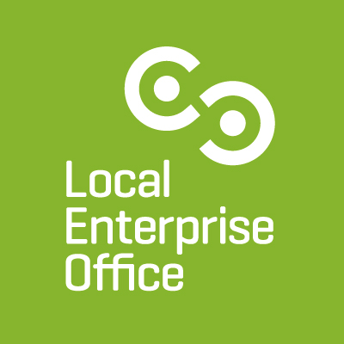

James Barrett Mentor Bio
Mentor Profile
James learned the basics working in his family retail business before his long and successful career with: Mars, Diageo, Campbell Soup, Bio-Medical Research, United Biscuits and Birds Eye.
Running his own business since 2007 James has helped Irish and international businesses to launch their operations and achieve their commercial ambitions.
Areas of Expertise: As a General Manager running European Businesses, James prioritises Financial, Commercial and Marketing planning as the key foundations for success. He is also known for enabling business clients to set out their vision and supporting plans that underpin the achievement of: WHAT – details of what each business wants to achieve HOW – the actions, leadership, stakeholders, resources and delivery milestone dates of the components of each plan. CONTROLS – the formalised business and financial metrics to inform business owners of their progress versus plans and agreed actions to close gaps
Experience to Date
- Various Client Businesses within the Food, Drink, Retail, Health, Fashion, Hospitality, Education, Financial, Sports & Distribution Sectors, by:
  - Quantifying market opportunities by each Sales Channel
  - Identifying optimum Pricing & Margin Streams
  - Developing Annualised P & L and Cash Flow plans consisting of: Volumes, Pricing, Revenues, Gross Margins, Running Costs & Net Profitability
  - Creating Marketing Plans reflective of what makes each business Stand Apart and leveraging their unique Value Proposition
  - Process management through the identification and delivery of operating efficiencies

- LEO Supports:
  - Facilitating clients to identify the best possible support, in the form of Grants, Finance, Training, Networking and Events, that is consistent with their business needs
  - Support client applicants with their submissions for grant and/or financial loans, subject to fulfilling qualifying criteria

