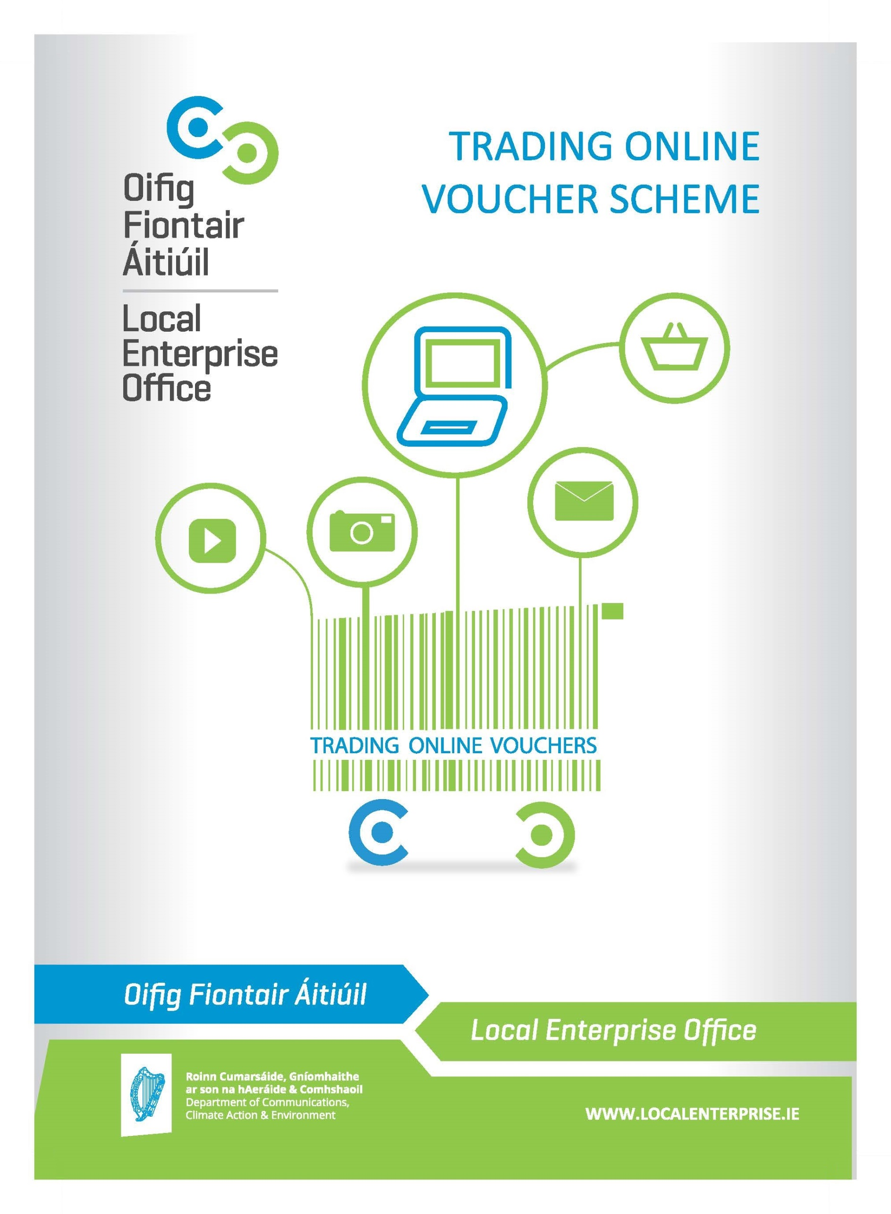
TRADING ONLINE VOUCHER SCHEME
With the trend ever increasing towards online spending it is estimated that only 23% of small Irish businesses are engaged in any meaningful way in eCommerce sales. For businesses employing less than ten people this percentage could be even lower. It is now believed that, of online purchases made in Ireland, up to 70% of these are done in overseas markets.
There is now an urgency to ensure that businesses recognise that this is happening and that they are encouraged and supported to correctly respond to this digital reality.
In order to support this goal, the National Digital Strategy aims to get more businesses trading online. To this end, the Department of Communications, Climate Action & Environment (DCCAE) launched a Trading Online Voucher Scheme and teamed up with the Local Enterprise Offices (LEO) to deliver this to Irish business. A limited number of vouchers are now available to eligible businesses.
What is it?
The voucher is a financial incentive to small businesses to develop or enhance their ability to trade online. Under the scheme a qualifying business may apply for matched funding to a maximum value of €2,500 or 50% of eligible expenditure (exclusive of VAT), whichever is the lesser. Following approval of their application, a successful applicant can engage suppliers and upon completion of the work, submit a request for payment to the LEO in line with the terms and conditions of their voucher.
Information seminars will be available to prospective applicants to support them in their application process and it will be a condition of applying for the vouchers that applicants attend one of these seminars. At each seminar attendees will be informed of the purpose of the scheme and how best to use and get value from the application of the voucher.
The application process for the vouchers will be a competitive process.

What are the eligibility criteria?
The vouchers are targeted at businesses with the following profile:
- Limited Online Trading presence;
- 10 or less employees;
- Turnover less than €2m;
- Applicant business must be trading for at least 6 months;
- Business must be located in the area covered by this phase of the scheme i.e. within the remit of the participating LEOs.

What are ineligible projects for this scheme?
- Companies with charitable status, commercial semi-state companies, trade associations and company representation bodies such as Chambers of Commerce are not eligible to participate in the scheme;
- “Not for profit” and social entrepreneurship applicants unless they operate in a commercial domain;

- Professional services specialising in IT type services who are already capable of trading online using existing in-house systems;
- Conferences and Seminars;
- Projects which are contrary to public policy;
- Duplication of support for projects which would be eligible for assistance from other State Agencies of EU funded Operational Programmes;
- Projects with employees in excess of 10 people;
- Projects deemed to be capable of proceeding in any event without scheme assistance i.e. deadweight;
- Projects essentially comprising importation and distribution.

What can the vouchers be used for?
- IT consultation;
- Development or upgrade of an e-commerce website;
- Implementing Online payments or booking systems;
- Purchase of Internet related software;
- Purchase of online advertising (this purchase cannot make up any more than 30% of approved Voucher costs and can only be drawn down in one payment phase);
- Developing an app (or multiplatform webpages);
- Development of a digital marketing strategy;
- Implementing a digital marketing strategy;
- Training/skills development specifically to establish and manage an online trading activity.

What are the things the vouchers cannot be used for?

- Development of brochure websites;
- Purchase of non-internet related software;
- Anything other than online trading related activity.

What else do I need to know about vouchers?

- Voucher approval must be gained prior to incurring any expense;
- Own labour is not an eligible expense;
- Third party costs only will be considered;
- All third party/supplier invoices must contain proper business details (e.g. tax or business registration details or proof that the supplier is a registered business in the territory in which the supplier is located).

What is the voucher application and drawdown process?
Application
- Read the terms & conditions;
- If satisfied you are eligible and wish to apply register to attend an information event;
- Attend information session;
- Submit copy of completed and signed application form in hard copy to your local LEO;
- Soft copy of completed application to be supplied by email to your local LEO.

Evaluation
- Evaluation of applications will be conducted by each LEO who will make recommendations for approval;
- An evaluation committee will assess the applications and make recommendations for approval;
- A competitive process will be put in place to assist with selection process. Selection of successful applicant will be based on the following criteria:
  - Eligibility for scheme;
  - Value added potential;
  - Export potential;
  - Job creation potential;
  - Financial Sustainability.
- Record decisions and report to the Local Enterprise Office approvals committee;
- As part of the application process applicants will be required to attend an information session on how to use and get the best value for money from the voucher.

Voucher administration
- If your application is successful, a letter of offer will be sent to you for you to forward to your preferred supplier.
- The voucher is a letter of offer which is sent to the successful applicant;
- Letter of offer signed, accepted and returned;
- Successful applicants have 9 months to complete the work as per their application.

Drawdown
Payment will be made directly to the successful applicant upon satisfactory receipt of the following:
- Applicant and supplier(s) sign declaration on the voucher and submit to Local Enterprise Office (LEO);
- Applicant submits:
  - copy of their Company Registration Office (CRO) registration;
  - an up to date tax clearance certificate ;
  - the original invoice from the supplier(s), with supplier(s) CRO or Tax Registration or VAT details (or proof supplier is a registered business in the territory in which the supplier is located) when submitting claim for payment;
  - Bank statement(s) showing proof of payment from the client company to supplier(s);
  - Declaration of project completion by supplier(s);
- All work must be completed and paid for prior to claim.

Payments will only be made with relation to approved expenses which form part of this application form.
All successful applicants agree that they will allow reference be made to them in case study materials, which may be used to promote the voucher scheme more widely.

What is post-voucher reporting and how does it apply to me?
By accepting a Trading Online Voucher, successful applicants agree to report on online trading from participation in the scheme, again in 6 months and at annual intervals up to three years thereafter. Reporting will include: jobs (new or reallocated), increased turnover, exports and/or domestic market expansion, reduced costs and expected follow on investment. This may be conducted by Local Enterprise Offices, Department of Communications, Climate Action & Environment or approved independent evaluators.
Suppliers will be required to report on the impact of their products and services supplied to the applicant business.
- Reporting will include how their product or service enabled trading online, improved business performance, reduced cost, opened markets etc.

Acknowledgements
The trading online voucher scheme is an initiative of the National Digital Strategy, developed and funded by the Department of Communications, Climate Action & Environment on behalf of Government. It is being administered by the Local Enterprise Offices.

Further Terms
Applications for assistance for expenditure incurred prior to grant approval are ineligible. The Local Enterprise Office reserves the right to refuse any application and the right to terminate this grant scheme at any time without notice. The approval of applications and the payment of all monies are dependent on the availability of resources under this scheme from the Department of Communications, Climate Action & Environment. Applicants are advised to check availability of resources with Local Enterprise Office prior to applying. All applicants approved must draw down in full within 9 months of the date of offer, or in exceptional circumstances within 12 months (i.e. 9 months, plus 2 months extension, and a further 1 month extension) as may be agreed between LEO and company. Failure to draw down all or any portion may result in automatic de-committal without notice, i.e. loss of voucher. The Local Enterprise Office may liaise/consult other agencies/local development programmes in relation to this proposal while respecting project confidentiality. Any false or misleading statement or the withholding of essential information from Local Enterprise Office (as determined by Local Enterprise Office) will result in cancellation of any grant approved under this scheme.

PLEASE NOTE: The Local Enterprise Office is not responsible for any disputes between the applicant and 3rd party suppliers. Therefore we recommend that you adhere to best business practice and get three quotes as well as carry out due diligence before selecting a supplier. Disclaimer – For the avoidance of doubt it is understood and accepted that it is the applicant companies who are selecting and entering into a contract with third parties. The State and its agents (including Local Enterprise Office(s), Enterprise Ireland or any Government Department) does not accept any liability whatsoever in respect of any deficit in or consequences arising from products or services procured by or provided to companies under this scheme. In submitting your application under this scheme you are confirming that you understand and accept this disclaimer.

Important: When completing the form please do not exceed 150 words or the space allowed in the boxes. If you require additional space, please write 'continued...' and use a blank page to complete the remaining text, starting with the name of the section you are completing, e.g. '1. Description of your Business Products/Services' AND attach any additional pages to the form.
TRADING ONLINE APPLICATION FORM 2019
Please use the TAB key to move on to the next input box (SHIFT + TAB to move to the previous input box) and use the left mouse button to select Tick Boxes
How did you hear about the Trading Online Voucher? | Click here to enter text.

COMPANY INFORMATION
This form will provide you with a project specification that you can use to circulate to suppliers and will also be the basis for nearly all your application for the voucher.
Name: | Click here to enter text.
Company name: | Click here to enter text.
Company address: | Click here to enter text.
Telephone: | Click here to enter number.
Mobile: | Click here to enter number.
Email: | Click here to enter text.
Website address: | Click here to enter text. | Tick if not online
Business type: | Click here to enter text.
CRO Number: | Click here to enter number.
Year business was established | Click here to enter year.
How long has the business been trading? | Click here to enter years/months.

DESCRIBE YOUR BUSINESS
Description of your Business's Products / Services
Overview of your businesses activities whether related to the project or not
Click here to enter text.

DESCRIBE YOUR TRADING ONLINE PROJECT
Business objective for your Trading Online project
What is it that your business expects this project to do that will help your business? Handle sales, generate new leads, handle customer service, etc… (please be as specific as possible)
Click here to enter text.

DEVELOP A PROJECT PLAN
Unique Selling Point of your Products / Services / Business processes targeted in this project
Look at your online competitors, decide what products/services you will focus on - not all of them need to be traded online. Why did you select what you have?
Click here to enter text.
Your Target Market through this project
Who are your customers going to be? (i.e. what customers will you target through your online channels?)
Click here to enter text.
Trading online competitors (list 3 to 5 with a link to their websites)
When you use a search engine to look for the product /services your company offers, what companies/sites are displayed
Click here to enter text.
Scope of work to be carried out
What are the specific deliverables of the project relating back to the business objectives? Describe the work to be undertaken in this project.
Click here to enter text.

BUSINESS INVESTMENT
Internal resources brought to the project
Click here to enter text.
External resources brought to the project
Click here to enter text.
Existing Assets the project should leverage off
What additional information can you provide to help suppliers assist you? Social media presence you want to leverage? Design material? Photographs? Brand & marketing material?
Click here to enter text.

PROJECTED OUTCOMES
Market expansion potential
What impact will the trading online project have on your business in terms of employment, revenue and ability to export? Based on your target market and competitor analysis, how will this project help you grow your revenue? Export potential? Gain back lost market share to existing online traders?
Click here to enter text.
Financial Information |  | Current |  | Projected 12 months |  | Projected 24 months
Turnover |  | € Enter amount here |  | €Enter amount here |  | €Enter amount here
Staff numbers
- Full time |  | Enter Number |  | Enter Number |  | Enter Number
- Part-time |  | Enter Number |  | Enter Number |  | Enter Number

INDICATE PROJECT ELEMENTS FOR GRANT SUPPORT
The work you are seeking to have done by external service provider(s) will entail (click all that are applicable) | Yes | Unsure
IT Consultation
Project Management
New eCommerce site development (from scratch)
Upgrade of existing eCommerce site
Content Management System – a computer program that allows publishing, editing and modifying content as well as maintenance from a central interface
Implementing an online payments system
App development
Development of a digital marketing strategy
online advertising*
* purchase of online advertising cannot make up any more than 30% of approved Voucher costs and can only be drawn down in one payment phase
Training specific to the establishment of trading online
Copy (written or graphic content) for website
Search Engine Optimisation (SEO) services – process of optimizing the visibility of a website or a web page in a search engine’s organic search results
Analysis of existing site analytics – analysing web data for purposes of understanding and optimizing web usage
Other

PROJECT COSTS
Trading Online Expenditure
Please note: supplier is not restricted to those based in Irish/EU territory. |  | Product / Service |  | Service provider |  | Cost (€ Excluding VAT)
Supplier 1 |  | Enter text |  | Enter text |  | €Enter amount
Supplier 2 |  | Enter text |  | Enter text |  | €Enter amount
Supplier 3 |  | Enter text |  | Enter text |  | €Enter amount
Any additional supplier quotes obtained may be attached.
Trading Online Voucher request amount
- Expected cost based on quotes (ex VAT) |  | €Amount
Eligible voucher amount requested €2,500.00 Maximum voucher award |  | €Amount

VOUCHER PAYMENT CONDITIONS
* | If your application is successful you will receive a letter of offer detailing the amount approved. (Maximum Grant/Voucher exclusive of VAT is €2,500)
* | Payment will be made directly to you on completion of the work and subject to the following being provided satisfactorily:
1 | Copy of your Company Registration Office (CRO) registration
2 | Up to date tax Clearance Certificate
3 | Original Invoice(s) for work undertaken
4 | Declaration of project completion by supplier(s)
5 | Bank statement(s) showing proof of payment from the client company along with evidence of Supplier details (e.g. Company Registration Office (CRO) details or VAT details or Tax Clearance Certificate or proof that the supplier is a registered business in the territory in which the supplier is located)
* | Payments will only be made with relation to approved expenses which form part of this application form

SCHEME TERMS & CONDITIONS

No. | Key Terms of this Scheme | Please tick you have read & agree to comply with the scheme terms
1 | Vouchers will be available to a maximum value of €2,500 or 50% of eligible expenditure, exclusive of VAT, whichever is the lesser.
2 | Trading Online Voucher Scheme is operated under a matched investment arrangement.
3 | Businesses are required to attend an Information session. This requirement is to ensure applicants are supported in developing the project plan which forms part of their application.
4 | Businesses can apply for Trading Online Voucher Scheme to support expenditure only on the following:  - IT consultation;  - Development or upgrade of an e-commerce website;  - Implementing Online payments or booking systems;  - Purchase of Internet related software;  - Purchase of online advertising (this purchase cannot make up any more than 30% of approved Voucher costs and can only be drawn down in one payment phase);  - Developing an app (or multiplatform webpages);  - Development of a digital marketing strategy;  - Implementing a digital marketing strategy i.e. Social media marketing;  - Training/skills development specifically to establish and manage an online trading activity.
5 | All relevant supporting documents should be included with the application form:  - a copy of a quotation from 3 suppliers detailing the works to be done and cost*  - evidence of duration of trading if an unregistered business or sole trader  Failure to provide the supporting documents could result in the application being turned down.  *Where 3 quotes for a particular product/service is not possible or overly burdensome in the case of multiple project components, the requirement for 3 quotes per item may be waived and the application may be evaluated on the quotes available. The applicant should consult with the LEO prior to submitting their application. The LEO must be satisfied that the application represents value for money and that the applicant has engaged with suppliers in developing their trading online proposal.
6 | An evaluation Committee will assess the applications. A competitive process will be put in place to assist with the selection process. I have noted the criteria on which evaluation will be based.

SCHEME TERMS & CONDITIONS CONT’D

No. | Key Terms of this Scheme | Please tick you have read & agree to comply with the scheme terms
7 | Project expenditure can commence from date of voucher approval. Date of voucher approval is confirmed in writing to the company by the Local Enterprise Office. Any expenditure incurred by a company prior to this date is ineligible. There is no physical voucher. The letter of offer is the voucher.
8 | A letter of Offer is sent to the company to provide legal confirmation of the company’s participation in the scheme. Companies must return a signed letter of offer by return. Failure to do so will result in the voucher approval being cancelled.
9 | Project Time Limit is 9 months from date of voucher approval.
10 | Businesses should submit only one claim at the end of the project. It is not possible to submit more than one claim for this grant.
11 | If required, the deadline for completion of projects may - at the discretion of the LEO - be extended by an initial period of 2 months at the end of the 9 month period, if there is evidence that the beneficiary has engaged work in line with their letter of offer. Following this, a further, final extension of 1 month is permissible to allow completion of the project (12 months in total). After this time, a LEO will de-commit the project and withdraw the letter of offer. The applicant may reapply for funding
12 | Applicants should retain all relevant paperwork during the project in order to assist them in processing their claim at the end of the project including: applicant Tax Clearance Certificate, original Invoices from supplier with required supplier details (see page 3) and proof of payment to supplier and proof that all work being claimed for is completed prior to claim.
13 | I note the Indemnity Clause on page 4 of the application form.
14 | Applicants agree that on successful completion of their projects they will allow reference be made to them in case study materials which will be used to promote the voucher scheme more widely.
15 | I note the voucher payment conditions on page 10 of the application form.

TRADING ONLINE VOUCHER SCHEME APPLICATION - SIGNATURE FORM

PLEASE NOTE: The Local Enterprise Office is not responsible for any disputes between the applicant and 3rd party suppliers. Therefore we recommend that you adhere to best business practice and get three quotes as well as carry out due diligence before selecting a supplier. Disclaimer – For the avoidance of doubt it is understood and accepted that it is the applicant companies who are selecting and entering into a contract with third parties. The State and its agents (including Local Enterprise Office(s), Enterprise Ireland or any Government Department) does not accept any liability whatsoever in respect of any deficit in or consequences arising from products or services procured by or provided to companies under this scheme. In submitting your application under this scheme you are confirming that you understand and accept this disclaimer.

PLEASE NOTE: Applications for assistance for expenditure incurred prior to grant approval are ineligible. The Local Enterprise Office (LEO) reserves the right to refuse any application and the right to terminate this grant scheme at any time without notice. The approval of applications and the payment of all monies are dependent on the availability of resources under this scheme from the Department of Communications, Climate Action & Environment. Applicants are advised to check availability of resources with their LEO prior to applying. All applicants approved must draw down in full within 9 months of the date of offer, or in exceptional circumstances within 12 months (i.e. 9 months, plus 2 months extension and a final 1 month extension) as may be agreed between LEO and company. Failure to draw down all or any portion may result in automatic de-committal without notice, i.e. loss of voucher. The LEO may liaise/consult other agencies/local development programmes in relation to this proposal while respecting project confidentiality. Any false or misleading statement or the withholding of essential information from the LEO (as determined by the LEO) will result in cancellation of any grant approved under this scheme.

PLEASE NOTE: The Local Enterprise Office is committed to its transparency obligations under the General Data Protection Regulation (GDPR). Our data protection notice for personal data that is supplied to us by our clients is available at www.localenterprise.ie/legal This notice tells you about your privacy rights and sets out how we, as a Controller, collect, use, process and disclose your personal data relating to your interactions with us. We request that you read the notice carefully and that you ensure that it is made available to any data subjects (e.g. your employees) whose personal data you provide to us.

By ticking “ I agree”, you confirm that: (a) you have complied with your own data protection obligations in respect of the personal data that you supply to us and that you are entitled to disclose such personal data to us; and (b) you will ensure that a copy of our data protection notice is sent to data subjects (e.g. your employees) whose personal data you provide to us.

[Iagree] (Please Tick)

DECLARATION: I/We hereby declare that the above information and details are accurate and true to the best of my/our knowledge and belief and I/we make this application for grant assistance on the basis of the information and details given. I/We have not sought and will not seek grant aid from any state agency or other sources in respect of this expenditure. I/We have read and fully accept the terms and conditions attaching to the ‘Trading Online Voucher’ from the Local Enterprise Office.
Sign here | Click here to enter text. | Enter date.

Sign by Business Name Date

Your Local Enterprise Office: |  | Click here to enter text.
Please return this form to us (your Local Enterprise Office - above), when completed.
You will receive a confirmation email that we have received your application within 5 working days, if you do not receive the confirmation email please contact your Local Enterprise Office.

Or satisfactory evidence of trading for at least 6 months if unregistered (e.g. sole trader)

