CAOIMHE DOYLE – SOUTH EASTERN CREATIVE CORRIDOR PARTICIPANT

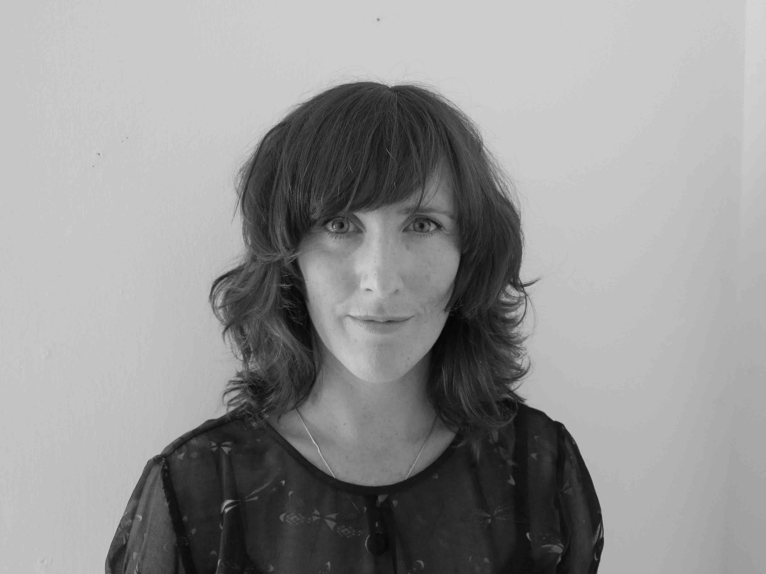
Caoimhe Doyle is a Foley Artist based in Ireland with 20 years experience creating original sound effects and footsteps for film, television and video games.

Caoimhe Doyle’s experience of The South Eastern Creative Corridor

As a result in participating in The South Eastern Creative Corridor, I have become more pro-active in terms of contacting people directly for work. There was a great mix of participants in the course and it really afforded me an opportunity to network and seek advice from my peers, something I had not being doing prior to this. I loved the mix of people from different creative backgrounds and really benefited from their stories, knowledge and support.”
This programme really gave me a renewed sense of confidence in myself, in my business and in what I could achieve.

About Caoimhe Doyle

Caoimhe Doyle is a Foley Artist based in Ireland with 20 years experience creating original sound effects and footsteps for film, television and video games. She began her Foley apprenticeship in 2000 with Andy Malcolm at Footsteps Studios, Canada.

She was nominated for an Emmy and won a MPSE Golden Reel Award for Game of Thrones: Season 1 (2011). In 2008, she was nominated for a MPSE Golden Reel Award for her work on David Cronenberg's Eastern Promises (2007).

CREDITS INCLUDE: Killing of a Sacred Deer (2017 dir, Yorgos Lanthimos) Room (2015, dir Lenny Abrahamson), Miss Julie (2016, dir, Liv Ullmann), Love/Hate (2014, creator Stuart Carolan), Knocked Up (2007, dir. Judd Apatow), Eastern Promises (2007, dir David Cronenberg), Game of Thrones, S1 (2011).

