Department of Rural and Community Development
Press Statement
31 May 2021
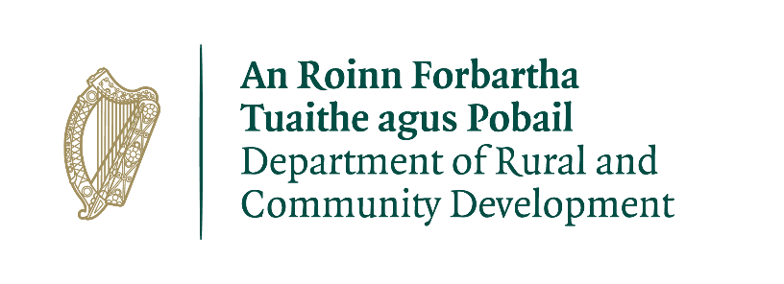

Our Rural Future: Minister Humphreys launches National Connected Hubs Network

- Ireland’s first ever digital hub network now live via ConnectedHubs.ie
- Network to make remote working a reality throughout Rural Ireland
- Some 66 hubs already on board; 100 plus targeted by end of 2021

Minister for Rural and Community Development, Heather Humphreys TD, has today launched the Connected Hubs Network, Ireland’s first national network of remote working hubs.

Connectedhubs.ie is a key action of Our Rural Future and will see over 100 hubs connected by the end of 2021.

Already, 66 hubs across the country are on board and are accessible to remote workers via an online map.

This number will rise to over 100 by the end 2021 with the overall target of 400 set to be exceeded.

Announcing the launch of the network in Swinford, Co Mayo, Minister Humphreys said:

“Remote Working is a key committment of ‘Our Rural Future’, the most ambitious policy for Rural Ireland in decades.

“Today, we are demonstrating the action behind that policy through the launch of Connected Hubs.

“Hub working can support the development of employment opportunities and career paths in rural areas. This will help to give young people the choice to stay closer to home while pursuing their careers and also to encourage people living in cities to consider moving to a more rural location. ”

“Throughout this pandemic, so many of us have experienced the benefits of remote working – reduced commutes, more time spent with your family, increased footfall in towns, a lower carbon footprint.

“As we look to the reopening of our country, I am determined that we make remote working a permanent and viable reality for thousands of people.

“The Connected Hubs Network provides the perfect opportunity for workers and employers to embrace a ‘blended working’ model, and to find the balance of hub, home and office working that works best for them.”

The Minister concluded:

“I would urge all existing or new hubs to become members of Connected Hubs. In addition to availing of the excellent platform and supports unveiled today, by having your details included in the National Hub Survey you can help Government to identify the scale of our nation’s remote working infrastructure. This information will help to guide and inform future investment decisions in future.

“I would also like to remind hub managers of two funding streams which I recently launched, the €5m Connected Hubs fund for existing hubs and the €15m Town and Village Renewal Scheme, which will place particular emphasis on projects supporting remote working and enhancing town centre living as outlined in Our Rural Future.

“I will also be making an announcement regarding the Rural Regeneration and Development Fund in the coming months.”

The National Hub Network Working Group led by the Department of Rural and Community Development has identified and mapped close to 400 remote working hubs across the country. These hubs will be invited to join the Connected Hubs Network to create shared infrastructure that will deliver real benefits across the country. A National Hub survey is currently underway to gather further information with regard to services offered by these hubs.

ENDS
Contact:
The Department of Rural and Community Development Press Office
076-1006843 / 087-1734633
Press.office@drcd.gov.ie

Notes for editors:

The ConnectedHubs.ie platform will offer a suite of booking, hub management and e-commerce applications to members of the Network. The Network will also facilitate the sharing of innovation, experience and best practices across the community. These supports will serve to maximise benefit to member hubs, hub clients, employers, local communities and the wider economy.

The National Hub Network Working Group led by the Department of Rural and Community Development has identified and mapped over 400 remote working hubs across the country. These hubs will be invited to join the Connected Hubs Network to create shared infrastructure that will deliver real benefits across the country. A National Hub survey is currently underway to gather further information with regard to services offered by these hubs.

Membership of the Connected Hubs Network is open to all existing and new hubs who wish to offer remote working services.

The following initiatives will be developed through this initiative;

- A Shared Connected Hubs brand identity for all member hubs
- A Centralised Connected Hubs media and promotional campaigns
- Access to the ConnectedHubs.ie suite of booking, hub management and e-commerce applications.
- Development of a Peer-to-Peer Hub Community
- Sharing of Innovation, Experience and Best-Practices within the community
- Developing a shared quality standard for hubs in the Network
- Supporting collaborative projects in the Network to drive economies of scale
- Developing a ‘shared voice’ for Connected Hubs
- Supporting collective engagement between Connected Hubs and large scale employers
- Supporting collective engagement between Connected Hubs and Government Agencies
- Helping to identify the benefits Connected Hubs deliver for their local communities and the wider economy
- Developing a dataset to inform future investment decisions in remote working facilities

List of Hubs on Connected Hubs (at launch)
To be inserted

You are receiving this press release / media notification as you are currently subscribed to the Department’s media list.
If you no longer wish to receive emails of this nature from the Department of Rural and Community Development please respond to this email with the word “unsubscribe” in the subject-line and we will endeavour to remove your email from our database.

