LAURA WAY – SOUTH EASTERN CREATIVE CORRIDOR PARTICIPANT

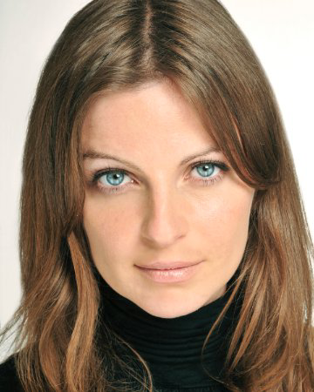
Founder of Bodecii Film http://bodecii.com/

Formerly a film and TV actress on BBC, RTE, HBO, Channel 4, TV3 and more, Laura Way is an award winning
Writer/Director/Producer.

Laura has written, produced and directed much of her own work including, short films, music videos and commercials.

Laura Way’s experience of The South Eastern Creative Corridor

“The South Eastern Creative Corridor came at exactly the right time for me, making the transition from sole trader to a limited company. I wanted to set up a film production company producing indigenous, high-end film, TV and brand films in my hometown, which I felt was an under-utilised county with massive potential for film and TV. I had a business mentor through the Local Enterprise Office who suggested I take part in the Creative Corridor Programme.

With over ten years of creative and practical film making experience, I had a strong portfolio of work, however, my business knowledge was limited. I needed to know more about business if I was to achieve my goals of developing our own IP and original content.

My confidence as a business owner has grown. It's unbelievable the difference a year can make! Developing a business plan was challenging, but fulfilling. It forced me to examine my business and myself more closely, to discover the company’s identity, it's uniqueness and clearly define who we are and what we do.

The film industry is filled with highly skilled practitioners, passionate about what they do. When you are creatively driven, you can overlook your true value. This programme has given me the business knowledge and confidence to value my work and myself.

Financial support through the Capital Grant has allowed me to purchase much needed equipment to speed up our workflow and a website to showcase Bodecii Film's work. Without this, the business would find it incredibly difficult to move forward.

The support of Creative Corridor has been invaluable and I hope that more practitioners in the creative industry will benefit from this initiative in the future. It makes sense to support the AV industry in regional areas. Forward thinking Counties will reap the benefits of an indigenous industry in the coming years. It's mutually beneficial. Taking part in the programme was one of the smartest business decisions I have made.”

About Laura Way

Formerly a film and TV actress on BBC, RTE, HBO, Channel 4, TV3 and more, Laura Way is an award winning writer/director/Producer. She has written, produced and directed much of her own work including, short films, music videos and commercials.

Laura was signed as a director with one of Ireland’s leading commercial production companies, Pull The Trigger and Storm Light before setting up Bodecii Film (pronounced 'Bo dee sea'), a Wexford based production company developing original indigenous TV and Film, commercials and branded vision films.

In 2016 and 2017, she was nominated and received an honorable mention at the ICADS Young Director Awards for Changeling (original TV series currently in development) and The Journey Home, a Bodecii Brand Film for Focus Ireland which went on to be a national Christmas TV campaign.

Laura wrote, directed and produced through Bodecii Film; the brand film 'I Can't Sleep' for Focus Ireland, which was the focus of a massive national TV and online campaign earlier in the year. It was featured on Gogglebox and was the first brand film to be broadcast throughout the entire commercial break before XFactor, Gogglebox and Coronation Street.

With Bodecii Film she conceptualized, wrote, produced and directed Ronan Furlongs music video ‘Hoplite Armour’ for Hub Music which went to No.1 in the iTunes Music Video Charts last year.
Laura runs the Screen Actors Program in the Gaiety School Of Acting and was writer/director on the 2017 graduate showcase. She is writer/director on this year’s 2018 graduate showcase. She also runs a film programme with the NCBI in Wexford. She is co-creator/director of Rising, a drama series currently in development, the pilot filmed last year.
Laura is a director on TV3 drama series Red Rock’s third series, recently sold to Amazon and BBC.

