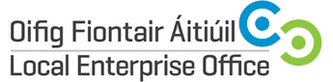

National Ploughing Championships / 19th and 21st September 2017
Expression of Interest
Contact Name:
Company Name and Legal Structure:
Address:
Landline Telephone:

Mobile Telephone :

E-mail Address & Website Address:

Year the company was established:
Company Description:

Product or Service Description:

Additional information that might be of interest to media? Eg awards/ exports?

Number of employees:
Social media accounts:
Any Special Requirements for NPA?

Preferred Briefing & Photography Session:

Session 1: Dublin 28th June, 2017
Session 2: Tullamore 5th July, 2017
LEO Contact Name
LEO Contact E-mail

Signature : __________________________________________

IMPORTANT: Please include product photos or service marketing materials with your application

