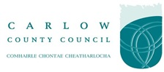
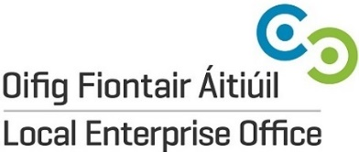

PR & Communications Services
Request for Proposals

Proposals must be received not later than 12:00 noon
on
31st August 2018

Late Proposals WILL NOT be considered.
Advertised: 16th August 2018

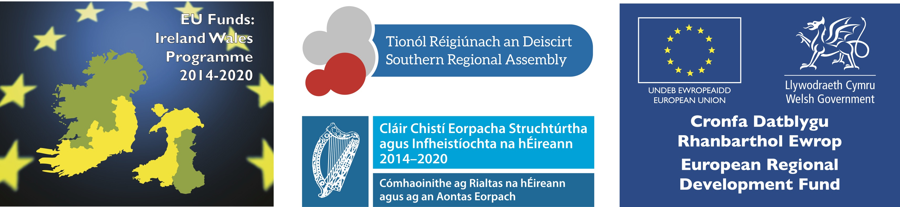

INTRODUCTION
Carlow County Council’s - Local Enterprise Office was established in April 2014 as part of a network of 31 Local Enterprise Office teams across the Local Authority network in Ireland. We provide advice, information and support to entrepreneurs, early-stage promoters, start-ups and expanding businesses. An initiative of the Action Plan for Jobs, Local Enterprise Offices (LEOs) act as “First Stop Shops” for anyone seeking information and support on starting or growing a business in Ireland. The Local Enterprise Office implements measures to assist job sustainability and creation through the development of business know-how, efficiency, expertise and business-related infrastructure in the area.

PROPOSAL REQUIREMENT
Carlow County Council’s - Local Enterprise Office is currently in the development phase of a variety of projects which require Public Relations and Communications support, in particular, the area of Food, Drink, Life Sciences & marketing for Christmas events. The following are the requirements for the project:

- Develop key press contacts and effectively manage those relationships on a continuous basis. Dissemination of press releases to Regional & National Media Outlets.
- Research, prepare and secure relevant sign off prior to issuing press statements.
- Obtain and provide timely and accurate information for the press.
- Assist Carlow County Council in dealing with queries from the media and other sources.
- Support existing PR efforts already in place for Carlow County Council or Carlow County Council supported events as required.
- Liaise with appropriate photographers to provide photography service as required.
- Special projects which require a Public Relations and Communications strategy for the Local Enterprise Office.

The primary function of the PR contractor is measured on the level of public relations placement in print, digital, TV & Radio format for the core message of the project campaign, the Local Enterprise Office, Carlow County Council and its clients as part.

Carlow County Council utilize the services of Content Plan for its Social & Digital Media Campaigns and the chosen contractor will be expected to engage with them in respect of Digital Content.

At present the following campaigns are envisaged as part of this proposal:

Work Package 1: Carlow Agri-Food Tourism Project / Carlow Culinary Christmas

This project will include:

- Project Element 1: Agreement of a Communications Plan which outlines core roles & responsibilities for each partner.
- Project Element 2: Facilitation of PR for the Launch of Carlow Culinary Christmas (End October 2018) – Carlow Culinary Christmas is a three day Food & Drink Event which showcases County Carlow food via an exhibition, food showcase event and experience workshops.
- Project Element 3: Provision of PR support for six core clients/groups over a four month period. It is proposed as part of this project, six clients/groups would be selected and the PR company would work to (1) develop their core story (2) align the core messages of County Carlow Food & Drink Sector with their story (3) develop Press Releases materials and manage dissemination to the press in partnership with the client and the Local Enterprise Office.
- Project Element 4: Media Evaluation & Monitoring: the chosen provider will be expected to recommend, cost and manage a media monitoring solution.

Work Package 2: Christmas in Carlow

This project will include:
- Project Element 1: Agreement of a Communications Plan which outlines core roles & responsibilities for each partner.
- Project Element 2: Facilitation of PR for the Launch of Christmas in Carlow (November 2018) – Christmas in Carlow is a series of events which will be developed into Carlow Christmas Trail.
- Project Element 3: Media Evaluation & Monitoring: The chosen provider will be expected to recommend, cost and manage a media monitoring solution

Work Package 3: Ad-Hoc Work – Catalyst Project

This project will include the provision of Public Relations services in respect of the Catalyst Programme as required over a three day period. Each project outline will be agreed in advance and an agreed number of days against each activity. This package may be a requirement of any of the Irish project partners i.e., Tipperary County Council , Carlow County Council or IT Carlow.

CATALYST is a cross-border pilot operation that aims to use sustainable development to drive design and innovation for Welsh and Irish SMEs. CATALYST also focusses on two priority sectors of the Ireland - Wales programme i.e. Life Science and Food & Drink.

PROPOSAL SUBMISSION
Submissions should include, but not necessarily be limited to, the following:
- Company name, address and contact details;
- A brief description of your organisation – your clients, history, projects and staff;
- An outline of the services to be provided addressing all aspects of this tender call;
- Your organisation’s experience in similar projects;
- Samples/descriptions of previous work (links will be accepted);
- References (a minimum of two);
- Detailed cost breakdown – per work package element;
- Rate per day;
- Value added/Innovative techniques;
- Any other supporting information you may wish to include with your submission.
- Failure to complete and include information as required may result in your submission not being considered.
Proposals via e-mail to enterprise@carlowcoco.ie
Queries in writing only by 28th August 2018 to enterprise@carlowcoco.ie
Carlow County Council is subject to the provisions of the Freedom of Information Act 1997. Prior to the award of any contract arising out of this competition the successful tenderer shall be required to produce a Tax Clearance Certificate from the Irish Revenue Commissioners and proof of Public Liability and Professional Indemnity Insurance.
SELECTION CRITERIA
Proposals will be evaluated on the following criteria. A minimum of 60% is required to be accepted to the panel.
- Comprehensiveness, understanding of brief and quality of approach: 20%
- Expertise, experience and previous experience: 30%
- Innovation and originality of submission: 20%
- Price: 30%

