PETER BAXTER – SOUTH EASTERN CREATIVE CORRIDOR PARTICIPANT
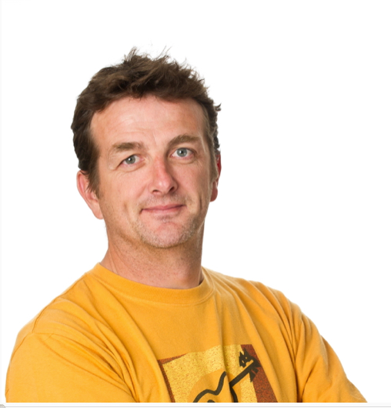

Experienced Educator – Founder & Manager of Songschool, Createschool & Brick Flicks.

Songwriter & performer with 3 albums released – The Blue Black Waves, The Miracle Bell & Since Then.

Peter Baxter’s experience of The South Eastern Creative Corridor

“I was drawn to The South Eastern Creative Corridor because it is hard to find specific supports for the sector, especially within the south-east region. I have found that business training can be very generic with a mix of industries; I knew the networking and the content of this programme would be tailored more towards the AV and creative industry.

Receiving direct financial support was of huge benefit to me. It was a competitive process and it gave me increased confidence in myself and in my business when I received the news that I qualified for it. This is extremely helpful to me and will assist me greatly with financing future marketing, equipment and job creation.

The modules delivered by The Entrepreneurs Academy were well thought-out and delivered. I found the session on finance in particular to be of huge value.

I found the opportunity to network with peers fantastic. The level of connection I got with others on the course proved to be a great support - learning within the group has helped me to be able to pick up the phone when I need advice or to collaborate on projects.

Participating in this programme was one of the best decisions that I have made in my business career. My relationship is stronger with my Local Enterprise Office and I am involved in many other opportunities with them. I am an advocate for LEOs to other businesses. The fact that ongoing support, training and advice is on hand, is of real benefit. My business is in better shape to take advantage of opportunities and review best practices and so am I as a direct result of being part of The Local Enterprise Office and The Creative Corridor.”

Follow Createschool on facebook.com/Createschool and twitter.com/Createschool

About Peter Baxter

Peter is an experienced educator, who has designed and delivered presentations, workshops, programmes, courses and projects throughout Ireland & UK, Germany, Croatia, Spain, Australia, Romania, Morocco, Malta and France.
Animation
Peter, co-produced and directed stop motion film "Freedom - A 1916 Story", which was commissioned by Wicklow County Council for Ireland in 2016 and is currently working on a new series “Legends of Wicklow”
Education Services
He established Createschool (for primary and secondary schools) in 2001, where he manages a busy team of dedicated education professionals delivering workshops and training to primary and secondary students and teachers in a variety of digital multi-media related subjects, including podcasting, stop motion, digital heritage, digital storytelling, movie making and more.
Since 2009, Peter has been designing and delivering an innovative, annual English Language Learning via music and media programme in Barcelona.
He is an accomplished songwriter, producer and performer. He has released 3 commercial albums and worked with Dónal Lunny, Ben E King to name but a few.
Podcasting
Peter produced the award- winning iWalks Podcast series for Dublin Tourism and has also produced podcasts for Guinness Storehouse and the GAA (Ireland's largest sporting organisation) and recently launched another podcast - Speak About The Spark which features artists talking about their creativity and spark!
Peter specialises in several creative sectors including Stop Motion Animation, Music Making, Song Writing, Music Technology, Non Formal Education & Podcasting.

