PHOTOGRAPHY SERVICE PANEL
Request for Submissions

Proposals must be received not later than 12:00 (noon)
on
31st August 2018

Late Proposals WILL NOT be considered.
Advertised: 16th August 2018

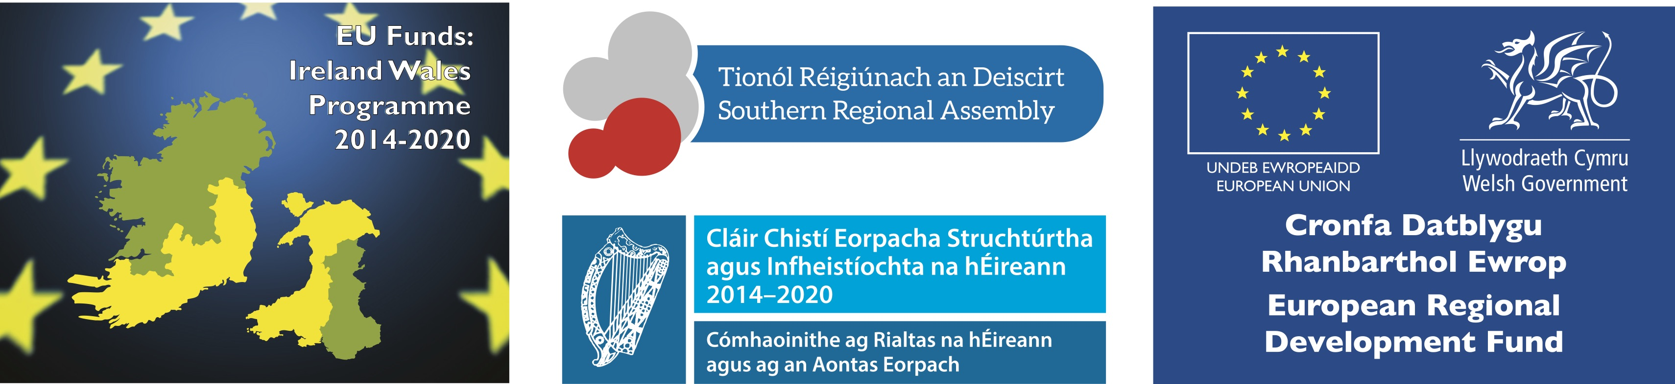

REQUEST FOR Submissions – PHOTOGRAPHY SERVICES PANEL
Carlow County Councils Local Enterprise Office was established in April 2014 as part of a network of 31 Local Enterprise Office teams across the Local Authority network in Ireland. We provide advice, information and support to entrepreneurs, early-stage promoters, start-ups and expanding businesses. An initiative of the Action Plan for Jobs, Local Enterprise Offices (LEOs) act as “First Stop Shops” for anyone seeking information and support on starting or growing a business in Ireland. The Local Enterprise Office implements measures to assist job sustainability and creation through the development of business know-how, efficiency, expertise and business-related infrastructure in the area.
Carlow County Council’s Local Enterprise Office is currently in the development phase of a variety of projects which require event, product and press Photography in the food sector and clients across a range of economic and enterprise sectors.
Objective
Carlow County Council Local Enterprise Office wishes to establish a panel for the provision of photography services from a suitably qualified photographer, as required over a period of 36 months to photograph a variety of events and business clients of the Local Enterprise Office.

The Photographer will liaise with a member of Staff of the Local Enterprise Office or designated contractor of the Office as required to achieve the aims of the Network and deliver on the objectives set out in the 2018 Programme of Activities.
Images are to be used for marketing and communications activities around initiatives of Carlow County Council Local Enterprise Office, such as:
- Product Imagery
- Events
- Advertisements
- PR features
- Social media and websites
Dates/Venues/Times
The arrangements for various work packages will be agreed with the Carlow County Council Local Enterprise Office in advance.
Instruction to Quote
- Please quote hourly and daily rate, inclusive of travel and mileage.
- The deadline to submit a written quotation is 12pm on Friday, August 31st 2018 and all quotations must appear on company headed paper with the following information:
- Professional photography experience and credentials of nominated photographer;
- Examples of any comparable projects over last three years (2015 – 2018);
- Ultimate cost, inclusive of all other costs.

For the purposes of inclusion on the panel, please note the following :
- Provider will need to liaise at all times with the designated staff member of Carlow County Council Local Enterprise Office and follow advice/direction on approach, logistics and requirements of each assignment.
- Provider may need to syndicate immediately from site to national and online media outlets.
- These photos will be used by the Local Enterprise Office, stakeholders (including local authorities and Enterprise Ireland) and clients for social media purposes and/or regional/local media distribution.
- Provider will be solely responsible for captioning and embedding captions.
- Provider will be able to offer creative ideas for photography on each day, including suggestions for props.
- Provider may be required to be flexible and responsive to changes at short notice.
- Provider may be required to work outside of normal office hours.
- Carlow County Council Local Enterprise Office in local authorities have the sole right and ownership of any and all images created in the provision of photography services and the right to modify and distribute same at their discretion.
- All rates and prices quoted in the pricing schedules must be in Euro, exclusive of VAT, except as expressly provided.

- All rates and prices quoted should be inclusive of any mileage/travel/subsistence/photography equipment hire.

- The quantities provided are estimated and provisional and are not to be considered as a guarantee of any minimum volumes. Prices quoted will remain fixed for the duration of any assignment awarded.

- The majority of work assignments will take place within County Carlow.

- Tax Clearance: Candidates must furnish an up to date Tax Reference Number (TRN) and Tax Clearance Access Number (TCAN)

- Insurance: If successful candidates must hold appropriate insurance and confirm as appropriate.

Insurance Type | Level in Place | Details of Any Excess | Expiry Date
Employers Liability
Public Liability
Professional Indemnity

Award Criteria

A minimum score of 60% is required to qualify for the position.

 | Criteria | Weighting | Maximum Score | Minimum Score Required
A | Professional photography experience and credentials of nominated photographer | 40% | 4,000 | 2,400
B | Examples of any comparable projects over last three years (2015 – 2018) | 40% | 4,000 | 2,400
C | Ultimate Cost | 20% | 2,000 | n/a

The deadline to submit a written quotation is 12pm on Friday, August 31st 2018.

