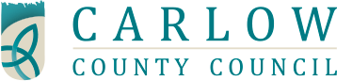

Town and Village Renewal Scheme 2018
Preliminary Call for Project Outlines
Closing Date: 13th April 2018

We are asking community & business groups across the county to bring forward details of any project which the Council could consider for submission to the Department of Rural and Community Development, under the criteria of the 2018/19 scheme.
How to express an interest on behalf of your community?
Please submit your initial proposals by Friday 13th April 2018 by post to:
Town & Village Scheme , Local Enterprise Office , Carlow County Council , Enterprise House , O’Brien Road , Carlow
or
by e-mail to: enterprise@carlowcoco.ie
Full details available on www.localenterprise.ie/carlow



