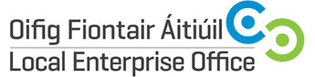
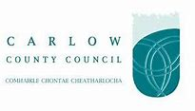

CATALYST - FOOD, DRINK & LIFE SCIENCES SECTOR
INNVOATION & DEVELOPMENT WORKSHOP
|

Duration | 3 Hours (Evening)
Date(s) | 1st October 2018
Time | 9.30am – 4.30pm
Location | Institute of Technology Carlow, Kilkenny Road, Carlow
Cost | Free of Charge

CATALST is a EU Funded Programme which offers Food, Drink & Life Sciences companies in Carlow & Tipperary with the opportunity to engage in a business innovation development programme over a two-year period which includes mentoring, training, innovation residences and cross border networking and exchange. The Irish kick- off event will be held in the Institute of Technology Carlow on 12st October 2018 and will provide Carlow & Tipperary companies with the opportunity to find out more about the programme and the opportunities it presents.

The 1st October is a 1-day workshop designed to develop and enhance companies’ understanding of key development and innovation opportunities for their business and following the day companies will be given the opportunity to apply for a place on the main Catalyst Programme.

Food & Drinks and Life Science businesses based in Carlow and Tipperary can avail of a range of supports for their businesses to drive innovation in Product Development, Communications and Resource Efficiency. CATALYST is INTERREG funded and works with partners in Wales to optimise access to expertise and develop new markets.

The Catalyst Project is led by the University of Wales Trinity Saint David working with WRAP Cymru, the Institute of Technology Carlow, Tipperary County Council and Carlow County Council.

Further information www.localenterprise.ie or email catalyst@carlowcoco.ie

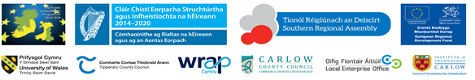

Carlow County Council – Local Enterprise Offices
Enterprise House
O'Brien Road
Carlow

Phone: 059 9129 783
E-mail: enterprise@carlowcoco.ie
Web: www.localenterprise.ie/carlow

