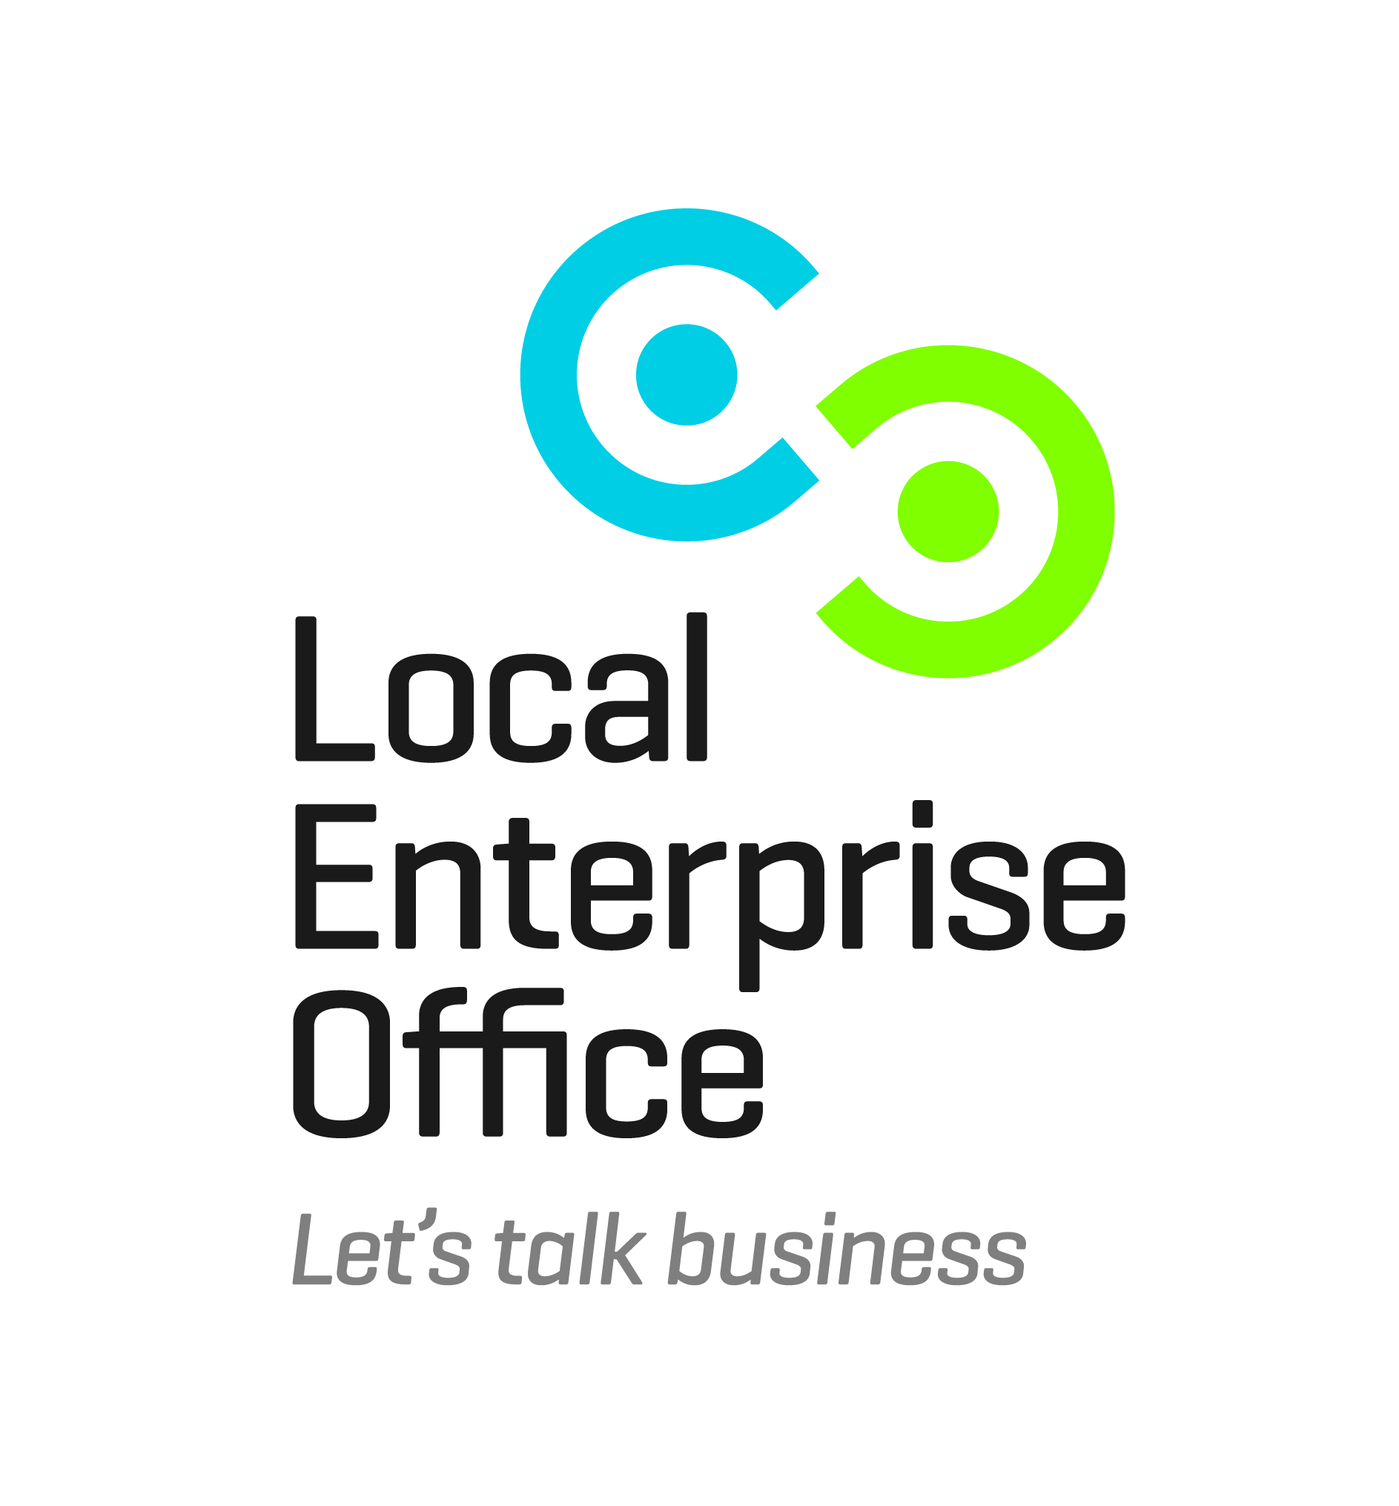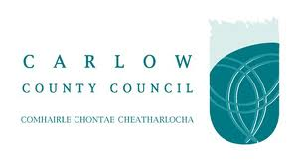

Start Your Own Business (Day)

Dates: | 23rd, 30th November & 7th December 2017
Location: | Enterprise House, O'Brien Road, Carlow
Time: | 9.30am – 4.30pm
Duration: | I day per week
Course Fee: | €50.00 (Free of Charge if completion of a Business Pathway Programme)
Trainer: | Christine O’Brien, Talentpool
This 3 day Start Your Own Business programme will guide you through the various aspects of starting and running a business in Ireland. The objective is to assist you in assessing the viability of your business idea. No prior knowledge is required.

The course will cover the following topics:
- Introduction to Starting your own Business
- Business Plans
- Taxation
- Basic Marketing / Market Research
- Sources of Funding
- Essentials of Pricing
- Credit Control & Importance of Cash Flow
Objectives:
- To give participants a detailed understanding of the core issues involved when considering establishing their own business.
- To give participants a detailed knowledge of all the key operational areas which are an integral part of operating a business in Ireland today
- To give participants a framework they can use to maximise their potential for success
At the end of this programme participants should understand how to assess the feasibility of their business idea. Be able to develop an action based marketing plan for their business and have skills for achieving their projected sales targets. The participant should also be able to understand how to manage cash flow in their business.
To book a place on this course please email enterprise@carlowcoco.ie
Or phone 059 9129783

