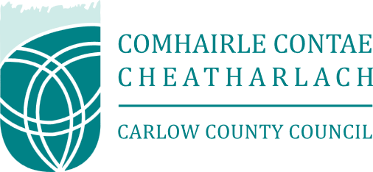

Request for Proposals (RFP): Community-Led Mural Replacement Project

1. Project Overview
Carlow County Council is seeking proposals from experienced artists or creative collectives to design and execute a replacement mural located at College Street, Carlow. The existing mural is to be decommissioned and replaced with a high-quality, durable artwork that reflects the heritage, identity, and aspirations of the local community.
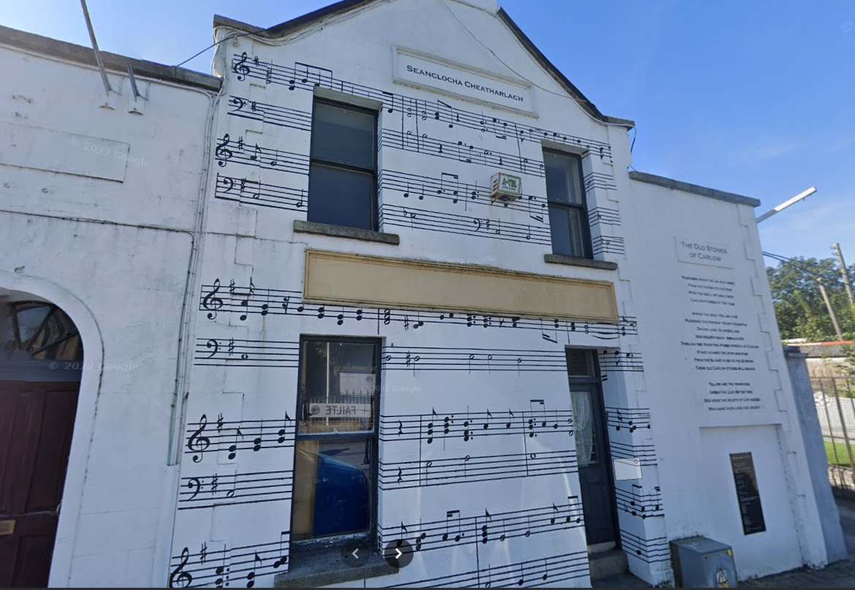

2. The Creative Brief: "Telling a Story"
The successful proposal must go beyond aesthetics. We are looking for an artist who can:
- Narrate a Theme: Translate local history, folklore, or contemporary community spirit into a visual narrative.
- Engage the Public: Act as a facilitator to extract "the story" from interested community parties.
- Site Specificity: Ensure the design complements the architectural context of the host building.
It is vital that all proposals honour the deep emotional and spiritual significance of the site, which sits directly facing the Cathedral’s main entrance and forecourt. This is a unique, "living" space that serves as a backdrop for life’s most profound moments from the joy of weddings and baptisms to the solemnity of funerals and the chosen artwork must sensitively reflect the diverse experiences of those who gather here.

3. Required Process & Scope of Work
The project is divided into four mandatory phases:
Phase | Description | Stakeholders Involved
Phase 1: Consultation | Hosting a minimum of two community workshops to gather themes, stories, and imagery from local residents. | Public, Artist
Phase 2: Concept Design | Development of three initial sketches/concepts based on workshop feedback. | Artist
Phase 3: Final Sign-Off | Presentation of the final design for formal approval. No work may commence without written consent. | Council, Building Owners
Phase 4: Execution | Preparation of the surface, painting, and application of a weather-resistant/anti-graffiti coating. | Artist

4. Budget
Budget Range: €5,000 – €8,000 (Inclusive of all costs)
The budget must cover:
- Artist fees and facilitation of workshops.
- All materials (paints, primers, sealants).
- Equipment hire (scaffolding/cherry picker).
- Health & Safety compliance (insurance and public liability).

5. Selection Criteria
Proposals will be evaluated based on:
- Artistic Quality (40%): Portfolio strength and previous mural experience.
- Community Engagement Plan (30%): Innovation in how workshops will be conducted.
- Project Management (20%): Ability to work with Council/Property owners and meet timelines.
- Value for Money (10%): Comprehensive breakdown of the budget.

6. Submission Requirements
Interested artists should submit a single PDF document including:
- Artist CV & Portfolio: Examples of previous large-scale outdoor works.
- Methodology: A brief outline (max 2 pages) of how you will manage the community workshops and tell the local story.
- Insurance: Proof of Public Liability Insurance (minimum €6.5 million).
- Proposed Timeline: From initial workshop to final unveiling.

The closing date for submissions is 10th April 2026. Submissions via e-mail to enterprise@carlowcoco.ie. Queries to Linda Culleton on enterprise@carlowcoco.ie or by calling 059-9129783

