Application Form 2020
National Enterprise Awards 2020 Application Form
LOCAL ENTERPRISE OFFICE CAVAN
Applicant Name: Please insert client name
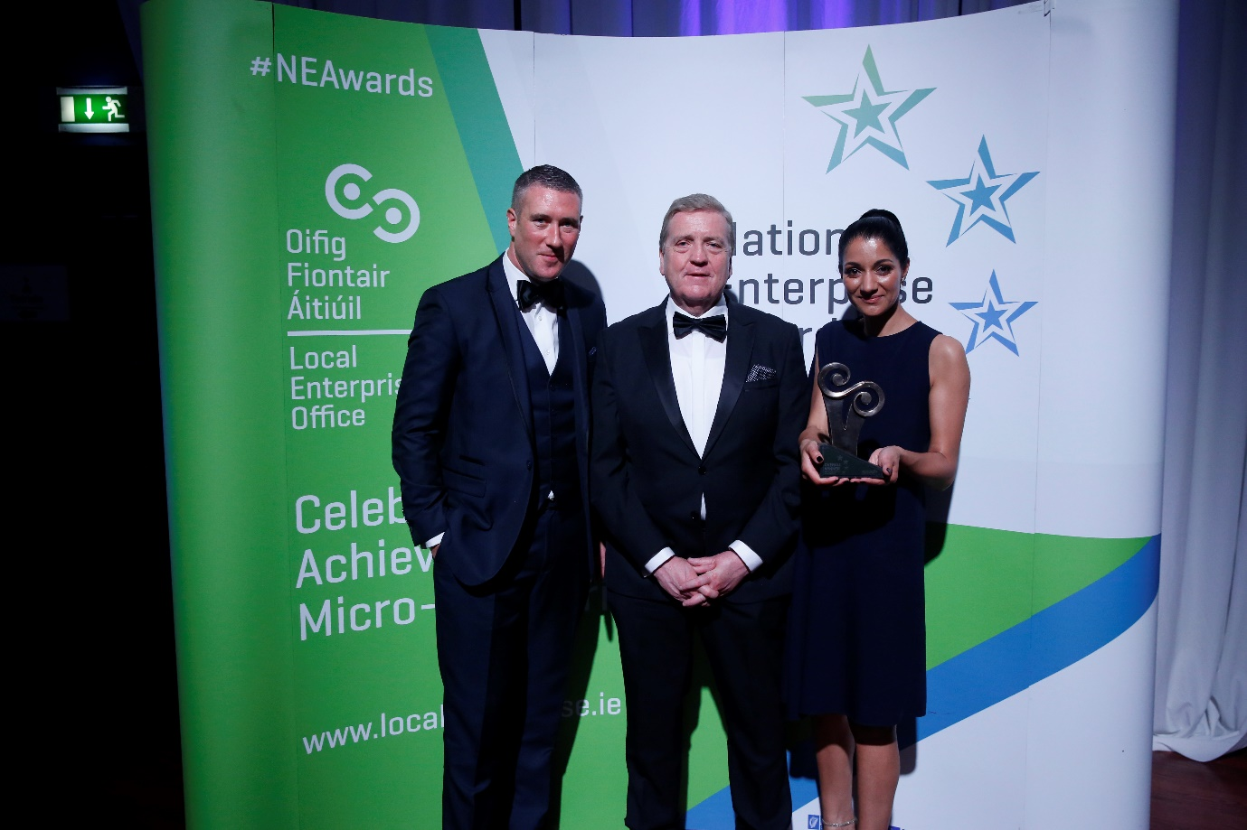
GENERAL INFORMATION
Name of Applicant: __________________________________________
Address: __________________________________________
__________________________________________
Region: __________________________________________
Legal Status: (Tick one) Sole Trader Partnership Limited Company
Date of Commencement of Business: _________________________ ______
Phone: _______________________ Business ______________________ (Mob)
Website: _____________________ E-mail:___________________________

Business Information
What product or service do you supply?

Describe your own background and why you set up in business?

What are the key strengths of your business?

How and when did your Local Enterprise Office help your business? (Please include the year, type and level of support i.e. Grant aid and /or Training Supports)

Has this business been grant aided by any other government agency such as Enterprise Ireland, An Bord Bia, Leader Partnership, Inter Trade etc. (If so give details i.e. Agency, Year, Grant Amount, Type etc)

Marketing Your Business
Describe what is different or innovative about your product or service?

Is your customer base local, regional, national, international? Please give details.

How do you market your business? Do you measure the impact of these activities?

Are there potential new markets for your business and how do you plan to take advantage of these opportunities?

Social Media
What forms of social media do you use to promote your business and describe any campaigns you have undertaken?

Technology
How do you use technology in your business? Do you see this changing over the next 3 years?

The Future of your Business
What long-term plans do you have for your business and how do you see it growing and developing over the next 3 years?

Future Focus Initiatives
What actions if any have you taken to improve the sustainability of your business, improve your business carbon footprint or energy efficiency? Have you implemented any environmentally friendly business practices? Have you implemented any Lean or business process improvement initiatives in your business? What were the outcomes?

What do you see as the key threats/weaknesses to your business? How do you propose to address them?

Employment Details

 | 31/12/2017 | 31/12/2018 | 31/12/2019 | Projected 2020
Full Time
Part Time

Financial Details
Business Growth | 2017 | 2018 | 2019 | Projected 2020
Annual Sales
Net Profit

Investment | 2017 | 2018 | 2019 | Projected 2020
Own Funds
Loans
Grants
TOTAL

Please provide any financial statements you feel will support your application in soft copy attached to this application.
Please provide any reports on future focus initiatives or ongoing projects and outcomes which support your application in this category if applicable.

Please provide short description of your business for inclusion in the NEA brochure – Max 50 words
SAMPLE WORDING FOR ILLUSTRATION - BROCHURE DESCRIPTION
Cork (South): Start of word count: Haven Bay Care Food Ltd. supplies a frozen range of restaurant-quality readymade meals under the 'Kinsale Gourmet' brand. The meals are handmade in Kinsale by its six staff for the retail and foodservice markets. Currently supplying all major retail multiples in Ireland, the company has also begun exporting to the UK. End of word count. Promoter: Owen O’ Brien E: info@kinsalegourmet.ie W: kinsalegourmet.ie

(Please return your completed application form, together with a current Business Plan and financial statements such as your last end of year accounts / current year’s management accounts to your Local Enterprise Office by the indicated deadline.

Signed: ___________________________________

Date: ___________________________________

