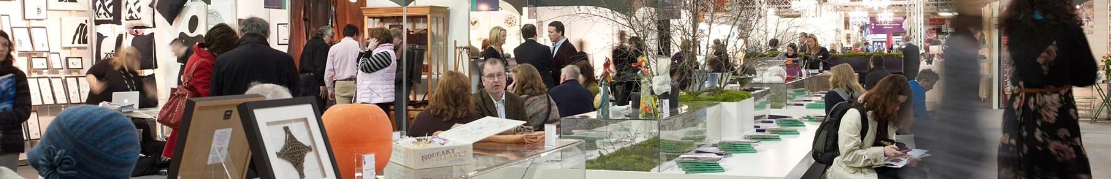
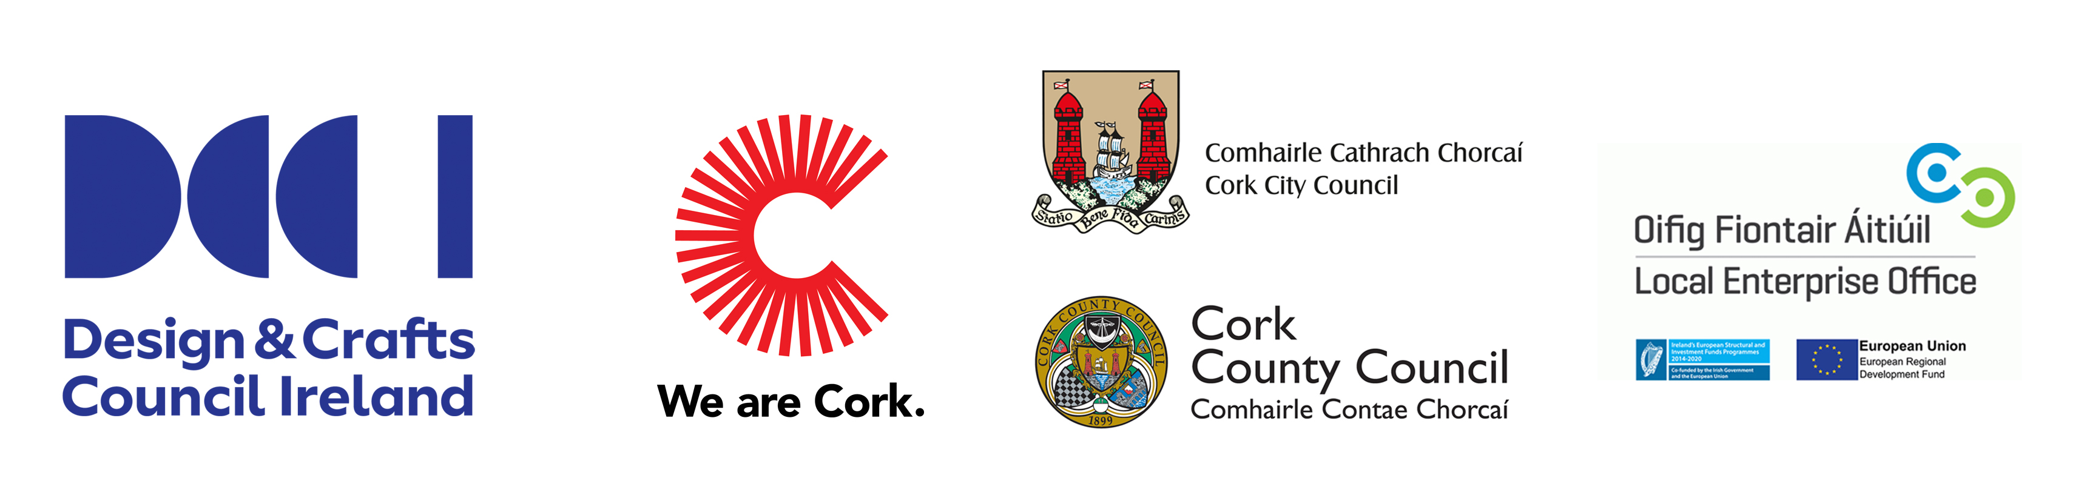

Building a Craft & Design Enterprise Programme 2020
Premium package of support tailored for designer-makers who are trading for a minimum of 18 months. These supports aim to boost product development, export potential, employment and commerciality of websites through bespoke workshops, mentoring and an accompanied retail/trade research visit to London. Design & Crafts Council of Ireland in partnership with Cork LEOs.

Deadline for submission of applications: 5pm Friday 14 February 2020.
Please submit application form along with 3 digital images of your work.
Applications should be sent via email to your LEO Office, see contact details below.

Applicant Details

Name of Applicant

Craft & Design Discipline

Business Address

PPS/ CRO number Mobile

Email

How long have you been in your current business?

Are you registered with the DCCoI? Yes / No Website
Social Media Sites

What is your annual turnover? (tick as appropriate)
Less than €10k | €20 - 40k | Over €60k
€10 - 20k | €40 - 60k

Describe your product range and your target market: (max. 300 words)

Who are you currently selling to?

How will the Building Craft & Design Enterprise Programme assist you in developing your business? (max. 300 words)

What supports have you received from your LEO and/or DCCoI in the past?

Please email with images by 5pm, Friday 14 February 2020, to your local LEO Office:
LEO Cork City | LEO Cork North & West | LEO South Cork
Ita Madden  E: ita_madden@leo.corkcity.ie  T: 021 4961828 | North: Joan Kelleher  E: joan.kelleher@leo.corkcoco.ie  T: 022 43235  West: Christine Heffernan  E: christine.heffernan@leo.corkcoco.ie  T: 023 8834700 | Ciara Mc Gee  E: ciara.mcgee@leo.corkcoco.ie  T: 021 4285200

