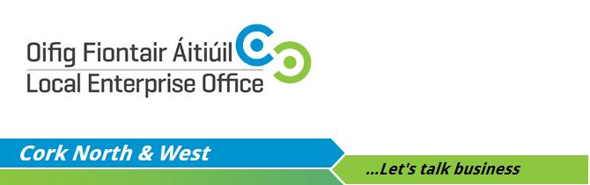
“Food Export Ready Business Development Programme” 2015/2016

This programme will assist County Cork Food companies who are export ready to explore export opportunities, maximise potential for export success and minimise risk by training and supporting companies to take a systematic approach to entering new export food markets.

The programme aims to:

1. Define the new export market opportunities that the participant wants to serve and identify whether the business has or can develop a “market niche”.
2. Assist participants to develop products to meet the need of the customers in the defined export market.
3. Support participants to acquire adequate resources (including people, equipment, facilities and financial resources) and effectively manage these resources in order to execute the client’s export strategy.
4. Develop the “operational” systems needed to manage the business on a day-to-day basis, including production systems, accounting/financial management systems, information systems, sales/marketing

The programme will take place over a three month period (Jan-March) and will culminate in a group exhibition under the ‘Taste Cork’ stand at a pre-agreed international speciality food show.
If you are interested in taking part please fill out this short application form and return it to westcork@leo.corkcoco.ie before MONDAY THE 15TH OF DECEMBER

Business name:
Description of your business:
Home phone number:
Mobile phone number:
Email address:
Website:
Address:

Name:

