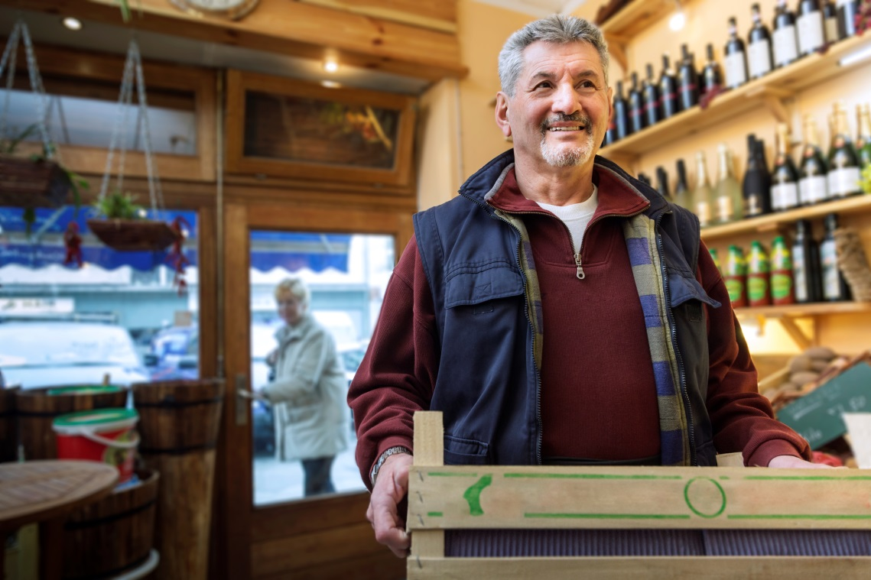

Retail Business - Strategy Support Programme

Expression of Interest Form

Introduction
New for 2017, Dún Laoghaire-Rathdown County Council is seeking expressions of interest to participate in this short retail support programme, designed to give your business expert advice and strategic focus. It might now be time to challenge what you are currently doing within the business, and look at real ways to improve your sales growth and profitability.

You may have participated in a retail programme in the past, however this programme represents brand new material delivered through a short seminar and one to one bespoke advice for your business which will allow you to revisit and update your strategy. Alternatively it might be your first time participating in a support programme. Either way, this programme is for you.

Programme Structure
The programme consists of a three hour early morning seminar which will look at global innovation for retail/consumer facing businesses. There will also be a section of this seminar dedicated to practical sales and marketing tips. The objective of this seminar is to learn from what others are doing and implement new ideas for your business.

Site Audit/Training Session
Each participant will also receive a two hour site visit/audit from retail expert James Burke. This session is to facilitate customised training of each of the participants in response to their own individual needs. The visit will include a detailed business analysis including, identification of growth opportunities, competitor analysis, opportunities to differentiate, management skillsets, customer service initiatives, etc.

Target Participants
This programme is targeted at the owner/manager of any business which is consumer facing e.g. retailers from all sectors, cafés, restaurant and foodservice outlets, hotels, beauty salons and hairdressers, gyms, opticians and other service providers, etc.

This programme is for business owners and managers only (not for front line staff)

Business Owner Name
Mobile
Email
Type of Business e.g. Butcher, Hairdresser, etc.
List three key challenges you would like to programme to address which are specific to your business
1.

2.

3.

Please return your expression of interest to Eoin Roche, Economic Development
Dún Laoghaire-Rathdown County Council, eroche@dlrcoco.ie

By 5pm on Friday, 29th September 2017

Cost
Cost for participation on this programme will be €100

