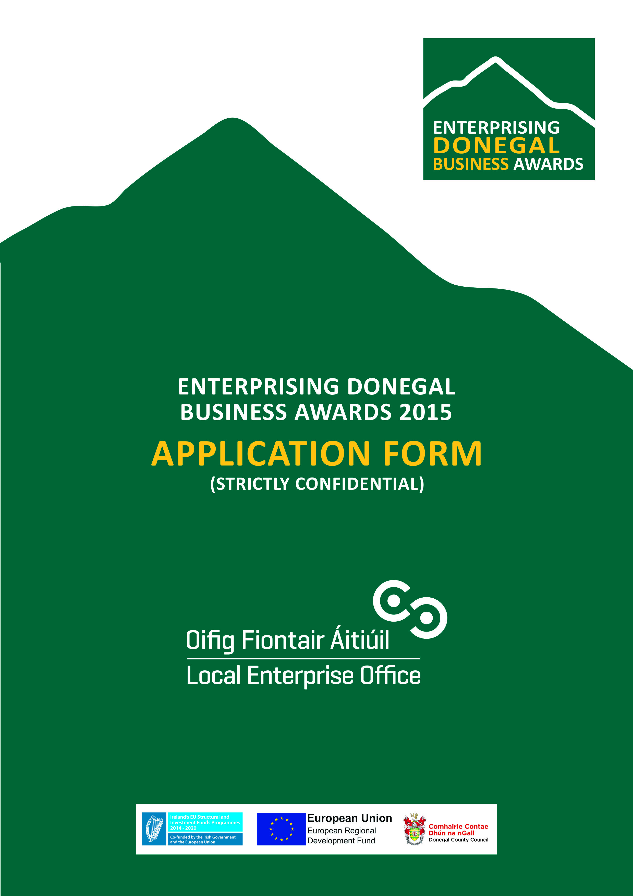

Guidelines for completion of application

- Please complete all sections as fully as possible and indicate which category(s) that you intend to apply for. The judges can only adjudicate on what they can view in the application presented.
- All applications must be typed and three copies submitted to the offices of the Local Enterprise Office on or prior to the 27th February 2015 at 3pm.
- When submitting any additional materials such as product samples or packaging, branding or drawings etc please submit three copies.
- All of the boxes on the application can be filled in as fully as possible and additional space can be used.
- Previous Overall winners of the Enterprising Donegal Business Awards are not eligible to apply however individual category winners may apply
- Please submit most up to date accounts and Business Plan for your Business.
- If the business is a start up that does not have a full years trading then please include management accounts.

GENERAL INFORMATION
Name of Applicant: __________________________________________
Address: __________________________________________
Legal Status: (Tick one) Sole Trader Partnership Limited Company
Date of Commencement of Business: _________________________ ______
Phone : _______________________ Business ______________________ (Mob)
Website : _____________________ e- mail:____________________________

Tick box of relevant award categories you are entering (You may tick multiple boxes providing you can provide the relevant information to support your application).

Business in operation less than 18 months (Start-Up)
Business in operation more than 18 months (Business Expansion)
Excellence in design
Export Business

Business Information
What product or service do you supply?

Describe your own background and why you set up in business?

What do you see as the key strengths of your business?

In what way and when, did your Local Enterprise Office help you (formerly CEB)? (Please include the year, type and level of support i.e. Grant aid and /or Training Supports)

Has this business been grant aided by any other government agency such as Enterprise Ireland, An Bord Bia, Leader Partnership, Inter Trade etc . (If so give details i.e. Agency, Year, Grant Amount, Type etc)

Excellence in Design
Please highlight any aspect of your product or service that conveys excellence in design

Describe what is different or innovative about your product or service?

Technology
How do you use technology in your business?

Exporting
Is your customer base local, regional, national, international? Please give details

If you export, what markets do you currently export to? (E.g. Northern Ireland, Rest of UK, France, US).

How do you market your business? Please describe all methods including use of social media and website. Please also include links and or web addresses as appropriate.

Are there potential new markets for your business and how do you plan to take advantage of these opportunities?

The Future of your Business
What long-term plans do you have for your business and how do you see it growing and developing over the next 3 years?

What do you see as the key threats/weaknesses to your business? How do you propose to address them?

Employment Details
 | 31/12/2013 | 31/12/2014 | Projected  2015 | Projected 2016
Full Time
Part Time

Financial Details
Business Growth | 2013 | 2014 | Projected  2015 | Projected  2016
Annual Sales
Net Profit

Investment | 2013 | 2014 | Projected  2015 | Projected  2016
Own Funds
Loans
Grants
TOTAL

Please return three hard copies of your completed application form typed, together with a current Business Plan and financial statements to the Donegal Local Enterprise Office by the 27th February 2015 at 3pm. Only fully completed applications with all materials submitted will be accepted.

Signed: ________________________________
Date: __________________________________

P.S. We can only adjudicate on the basis of information provided. The more information in your application the better.

