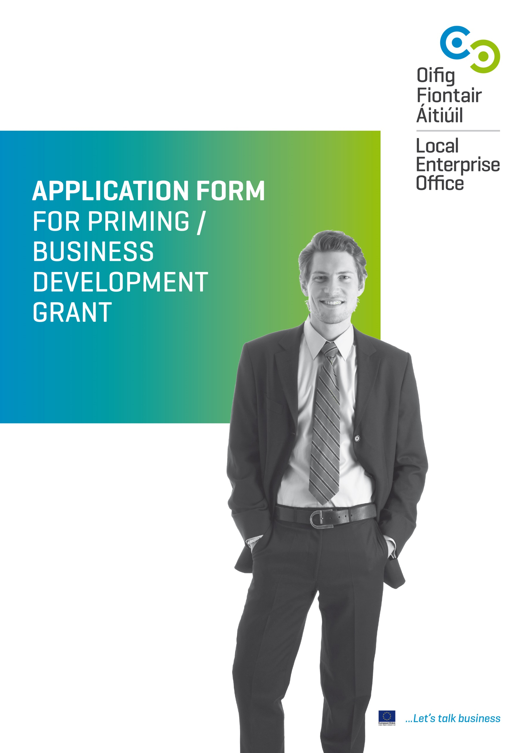

Freedom of Information
The Local Enterprise Office will not release any information received as part of this application except as may be required by law, including the Freedom of Information Acts 1997 and 2003. In the event of a Freedom of Information request, the client will be given reasonable advance notice in order to contest such disclosure.
Data Protection
Any personal information which you provide to the
Local Enterprise Office will be obtained and processed in compliance with the Data Protection Acts 1988 & 2003. The information in this Application Form will be used by the Local Enterprise Office in the processing of your application and for ongoing administrative purposes between you and your Local Enterprise Office.
Note
Beneficiaries of grant aid should note that the acceptance of funding is an acceptance of their inclusion in the list of beneficiaries under Article 7(2) of the Implementation Regulation (EC) No 1828/2006. This list can be accessed on Border Midland & Western and Southern & Eastern Regional Assembly websites.
All questions marked with an asterisk ( * ) are mandatory
1. CONTACT DETAILS
Primary Contact Details
Gender*
Prefix (Mr. Mrs. etc.)*
First Name*
Last Name*
Tax No.*
Address*
Telephone* |  | Mobile*
If the applicant details are the same as the primary contact details please tick the box If not, please give contact details:
Applicant Contact Details (if different from Primary Contact Details)
Gender*
Prefix (Mr. Mrs. etc.)*
First Name*
Last Name*
Tax No.*
Address*
Telephone* |  | Mobile*

New Enterprise Priming Grant (Business less than 18 months old)
All questions marked with an asterisk ( * ) are mandatory
1. GRANT TYPE
Please tick whichever is applicable:
Business Development / Expansion Grant (Business greater than 18 months old)

2. CONTACT DETAILS
Business Contact Details
Gender*
Prefix (Mr. Mrs. etc.)* | First Name*
Last Name*
Business Name*
Tax No.*
Business Office Address*
Telephone* |  | Mobile*
Email * Website
……………………………………………………………………………………………………………………………………………………………………………………………………………….

Personal Contact Details (Include all Promoters details)
Gender*
Prefix (Mr. Mrs. etc.)* | First Name*
Last Name*
PPS No.*
Home Address*
Telephone* |  | Mobile*

3. APPLICANT DETAILS
(Please tick)
Business Name*
Stage of Business*  (please tick box) | Pre-Start Up | Start Up (<18 months) | Growth (>18 months)
Date Trading Commenced*

Applicant Type*
(Please tick)
Sole Trader / Individual
Company |  | CRO No.
Partnership

If Applicant is a Limited Company please complete section below:
Company Registration Number*
Date of Incorporation*
If Applicant is a Limited Company please complete section below;
Company Registration Number
Date of Incorporation
Share Capital
Authorised Share Capital
Issued and Paid up
Shareholders Names
Shareholding (%)
Associated Companies (if any)

4. PREVIOUS STATUS OF PROMOTER*
(Please tick)
Self Employed | Employed | Unemployed | Training / Education

AGE OF PROMOTERS

21 – 30 | 31 – 40 | 41 – 50 | 51 – 60 | 60+

HAVE YOU AVAILED OF ANY LEO PRPOGRAMS

Mentoring | Training | Networks

Please Give Details e.g. Name of Mentor
…………………………………………………………………………………………………………………………………………………………………………………………………………

………………………………………………………………………………………………………………………………………………………………………………………………………..

5. PROJECT DETAILS
What type of business are you involved in / plan to be involved in?*
(Please see page 12 for qualifying businesses in each sector)
Please tick and detail in the box below:
Business Services
Clothing & Fashion
Communications, Media & Entertainment Services
Consumer Services
Craft
Electronics
Engineering
Environment /
Green Technologies
Food Manufacturing & Processing
Food Primary Sectors
Furniture / Light Consumer Goods Manufacture
Manufacturing Other
Medical Devices Manufacture
Packaging Manufacturing
Software / IT
Other

Please Describe Your Business / Proposed Business*(Give details of your Commercial Sales, specify customers)

6. INVESTMENT COSTS
Please list the items to be purchased and their cost. Only costs listed in your application may be claimed. Costs cannot be changed once they are approved. * You must submit 3 written quotations for each item you are applying for.

Item Description | Expected Cost € | Net of VAT (excluding VAT)
Salary Costs* (all applications must include new fulltime paid jobs)

Capital Items (eg. Industrial equipment.
NOT mobile assets such as laptops or vehicles)
Consultancy or Marketing Costs
TOTAL COSTS €

Amount of Grant Assistance for Capital & Consultancy/ Marketing sought (maximum 50% of total excluding VAT) | €
Amount of Grant Assistance sought for new full-time employees  (grant max of €10k per new full-time job) | €
Investment in project from own resources | €
Investment in project financed by borrowing | €
TOTAL INVESTMENT IN PROJECT | €

Will this project proceed without grant assistance? (please tick)
Yes | No
*Self Declaration – please give details of ALL Previous Grant Aid and State Support (mandatory question)
Have you discussed or received any other State Supports or EU supports (New Frontiers, Enterprise Ireland, Bord Bia, Craft Council of Ireland, Failte Ireland or any other state support agency ? (please tick)
Yes | No
If YES above please give details including the date, amount and the purpose of the grant or support you received:
Other Grants Provider |  | Date |  | Amount | Purpose

7. EMPLOYMENT DETAILS*
Estimated Job Potential* (Including the applicants)

Current |  |  |  | Potential Year 1
 | Full-time | Part-time |  |  | Create New |  | Sustain Existing
Male |  |  |  |  | Full-time | Part-time | Full-time | Part-time
Female |  |  |  | Total
Total

Potential Year 2 |  |  |  |  |  | Potential Year 3
 | Create New |  | Sustain Existing |  |  |  | Create New |  | Sustain Existing
 | Full-time | Part-time | Full-time | Part-time |  |  | Full-time | Part-time | Full-time | Part-time
Total |  |  |  |  |  | Total

Describe the new / sustained jobs (ie. job titles, type of employment, salary scale)
Job Title | Full Time No. | Part Time No. | New | Sustained | Salary Scale

8. FINANCIALS
Summarised Trading Accounts & Trading Projections
Last Trading Year Ended
Are Accounts Audited (please tick) | Yes | No

Please provide a copy of your latest set of Certified Accounts
(For Priming Grant Applicants, ie. those trading less than 18 months, management accounts should be provided if available)
 | Actual (if applicable) | Projected
 |  | YEAR 1 | YEAR 2 | YEAR 3
1 SALES (turnover)
COST OF SALES
2 Raw Materials
3 Drawings
(ie. applicants own wages)
4 Staff Wages
5 Phone and Fax
6 Electricity
7 Insurance Premium
8 Advertising
9 Transport Cost (petrol etc.)
10 Printing and Stationery
11 Loan Repayments
12 Accountancy Fees
13 Depreciation
14 Rent & Rates
15 Cleaning / Waste Disposal
16 Repairs & Maintenance
17 Other
18 TOTAL COST OF SALE
(Add items 2 to 17)
19 NET PROFIT
(Deduct 18 from 1)

9. ADDITIONAL INFORMATION
(Please tick)
- Are you in receipt of, or you will be an applicant for, any Social Welfare Support in respect of your own or your employee’s employment?* (please note those in receipt of Job Plus cannot avail of grant support)
Yes | No
- This application may have to be referred to other Agencies (on a confidential basis) as part of the Local Enterprise Office’s processing procedure. Do you consent to this?* (please tick)
Yes | No
- Are you (or the company) registered for VAT? (please tick) (Tax clearance certificates is required for all claims.
Yes | No
- Do you require planning permission or other permission to proceed with your business?* (please tick)
Yes | No
- Please give details of the following:*
Bankers
Accountant
Solicitor
Insurers
Beneficiaries of grant aid should note that the acceptance of funding is an acceptance of their inclusion in the list of beneficiaries under Article 7(2) of the Implementation Regulation (EC) No 1828/2006. This list can be accessed on Border Midland & Western and Southern & Eastern Regional Assembly websites.
Required Supporting Information ( your application will not proceed if there is any of the following information missing)
Please attach the following as appropriate (tick items attached):
- Curriculum Vitae for each Promoter
- Business Plan (Please use the Business Plan Template)
- 3 year cash flow projections
- Quotations (3 written quotes for each proposed expenditure)
- Latest set of certified accounts and/or management accounts as appropriate (if already in business)
- Certificate of Incorporation or CRO Number (company only) or Certificate of Registration of Business Name if available

Other Supporting Information
- Forward Orders
- Photographs If Appropriate
10. SIGNATURE*
I hereby declare that the details given in this application, together with any supplementary information supplied are true and accurate. If application is for a limited company 2 directors signatures are required.
Signed | Date
Signed | Date
Signed | Date

Please Note
Application form and supporting information to be signed and returned to the Local Enterprise Office.
Contact details can be found on http://www.localenterprise.ie

APPENDIX 1
Application Check List
You must send both a soft copy (emailed to grants@leo.dublincity.ie) and a hard copy of all documentation to our LEO office by the deadline date.

Application signed and dated (Incomplete Applications will be rejected)
Business Plan / Framework
If you are using your own Business Plan please include all of the questions in the Framework
3 quotations for all costs for which Grant Aid is sought
Latest set of Certified Accounts (if already in business)
(For Priming & Business Development Grant management accounts should be provided within 3 months of date of application)
3 Year Cash Flow Projections on a monthly basis
3 Year Profit & Loss Projections on an annual basis
Certificate of Incorporation, CRO Number or Certificate of Registration of Business Name
Loan Sanction evidence if available (letter from lending institution verifying loan/overdraft approvals)
Your own qualifications (CV)
Confirmation of Grant Aid sought from other Agencies
Business Tax Clearance Certificate (verifying Dublin City address)

REMEMBER INSUFFICIENT INFORMATION WILL RESULT IN DELAYS

APPENDIX 2

Business Services | Services provided to other businesses
Clothing & Fashion | Design and manufacture of clothing / fashion
Communications, Media & Entertainment Services | Digital media, wireless communications, broadband, animation,  e-learning, media & entertainment.
Consumer Services | Services provided to other consumers / general public
Craft | Manufacture craft products
Electronics | Manufacture of components / sub supply
Engineering | Manufacture aerospace, agricultural machinery, automotive,  tanks & vessels, tool making & plastics
Environment / Green Technologies | Manufacturing & delivery of environmental / services / products  and green technologies
Food Manufacturing & Processing | Manufacture and processing of food
Food Primary Sectors | Primary production of food
Furniture / Light Consumer Goods Manufacture | Manufacture of light consumer products
Medical Devices Manufacture | Manufacture of medical devices
Manufacturing Other | Other manufacture not classified above
Packaging Manufacturing | Packaging manufacture
Software / IT | Development & delivery of software & IT services. E-Commerce

Business Plan Framework | Please include All of these Topics in your Business Plan  for Priming Grant or Business Expansion Grant applications to LEO Dublin City
Executive Summary where is it going and how can it get there? | Where has the business come from?  Where is it currently? Where is it going and how can it get there?
1. The Promoter | Promoter(s) Background/qualifications/ experience/reason why the company was formed.  Overview as to the challenges and success of the business
2. Business Project Overview
Objective | What are the overall aims and objectives?  Where has the business come from and what are the plans for the future 3 months (short term), 1 year (medium term) and 3 years (long term)?
Products/ Services to be provided | What services / products is being offered / manufactured?  From a timing perspective - How advanced is the project idea/business?
Management & Employment | How will the business be managed, how many currently employed, are there plans to increase employment and management structure?  Employment number ; current 3 months (short term) 1 year (medium term)
Premises | Where is the business being operated from? Is the premises owned by the company / Promoter? Is it leased and if so on what terms?
Key Skills | What skills are required – specialist skills? Include your C.V.
Advisors and Bankers | Who are your advisors – business, regulatory, financial, legal?
Revenue Model | How are you going to make money from this business – what is your revenue model?
3. The Market | An overview of the market, what is the specific market that’s being targeted?
Target Market | What markets do you intend to target?  What is the size of your target market sectors?  What research or sales activity have you carried out in this market?  How will you reach, sell to and deliver your product/solution to customers?
Customers | What is the customer problem you are solving?  Who are your customers? List your top 3 customers, size of orders and their locations. Give details of your sales pipeline  Have you spoken with any potential customers or commercial partners? Please outline who you have spoken to and the outcome of the discussions.
Competitors | Who Who is your competition in the market – main competitors in Ireland and in your international target markets and how does your offer compare?
Competitive Advantage | What specific benefits do customers obtain from using the company’s product or service in terms of increased revenue, decreased cost?  What gives your business or products the advantage over your competitors?
Distribution Channels | How will your goods be distributed?  Will you increase your geographic area, will you sell directly or will you use agents or wholesalers?
Market and Promotion Strategy | How will you improve your marketing, how will you achieve more customers? How will you advertise e.g. directories, personal selling or sales promotion (free offers) etc.?
Sales Strategy | What selling methods will be used – telephone, mail shots, cold calling, follow up from mailshots?  What short/medium/long term sales targets will be set?
Pricing Strategy | How did you decide your current pricing strategy and does it position the business correctly for all markets?
4. Financial Information
Financial Projections | 12 month projected Cash Flows (monthly basis), 3 year projected Profit & Loss Account, Balance Sheet
Capital Expenditure requirements | Detail capital expenditure requirements for 1/ 2/ 3 years
Other funding requirements | Soft Funding, Training, Website development etc.
Funding Sources | What has funded your business up until now?
What is the funding requirement for Year 1 and 2?
How do you plan to service this requirement?
 | Clearly outline any cash investment from the founders, any loans, private investment raised and financial support received or applied for from government agencies in your Business Plan.
Assumptions | Based on Trading Accounts and Trading Projections what benefits will accrue to the local economy as a consequence of this LEO investment?
5. Commercial Challenges | What are the biggest challenges for your company to be successful in this market?  What are your limitations?  What areas do you feel you need most assistance?  What are the key risks associated with your project?  Why do you believe that your start-up is capable of trading internationally?  What do you need to do to move the business to the next stage of  development?  Does your business have or intend to secure Intellectual Property protection?

