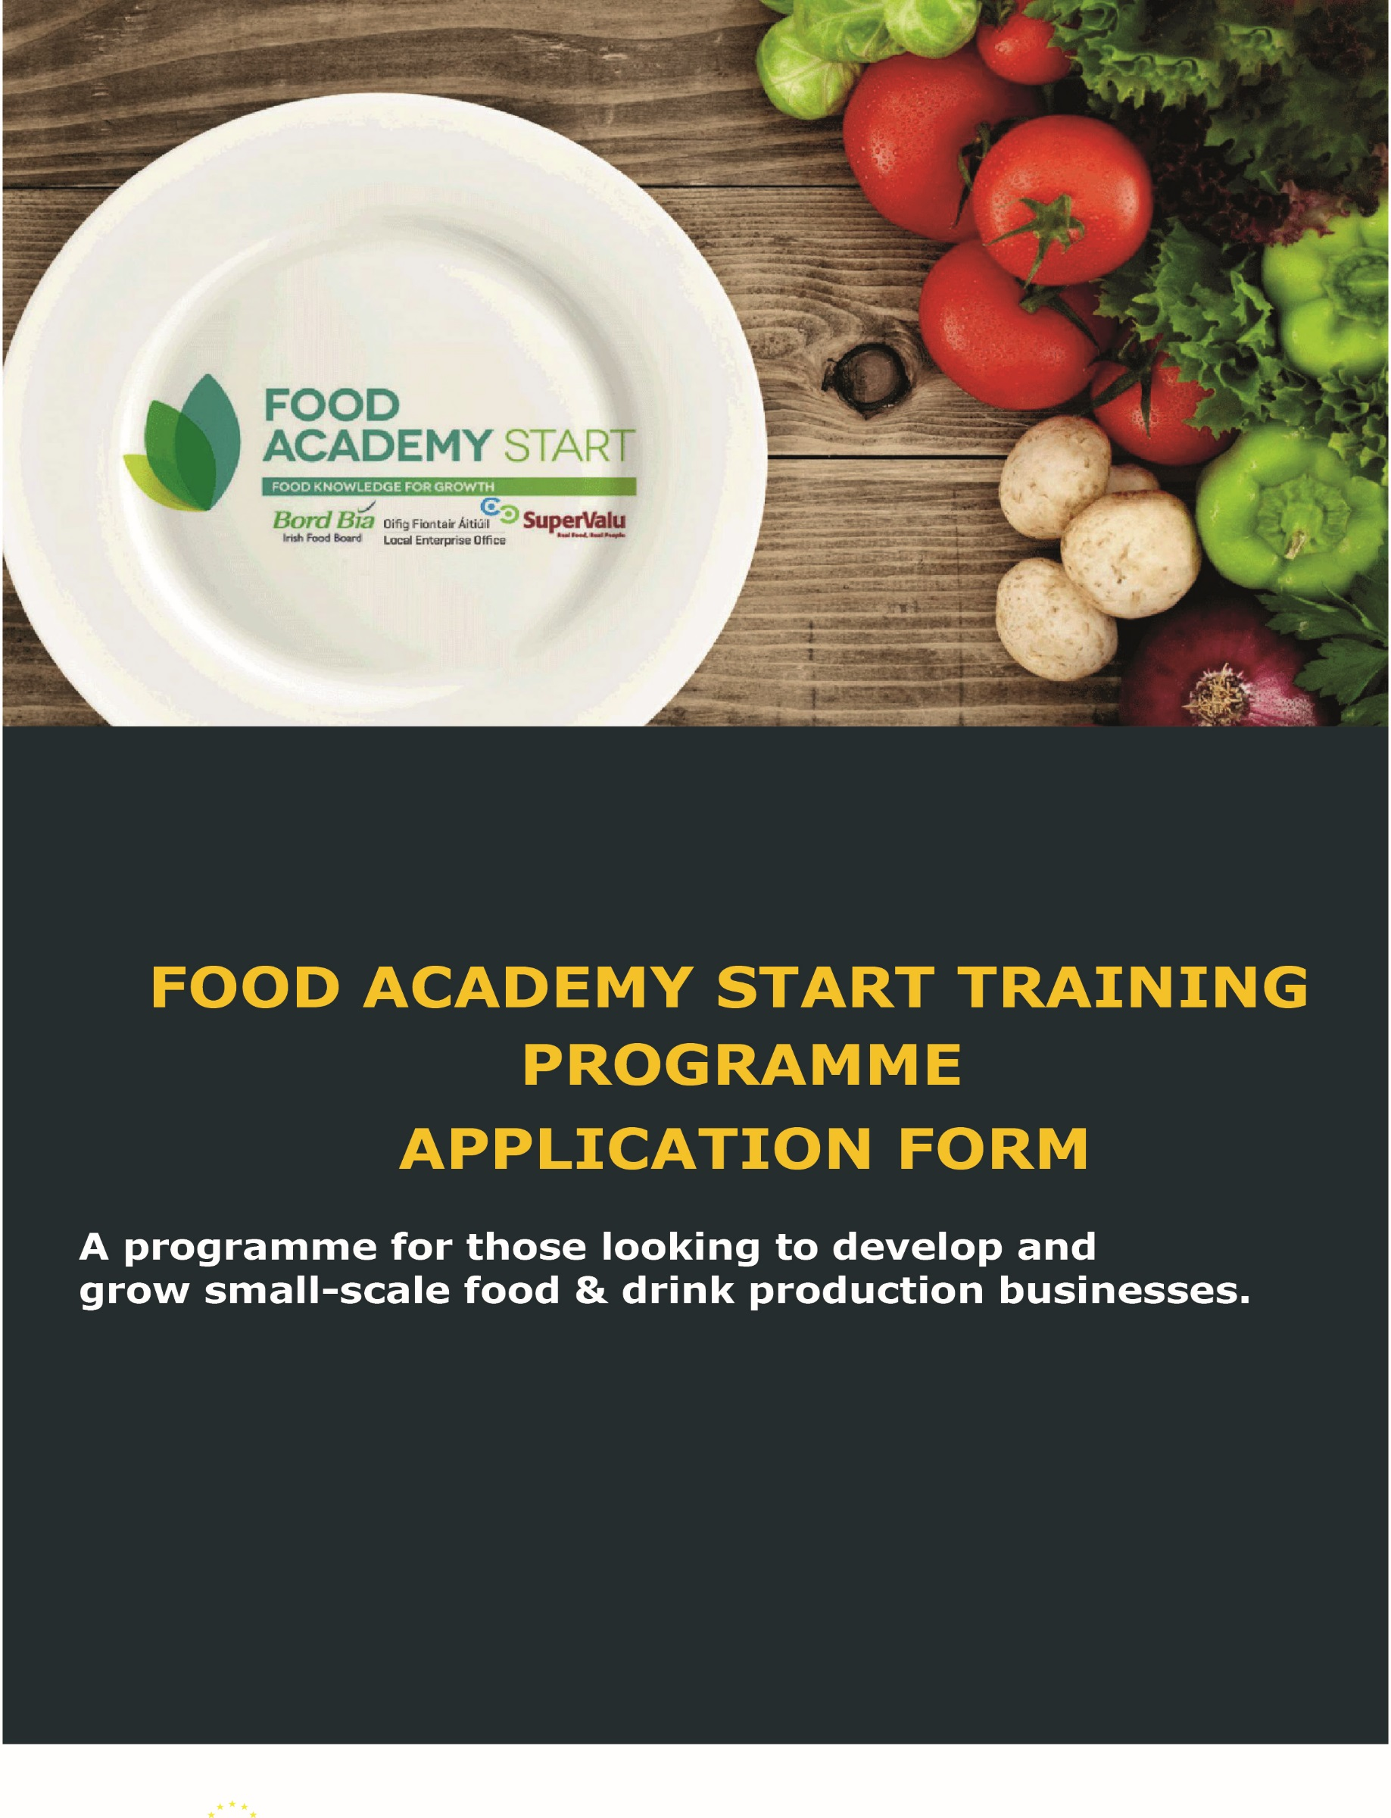

THE FOOD ACADEMY START PROGRAMME (Dublin Region) – 2017
Local Enterprise Offices: Dublin City, Dun Laoghaire-Rathdown, Fingal, South Dublin
FOOD ACADEMY START
Food Academy is a training programme aimed at supporting and nurturing start-up food businesses. The Local Enterprise Offices have joined forces with Bord Bía and SuperValu on this initiative to provide a consistent level of food marketing knowledge to new and early-stage food business owners.
At the final workshop, participants will get the opportunity to present their product to a panel from SuperValu and if successful, can participate in a trial based in local shops, which in the right circumstances, could progress over time to a national listing with SuperValu. There is no guarantee of your product being listed as part of the programme. However, the majority of products do proceed to trial with Supervalu.

For successful applicants to the Food Academy Start programme, the Local Enterprise Offices in the Dublin region are offering a subvention of up to €1,500 towards costs incurred in branding shelf life testing and nutritional analysis.

Programme Objectives
- Develop an in-depth knowledge of the tools which can be used to assess market background
- Understand core technical issues facing your food or drink business
- Learn how to grow sales for your product range through better branding and packaging design
- Gain all of the tools and knowledge necessary to launch and build a successful food business in Ireland

Who can participate?
The Food Academy is aimed at those in the early stages of developing a food or drink business. Selection criteria will apply.

How much does it cost?
The Academy costs €200 and is inclusive of all course materials, training and mentoring. If you are pre-approved you will receive a link to make your payment online.
Subvention
Successful applicants to the Food Academy programme may also be approved for a special subvention towards branding, shelf-life testing and nutritional analysis up to a maximum of €1,500 (or 50% of costs whichever is lower). This subvention is designed to assist small food producers to develop strong branding and to assist with costs of shelf-life testing and nutritional analysis.

If you spend a less amount, the grant will be up to 50% of the approved amount not exceeding €1500.
The criteria are as follows
• You should have received 3 quotations for any money you are planning to spend
• You should be able to demonstrate that you have conducted all the appropriate research on your idea and that it is viable

Please note that the Local Enterprise Office reserves the right to refuse any application.

Brand Design
With regard to brand design, there is a panel of three design companies who have tendered for FA design business. The lowest of these is €2500 and the highest is €4000. You will need to meet with at least 3 design companies to get an understanding of how they might handle your project. These prices are based on the brief below.
Specification:
A starter branding “package” is to be priced for. The outputs required for each producer are:
- Help with brand positioning and creating the consumer proposition
- Help with packaging selection (it is expected that the brand design company will be able to guide the producer through various suitable packaging options)
- Help with product naming (multiple names to be presented and then assistance provided to shortlist)
- The creation of a logo (3 directional options to be first shown to the client, then one worked up)
- The possible creation of a strapline
- The design and creation of 3 packs/sleeves or labels (client to be able to make a minimum of 6 amendments to the draft design within the base price)
- The design of a promotional flyer/leaflet
- The creation of a branded PowerPoint template
- The creation of an email signature logo

APPLICATION FORM

- PROMOTER DETAILS

Name of Applicant: | Click here to enter text.
Name of Business: | Click here to enter text.
Business Address: | Click here to enter text.
Telephone: | Click here to enter number.
Mobile: | Click here to enter number.
E-mail: | Click here to enter text.
Website: | Click here to enter text.

- BUSINESS DETAILS

Status of Applicant:  (Please tick) | Sole Trader ☒ | Partnership ☐
 | Limited Company ☐ | Other ☒ (Please specify)  Click here to enter text.
How long is the business trading: | Click here to enter text.
Current estimated annual turnover: | € Click here to enter number.
How much funding have you allocated to bringing your product to market, please tick one | - Less than €2000 ☐  - €2000 - €5000 ☐  - €5000 - €8000 ☐  - Greater than €8000 ☐

Give details of any funding assistance received to date from a state agency for this or any other business in which the applicant has an interest:
Click here to enter text.

Brief description of your business:
For example, products supplied, key customers, market served, please also list the products you will be producing, the weight of the pack and the price you will be selling to the customer at . If you are currently supplying any shops, cafes, etc., list the top 5 outlets you are selling your product through
Click here to enter text.

Description of the market you serve:

Who are your current customers / where are they located?
Outline results of any Market Research carried out to promote your product
Click here to enter text.

Who and where are your main competitors?

List competitor brands or brands in the nearest similar category to your product?
Click here to enter text.

- Manufacturing
Have you sourced either a suitable food manufacturing premise or a suitable manufacturing option for volume production? Please state where your product is being manufactured (home kitchen, rental incubation kitchen (Named) and if outsourced, to whom?
Click here to enter text.

- EXPERIENCE AND PREVIOUS TRAINING
Please state what if any relevant training programmes you have undertaken:

For example, a Start Your Own Business programme, Kick-Start Your Food Business programme or other
Click here to enter text.

- YOUR GOALS
Explain in a few words what you want to achieve from this programme:
Click here to enter text.

- COST ANALYSIS
In order to be approved for the subvention of up to €1,500 (or 50% of eligible costs, whichever is lower), you need to set out the budget costs that you expect to incur on your branding, shelf life testing and nutritional analysis. Eligible costs are net of VAT and may include the following
- New brand design, or improvements to current branding (branding work must be conducted through a professional brand design agency. Graphic designers or similar are not eligible
- Shelf life testing via an accredited body
- Nutritional analysis via an accredited body

Please provide details of the branding and testing work to be carried out and the costs involved.
(Payments will be based on pre-approved quotations and bank statements showing payment)
Description of branding work to be carried out (Net of VAT) | €
Click here to enter text. | Enter amount
Click here to enter text. | Enter amount
Click here to enter text. | Enter amount
Click here to enter text. | Enter amount
TOTAL COST | Enter amount

- JOB POTENTIAL
Outline how branding assistance will assist further job creation for your business:
Employment info. | Full-time | Part-time
Current no. of jobs | Enter number | Enter number
Post assistance jobs projected (6 months) | Enter number | Enter number
Post assistance jobs projected (12 months) | Enter number | Enter number

- FOOD BRANDING ASSISTANCE PAYMENT CONDITIONS
- Payment will only be made on provision of invoices, and confirmation of payment/bank statements.
- A current Business Tax Clearance Certificate is required for all claims.
- Applicant must settle all bills in full prior to making a claim to your Local Enterprise Office
- Payments will only be made in relation to approved expenses which form part of this application form.
- All claims must be accompanied by at least one quotation from a company with specification of branding work to be carried out and the full costs involved, including VAT. Your Local Enterprise Office reserves the right to contact suppliers for the purposes of verification if required.

IMPORTANT. Applications for assistance for expenditure incurred prior to date of receipt of application are ineligible. Invoices and proof of payment will be required prior to drawdown. This programme is available to qualifying food producers based in the Dublin region only. Your Local Enterprise Office reserves the right to refuse any application and the right to terminate this assistance scheme at any time without notice. The approval of applications and the payment of all monies is dependent on the availability of resources under this scheme from the Department of Jobs Enterprise and Innovation. Applicants are advised to check availability of resources with the relevant Local Enterprise Office prior to incurring any expenditure. All applicants approved must draw down in full within the time-frame per the letter of offer. Failure to draw down all or any portion may result in automatic decommittal without notice. Your Local Enterprise Office may liaise/consult/report to other groups or agencies/local development programmes in relation to this proposal, while respecting project confidentiality. Any false or misleading statement or the withholding of essential information from your Local Enterprise Office (as determined by the Local Enterprise Office) will result in cancellation of any assistance approved under this scheme.
DECLARATION: I/We hereby declare that the above information and details are accurate and true to the best of my knowledge and belief as I make this application for assistance on the basis of the information and details given. I/We have not sought and will not seek grant aid from any state agency or other sources in respect of this expenditure. I have read and fully accept the terms and conditions attaching to Food Branding Assistance Scheme from my Local Enterprise Office.

Sign here | Click here to enter text. | Click here to enter date.
Sign by | Business Name | Date

Click here to enter text.
Your Local Enterprise Office:

