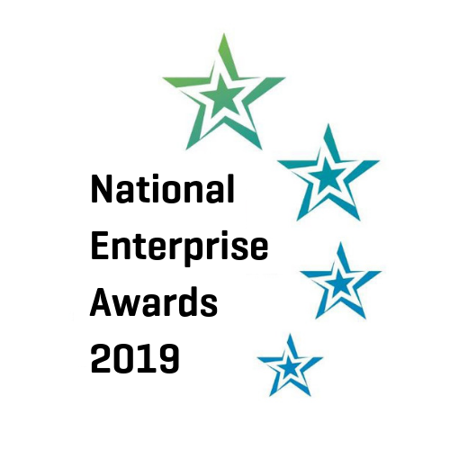

Eligibility Criteria for Applicants:
The 2019 National Enterprise Awards Competition will be open to the following:
The applicants must be current clients of the LEOs or transferred to Enterprise Ireland within the last 12 months (i.e. after 31st December, 2017).

All businesses must be involved in internationally traded services or manufacturing and have qualified for one or more of the following
- Measure 1 Financial Support
- LEO Innovation Investment Fund (LIIF) Support
- IBYE Support
- TAME Support
- Trading Online Voucher

Important Dates:

Thursday 31st January - Closing date for Fingal applications
Friday 15th February - Pitching training for shortlisted finalists
Monday 25th February - Pitching/judging for shortlisted finalists
Thursday 7th March - Final event in Atrium, County Hall, Swords

The overall winner will go on to represent Fingal at the National Enterprise Awards in the Mansion House on 29th May 2019.

Appendix 1 - Guidelines for judging criteria and marking system

LEO Name

Promoter

Address
Region

Date Business Established

Telephone

Email

Website

Social Media Details

Business Plan | 15 | Total Marks
- Management capability / staff structure
- Competitiveness
- Growth potential
- Employment potential
- Business strategy
Marketing | 20
- Marketing strategy
- Company’s success in national and export markets
- Growth in sales revenue this year over previous years
- Responsiveness to market trends
Finance | 25
- Financial commitment of the owner
- Profitability of the company
- Strength of the balance sheet
- Net assets of the company
Technology & Innovation | 20
- Use of technology
- Innovation in business e.g. finance, production, marketing, HR etc.
Entrepreneurial Skills of Promoter | 20
- Leadership qualities
- Vision and drive
- Commitment
- Entrepreneurial capability (risk taking etc)

TOTAL (out of 100) ________

