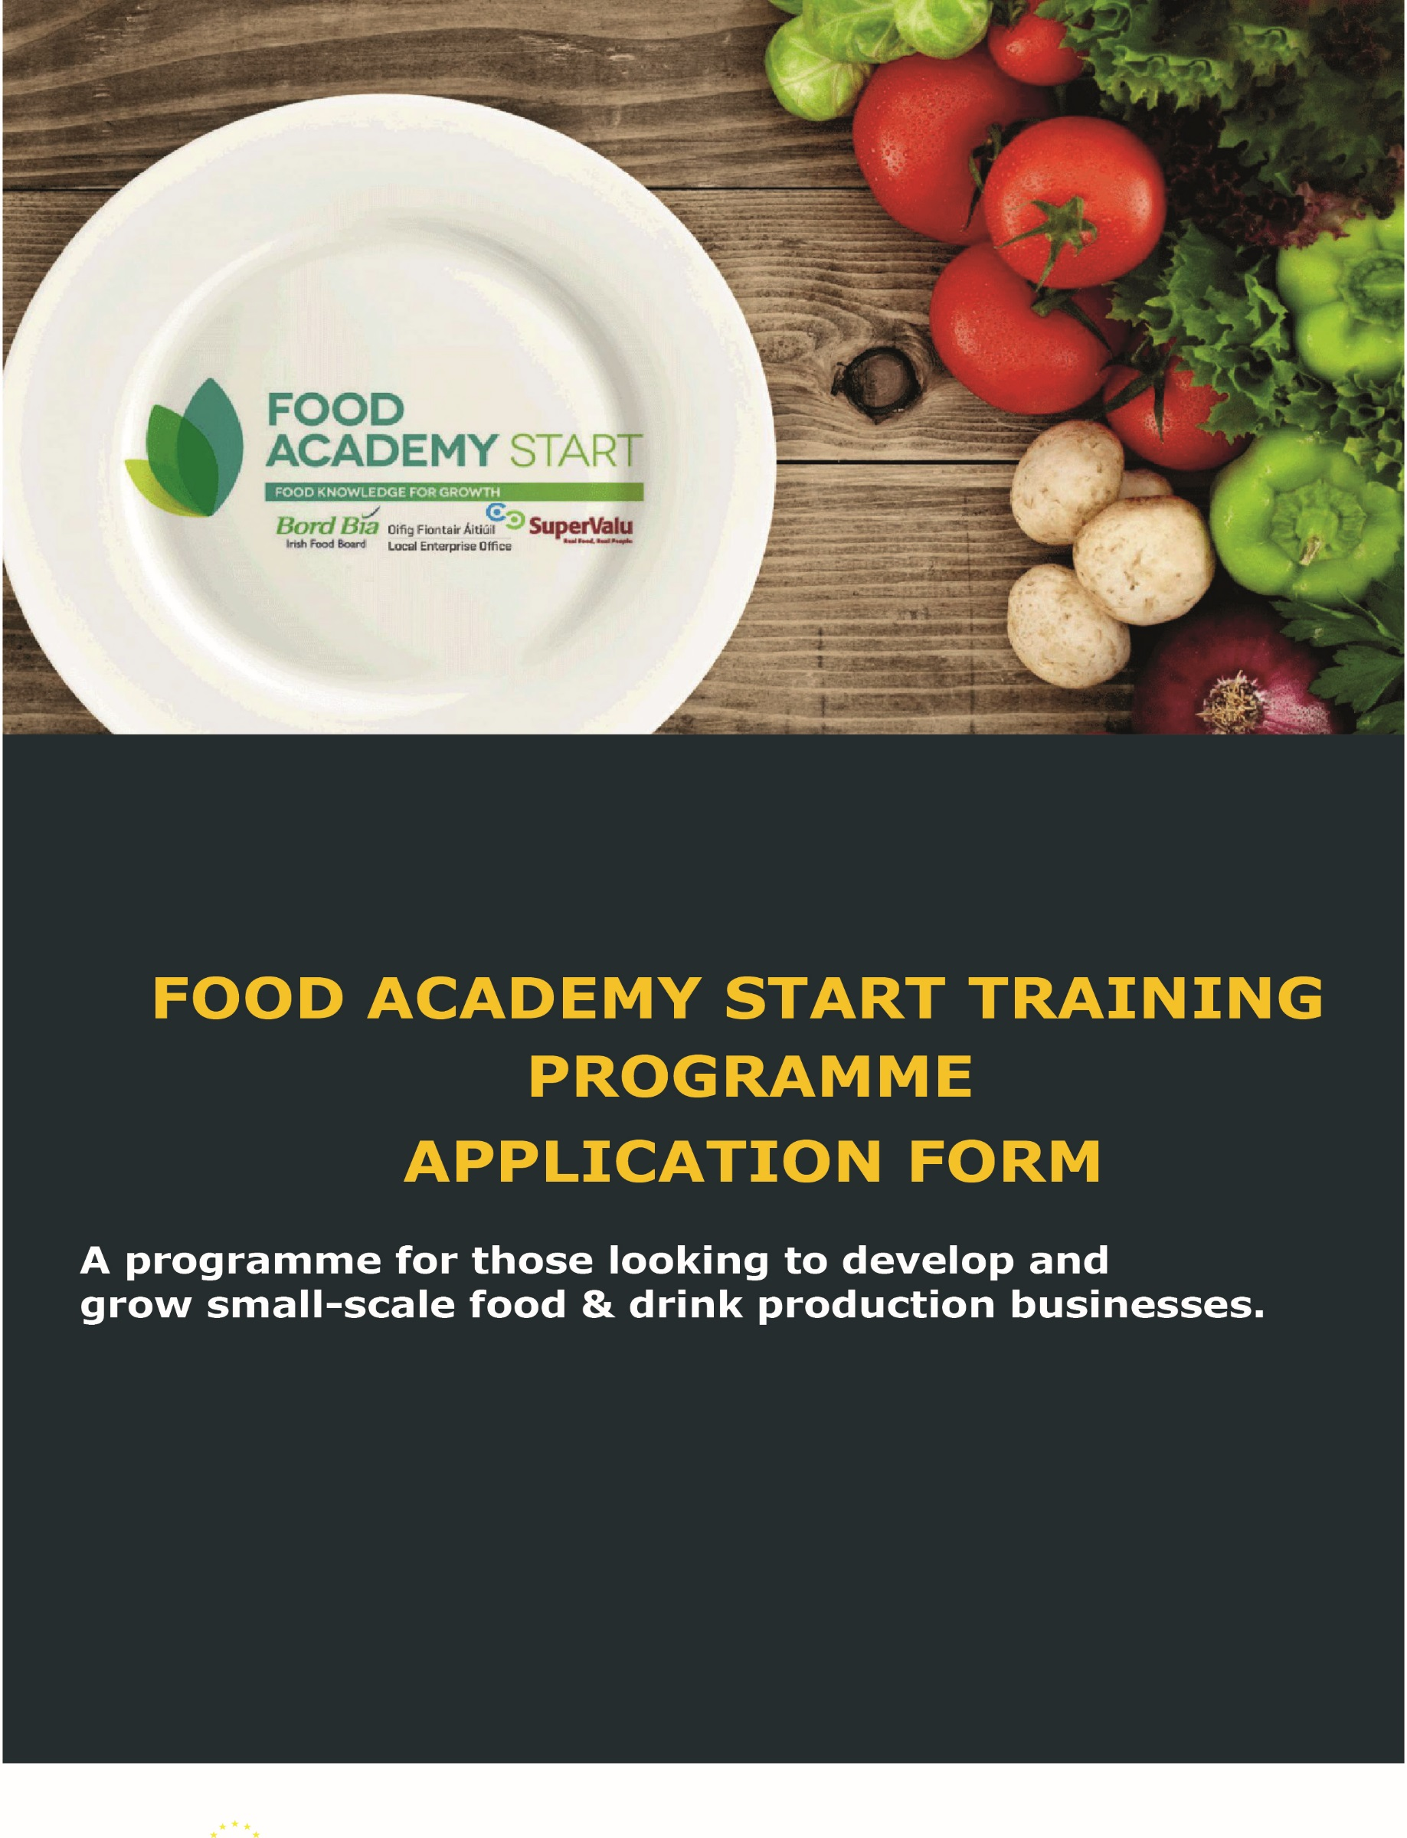

THE FOOD ACADEMY START PROGRAMME
FOOD ACADEMY START
Food Academy is a training programme aimed at supporting and nurturing early stage food businesses. The Local Enterprise Offices have joined forces with Bord Bía and SuperValu on this initiative to provide a consistent level of food marketing knowledge to early-stage food business owners.
At the final workshop, participants will get the opportunity to present their product to a panel from SuperValu and if successful, can participate in a trial based in local shops, which in the right circumstances, could progress over time to a national listing with SuperValu. There is no guarantee of your product being listed as part of the programme. However, the majority of products do proceed to trial with Supervalu.

Programme Objectives
- Develop an in-depth knowledge of the tools which can be used to assess market gaps for your product
- Understand core technical issues facing your food or drink business
- Learn how to grow sales for your product range through better branding and packaging design
- Gain all of the tools and knowledge necessary to launch and build a successful food business in Ireland

Who can participate?
The Food Academy is aimed at those in the early to mid-stages of developing a food or drink business. Selection criteria will apply.

How much does it cost?
The Food Academy is heavily subsidized and the final cost is inclusive of all course materials, training and mentoring. In 2019 the course cost €200 but we are currently reviewing the pricing for 2020. If you are pre-approved you will receive a link to make your payment online.

Application Importance
The content of the information you put in this application form is critical. A screening process is used to determine eligibility in the first instance, so if you provide insufficient information, your application may not be accepted.
Please take the time necessary to paint as clear a picture as necessary and answer all questions

APPLICATION FORM

- PROMOTER DETAILS

Name of Applicant: | Click here to enter text.
Name of Business: | Click here to enter text.
Business Address: | Click here to enter text.
Telephone: | Click here to enter number.
Mobile: | Click here to enter number.
E-mail: | Click here to enter text.
Website: | Click here to enter text.
LEO Region: This will be the same as your Local Authority where your business is based

- BUSINESS DETAILS

Status of Applicant:  (Please tick or shade one only) | Sole Trader ☐ | Partnership ☐
 | Limited Company ☐ | Other ☐ (Please specify)  Click here to enter text.
How long is the business trading e.g. selling at farmers market, supplying one or two shops or cafes, etc., (insert start up if not selling yet): | Click here to enter text.
Current estimated annual turnover for the next 12 months: | € Click here to enter number.
How much funding have you allocated to bringing your product to market, please tick/shade one | - Less than €4000 ☐  - €4000 - €6000 ☐  - €6000 - €8000 ☐  - €8000 - €10000 ☐  - Greater than €10000 ☐

Business Status
Please type YES or NO for the following questions
Have you completed a Feasibility Study on your product range/business
Have you contacted the Thinking House in Bord Bia for research on your category
Have you completed the Food Starter programme run by your LEO
Have you owned and run a previous business for more than 2 years
Have you completed the “Start your own business programme” run by your LEO
Can you allocate at least 3 full days per week from programme commencement to allow you work on the FA project
Has a business bank account been set up
Has your company name been registered with the Companies Office

Brief description of your business:
Describe your food or drink product (type of product, number of products in range, weight of the pack of each and the price you will be selling to the customer of each). If you are currently supplying any shops, cafes, etc., list the top 5 outlets you are selling your product through

Provide information for three products only (the products you are likely to put into the FA programme)
Product name
Pack size
Selling price to customer
Product name
Pack size
Selling price to customer
Product name
Pack size
Selling price to customer

List the top five outlets you are selling your product through currently

Who are your main competitors?

List competitor brands or brands in the nearest similar category to your product?
Click here to enter text.

- Manufacturing
Have you sourced either a suitable food manufacturing premises or a suitable third party outsource manufacturing option for volume production? Please state where your product is being manufactured (home kitchen, rental incubation kitchen (Named) and if outsourced, to whom?
Click here to enter text.

- YOUR GOALS
Explain in a few words what you want to achieve from this programme:
Click here to enter text.

