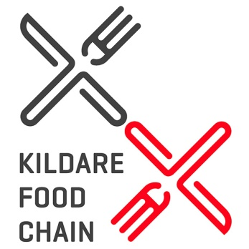

NEW MEMBER FORM – Kildare Food Chain Networking Forum
APPLICATIONS: via email to localenterprise@kildarecoco.ie

Information marked with * will be included on the website. Please tick this column if you wish this information to appear:
Please note, we need a mobile number and email address to show on your website listing and in order to be able to keep you updated on events and news
*APPLICANT’S NAME:
*BUSINESS NAME:
JOB TITLE:
*BUSINESS ADDRESS:
PHONE NUMBER: |  | * MOBILE NUMBER:
* EMAIL: |  | * WEBSITE:
* FACEBOOK: |  | * TWITTER:
* SUMMARY OF BUSINESS:
* UNIQUE SELLING POINTS:
* MEMBERSHIPS TO OTHER PROFESSIONAL ORGANISATIONS:

Consent to Contact about Future Business Support Services: Kildare Local Enterprise Office provides a service to inform clients about future business support services. If you would like to be kept informed of available business supports and opportunities, and consent to our office contacting you about these services, please tick any of the following boxes to indicate your preferred means of communication.
Your consent can be withdrawn at any time and we do not share personal data with third parties.

As a regular provider of business courses and a supplier of business support services, Kildare Local Enterprise Office may from time to time, need to contact clients to notify them of details related to their enquiry or business support service. Please tick the consent box below to confirm acceptance. Your consent may be withdrawn at any time by contacting us at localenterprise@kildarecoco.ie. The information you provide will be held in accordance with the Data Protection Acts 1988-2018. The full terms of our privacy, data protection and GDPR policies protecting your personal data can be found at www.kildare.ie/CountyCouncil/DataProtection

I consent to Kildare Local Enterprise Office contacting me in relation to general matters related to this enquiry and future business opportunities.

I do not consent to Kildare Local Enterprise Office contacting me in relation to general matters related to this enquiry and future business

opportunities.

Signed: |  | Date:

