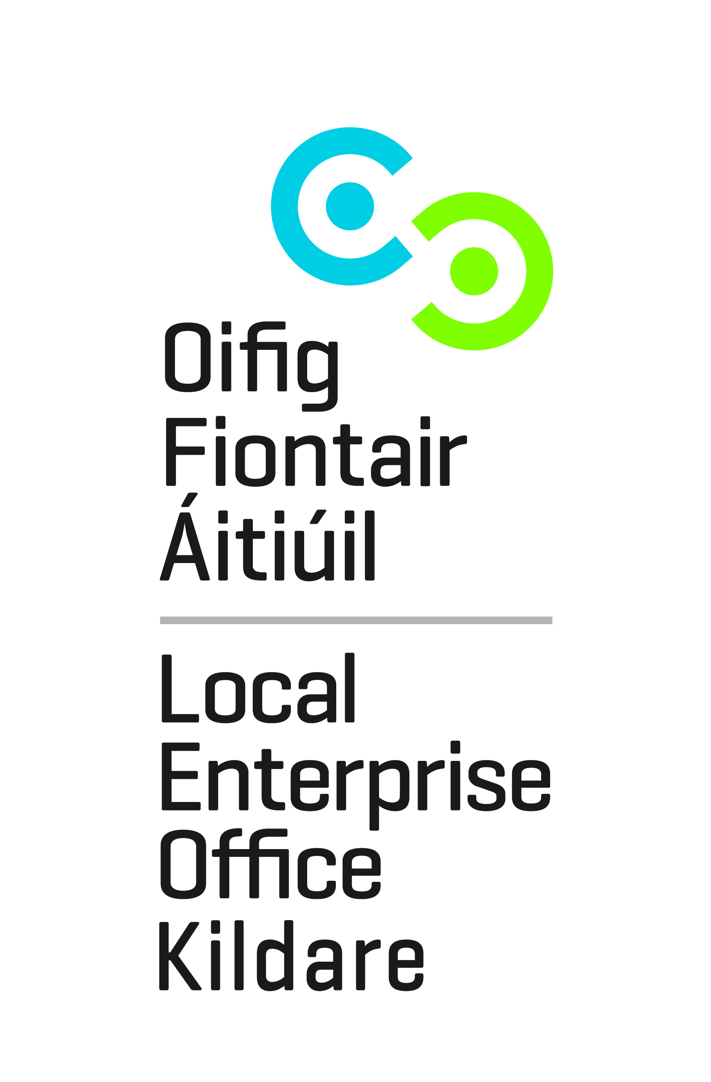
Development of a Craft Network in Kildare
Through Training and Facilitation – Expression of Interest Form
Building on the significant national profile of craft makers in County Kildare, Kildare County Councils Local Enterprise Office and County Kildare LEADER Partnership, now seek expressions of interest from professional makers, who wish to avail of bespoke training to facilitate the development of a craft network for County Kildare. The process will involve a training programme underpinning the formal process of developing the network and all associated planning and work.
Makers will be investing their time in developing and identifying how their work can be promoted, marketed and sold through a network. They will establish the structures and work on a development, operations and marketing plan.

Eligibility Criteria for Applicants:
- You must be a professional crafts person in County Kildare who endeavors to make your living from designing, making and selling your work or have vested interest in the craft/design sector.
- The programme is open to Makers residing in County Kildare who are willing to commit themselves to establishing and maintaining a dynamic and effective Network. Members will have a major role in developing the training programme and establishing the network. (circa. 3-5 year term as a network member and/or a committee member)
- Makers selected on the programme must commit to the process and attend no less than 85% of the training sessions ie. min attendance 20/24 training sessions required.

The training and establishment of the network will take place over a six month period starting on Tuesday 10th September 2019 from 2pm – 5pm, subsequent training sessions to take place weekly on Tuesday evening for up to 24 weeks. (6pm – 9pm).
The first block will run from September 2019 to November 2019
The second block starting in January 2020
A number of these sessions will include practical workshops in photography and design and will include field trips.
- Places on the training programme are limited therefore all applicants will be subject to an interview with the programme facilitator Mr Vincent O’Shea.
- Interviews will take place week beginning 26th August 2019.
- There will be no fees charged for those participating in the training programme hosted and facilitated by Kildare Local Enterprise Office. Funding has been provided by Kildare Leader Partnership. Kildare LEO staff will also support the programme.
- Selected participants will be informed on or before Friday 30th August 2019, the facilitator’s selection of participants is final and is not open to appeal.
- Interested crafts people should submit a completed expression of interest form along with a link to product images and a copy of your curriculum vitae.

I have read and agree to the eligibility criteria outlined above (please tick)

Signed: |  | Date:

Applicant Details

Name of Applicant

Craft & Design Discipline

Current Address

PPS/ CRO number Phone

Email Website

Are you full time employed in your business? Yes No

Link to your product Images:

Have you previously been a member of a board/committee/project team?
Please give an outline of your role and achievements. (max. 300 words)

What would you like to see the craft sector in Kildare achieve?
(max. 300 words)

Why would you like to play a role in the establishment of a Craft Network in County Kildare? (max. 300 words)

Please note to take part you must be fully committed to the training process

Describe your product range and your target market: (max. 150 words)

Consent to Contact about Future Business Support Services:
Kildare Local Enterprise Office provides a service to inform clients about future business support services. If you would like to be kept informed of available business supports and opportunities, and consent to our office contacting you about these services, please tick any of the following boxes to indicate your preferred means of communication. Your consent can be withdrawn at any time and we do not share personal data with third parties.
As a regular provider of business courses and a supplier of business support services, Kildare Local Enterprise Office may from time to time, need to contact clients to notify them of details related to their enquiry or business support service.
Please tick the consent box below to confirm acceptance. Your consent may be withdrawn at any time by contacting us at localenterprise@kildarecoco.ie.
The information you provide will be held in accordance with the Data Protection Acts 1988-2018. The full terms of our privacy, data protection and GDPR policies protecting your personal data can be found at www.kildare.ie/CountyCouncil/DataProtection

I consent to Kildare Local Enterprise Office contacting me in relation to general matters related to this enquiry.

I do not consent to Kildare Local Enterprise Office contacting me in relation to general matters related to this enquiry.

Signed: |  | Date:

Please return to Kildare Local Enterprise Office F.A.O Doreen Heavey via email localenterprise@kildarecoco.ie - by close of business: Thursday 22nd August 2019.
**Please do not include product images with your application as your form will be rejected by our IT Department, a link to your website or product images is sufficient.

