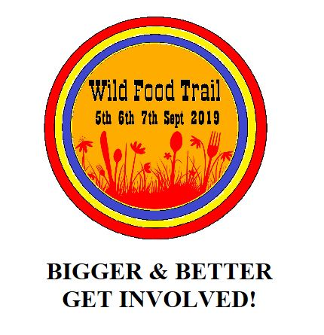
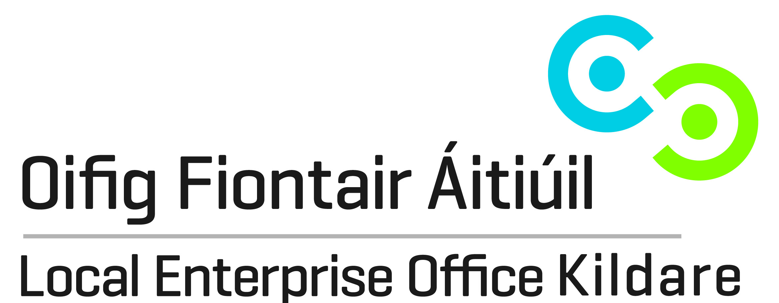
Local Enterprise Office Kildare
Expression of Interest
Naas Wild Food Festival 7th Sept 2019

The Local Enterprise Office Kildare would be delighted to support your business!
Closing Date Monday 22nd August

Contact Name:

Name of Company/Business:

Contact Address:

Telephone: |  | Mobile:

Email:

Website:

Age Group: | Over 35 |  |  | Under 35

Gender: | Male: |  |  | Female:

Description of Food/Drink Product

Signature: Date:

CONSENT TO CONTACT ABOUT FUTURE BUSINESS SUPPORT SERVICES
Kildare Local Enterprise Office provides a service to inform clients about future business support services and opportunities. As a regular provider of business courses and a supplier of business support services, Kildare Local Enterprise Office may from time to time, need to contact you to notify you of details related to your enquiry or business support services. Please tick the consent box below to confirm your acceptance to our office contacting you about these services. Your consent may be withdrawn at any time by contacting us at localenterprise@kildarecoco.ie.

The information you provide will be held in accordance with the Data Protection Acts 1988-2018. The full terms of our privacy, data protection and GDPR policies protecting your personal data can be found at www.kildare.ie/CountyCouncil/DataProtection.

I consent to Kildare Local Enterprise Office contacting me in relation to general matters related to these services.

I do not consent to Kildare Local Enterprise Office contacting me in relation to general matters related to these services.

Name : ______________________________________________
Company Name : ______________________________________
Address : _____________________________________________
Phone number : _______________________________________
Email address : ________________________________________
Signed: |  | Date:

Please return your completed consent to contact form to us either by email at localenterprise@kildarecoco.ie or by post to Kildare Local Enterprise Office, 7th Floor, Aras Chill Dara, Devoy Park, Naas, Kildare.

