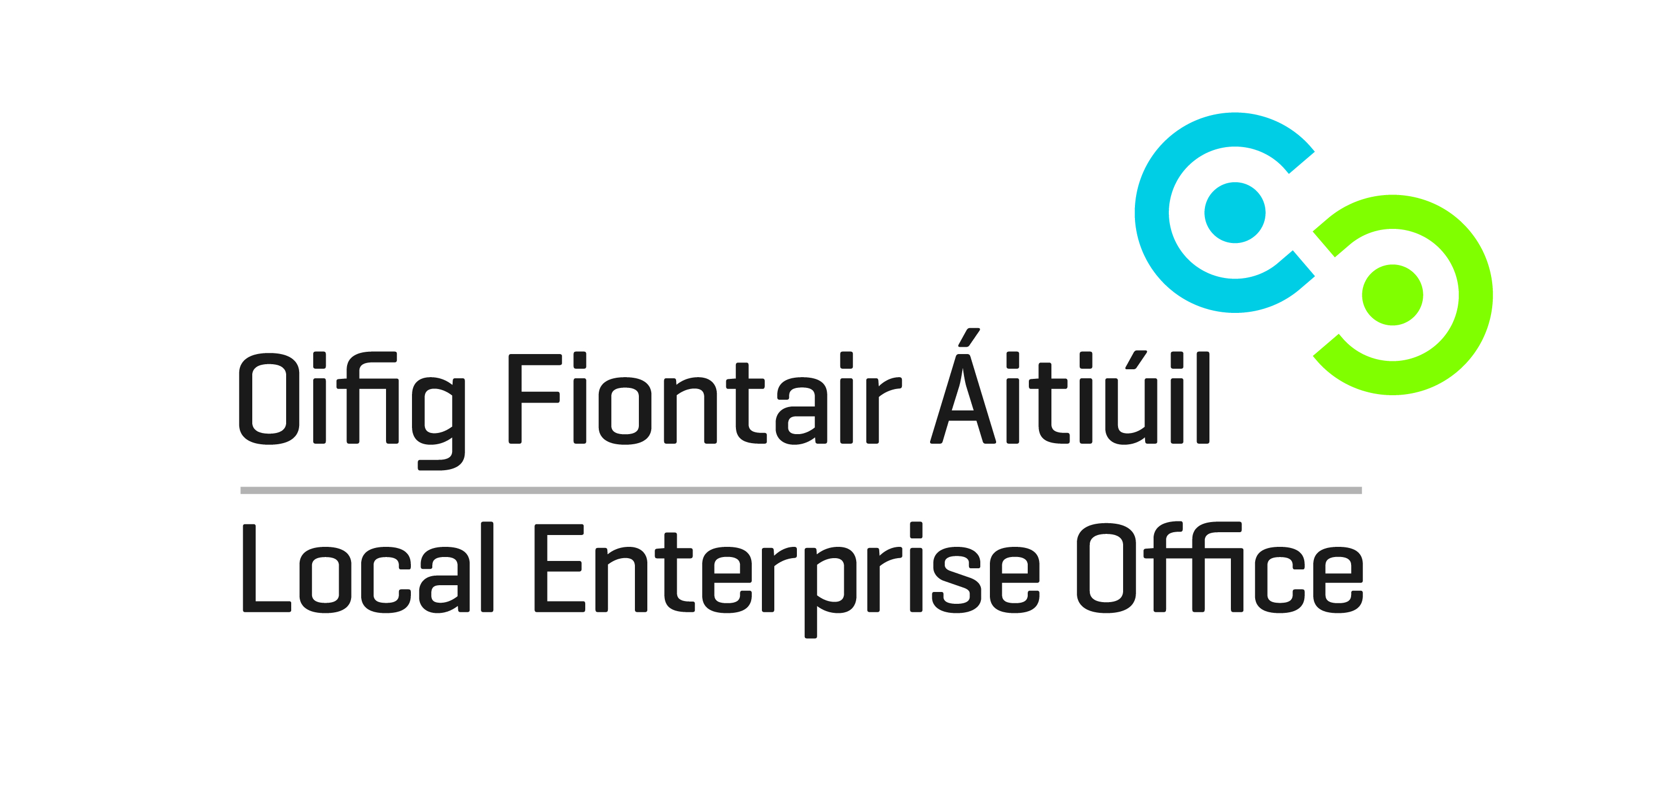

EXPRESSION OF INTEREST KILDARE RETAIL DEVELOPMENT PROGRAMME 2015
Please complete this form in order to be considered for a place on the retail development programme.

Applicant Details:
Name of applicant: …………………………………………………………………………………………………………………..
Address: …………………………………………………………………………………………………………………..
…………………………………………………………………………………………………………………..
Phone No. …………………………………………………………………………………………………………………..
Email: …………………………………………………………………………………………………………………..
Tax Ref. No. …………………………………………………………………………………………………………………..
Business Details:
Business Name: ………………………………………………………………………………………………………………….
Business Address: ..................................................................................................................
Type of Business: ..................................................................................................................
Member of North Kildare Chamber Yes [ ] No [ ]

Cost of the course is €200. A subsidy of €50 is available for North Kildare Chamber members.
Course will run in North Kildare Chamber Training Room, Sallins Road, Naas.
Workshop Dates (all daytime): 13th October, 10th November, 12th January, 2nd February.
Refreshments & light lunch included.
This course is suitable for owner/managers of independent retail outlets (shops, cafés, beauticians, anyone who meets the customer face to face).
Completed forms should be returned to:
Local Enterprise Office, Aras Chill Dara, Naas, Co. Kildare or emailed to localenterprise@kildarecoco.ie
Closing date for receipt of forms is Friday 25th September 2015. You will be notified if you have secured a place.

