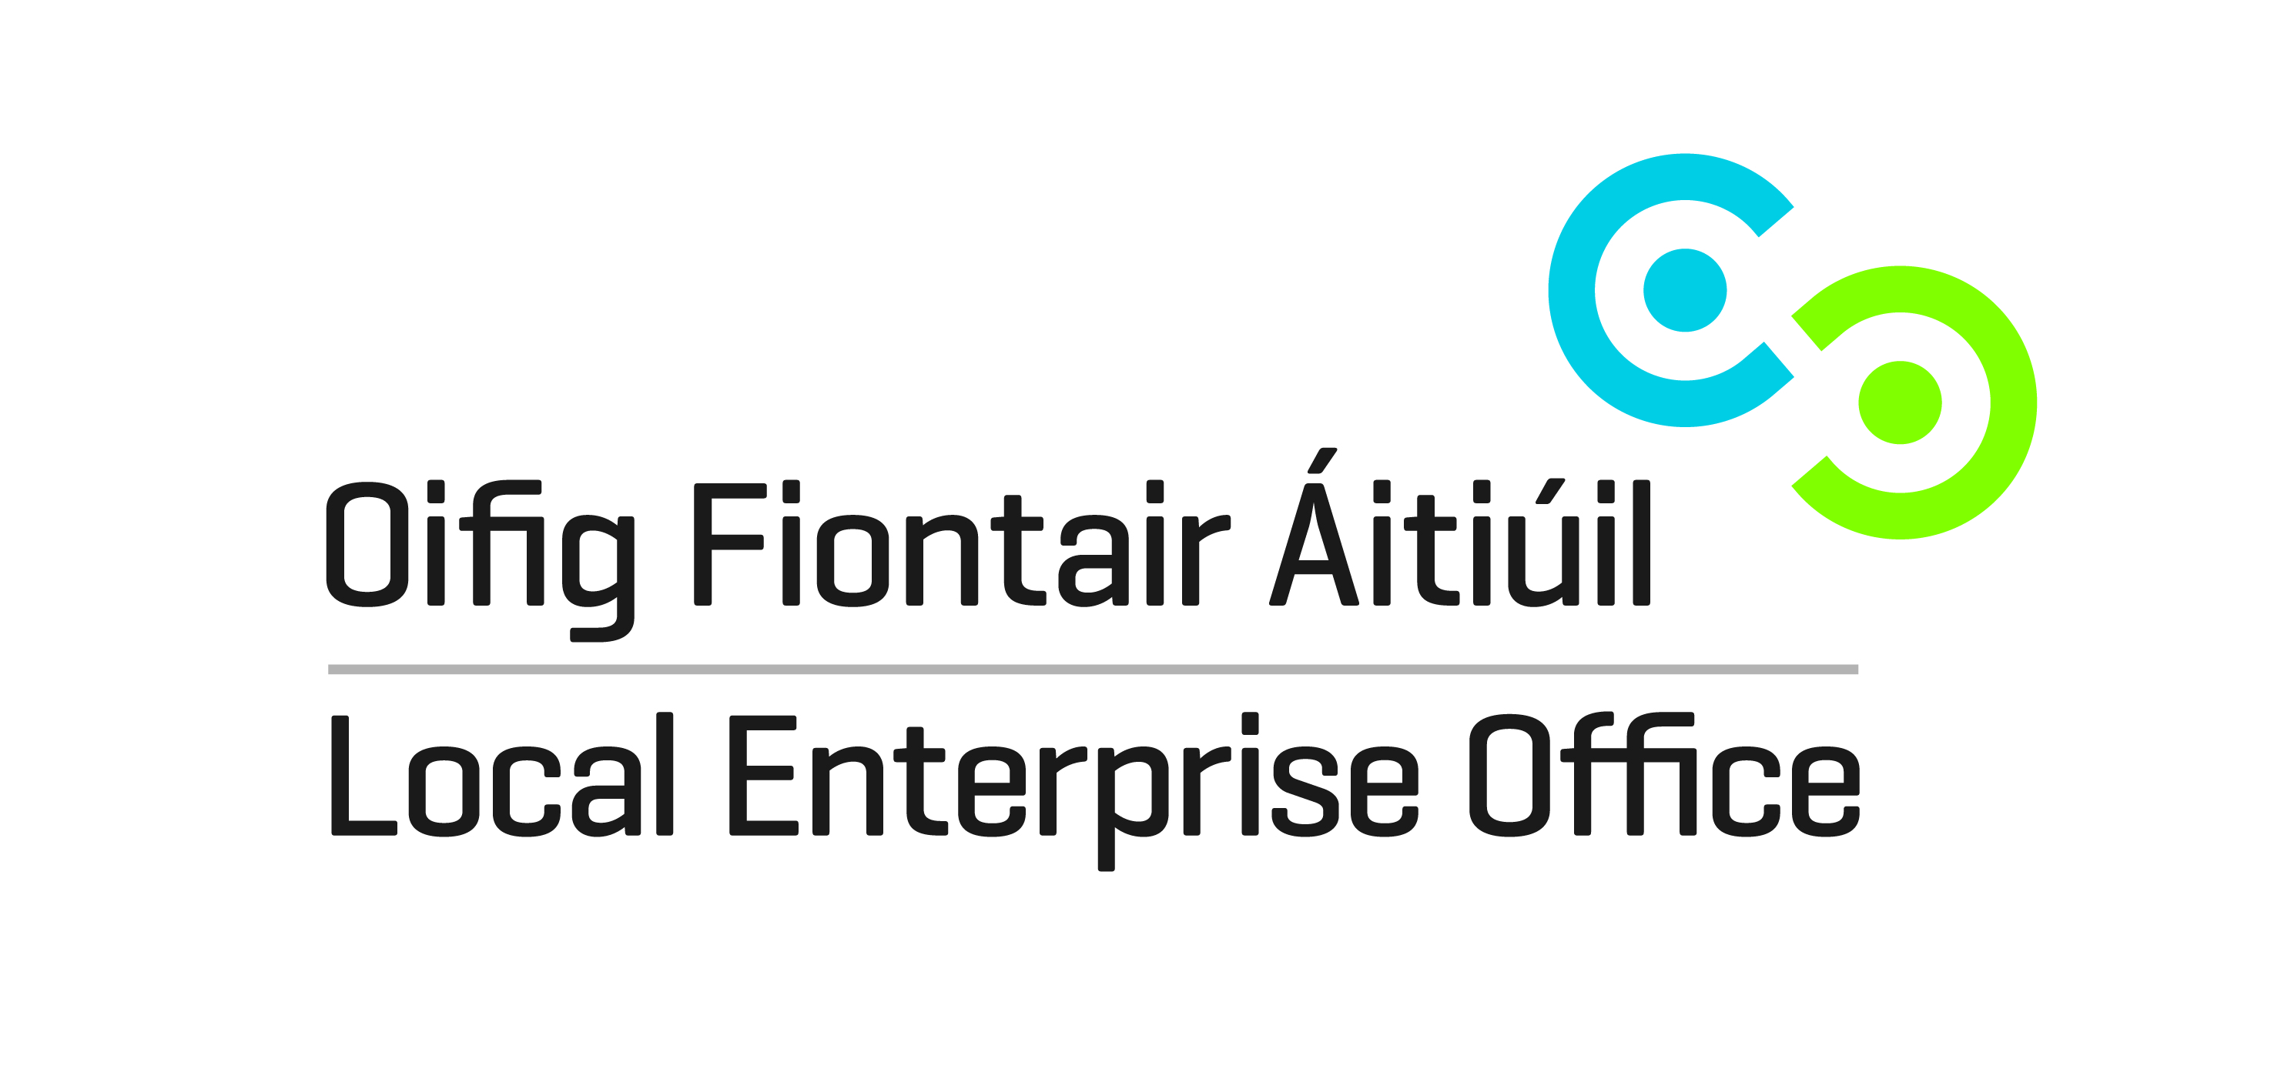
Meet West 2014
20th & 21st November 2014
Galway Bay Hotel, Salthill, Galway

Applicant Details
Name of Applicant
Address
Telephone
E-Mail

Business Details
Business Name
Business Status  (please tick opposite) | Sole Trader  Limited Company  Partnership
Number of Employees
Brief Description of Business

Priority will be given to businesses that meet the LEO financial assistance eligibility criteria.

Completed forms to be returned to localenterprise@kildarecoco.ie
Closing date for receipt of completed forms is Friday 14th November 2014.

