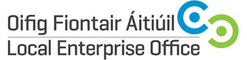

Local Enterprise Village
National Ploughing Championships / 19th-21st September 2017
Expression of Interest

Contact Name:
Company Name and Legal Structure:
Address:
Landline Telephone:

Mobile Telephone :

E-mail Address & Website Address:

Year the company was established:
Company Description:

Product or Service Description:

Additional information that might be of interest to media? Eg awards/ exports?

Number of employees:
Social media accounts:
Any Special Requirements for NPA?

Preferred Briefing & Photography Session:
Dublin – Crown Plaza, Santry 28th June, 2017
Tullamore – Tullamore Distillery, Clonminch, Tullamore 5th July, 2017
LEO Contact Name | Paula Comerford
LEO Contact E-mail | localenterprise@kildarecoco.ie
IMPORTANT: Please include product photos or service marketing materials with your application

Signature : __________________________________________

