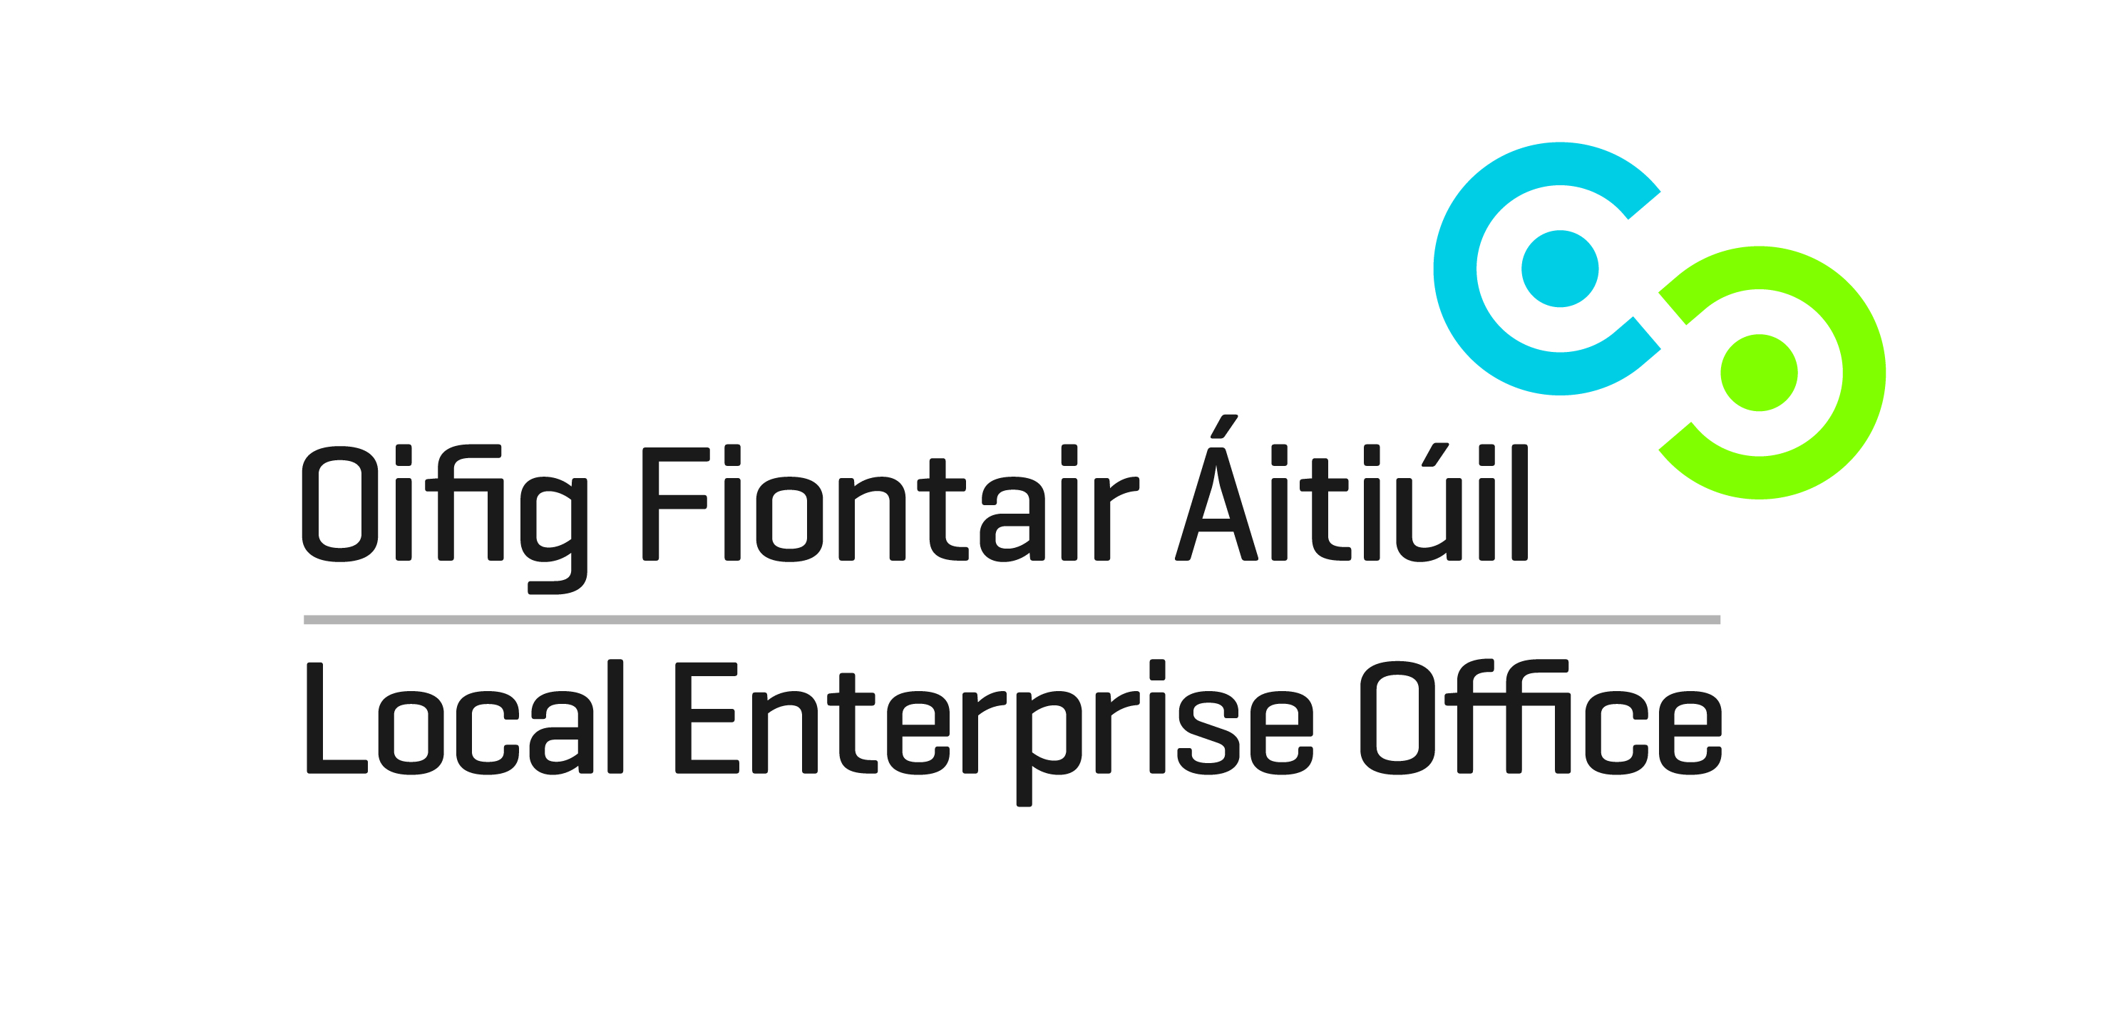
SHOWCASE 2016
24TH TO 27TH JANUARY 2016 RDS DUBLIN
Applicant Details:
Name of applicant: …………………………………………………………………………………………………………………..
Address: …………………………………………………………………………………………………………………..
…………………………………………………………………………………………………………………..
Phone No. …………………………………………………………………………………………………………………..
Email: …………………………………………………………………………………………………………………..
Tax Ref. No. …………………………………………………………………………………………………………………..

Business Details:
Business Name: ………………………………………………………………………………………………………………….
Business Status: Sole Trader [ ]
Limited Company [ ]
Partnership [ ]
No. of employees: …………………………………………………………………………………………………………………..
Brief description of business: ………………………………………………………………………………………………………
……………………………………………………………………………………………………………………………………………………….
……………………………………………………………………………………………………………………………………………………….

Benefits to your business of participating in Showcase: ………………………………………………………………..
………………………………………………………………………………………………………………………………………………………
………………………………………………………………………………………………………………………………………………………
……………………………………………………………………………………………………………………………………………………..
………………………………………………………………………………………………………………………………………………………
The subsidised cost of a 2m X 2m stand is €600. The stand can be shared with another business
Priority will be given to businesses that have not been previously supported by the LEO at Showcase
Completed forms should be returned to:
Local Enterprise Office, Aras Chill Dara, Naas, Co. Kildare or emailed to localenterprise@kildarecoco.ie
Closing date for receipt of forms is Friday 18th September 2015

