EXPRESSION OF INTEREST FOR GRANT APPLICATION
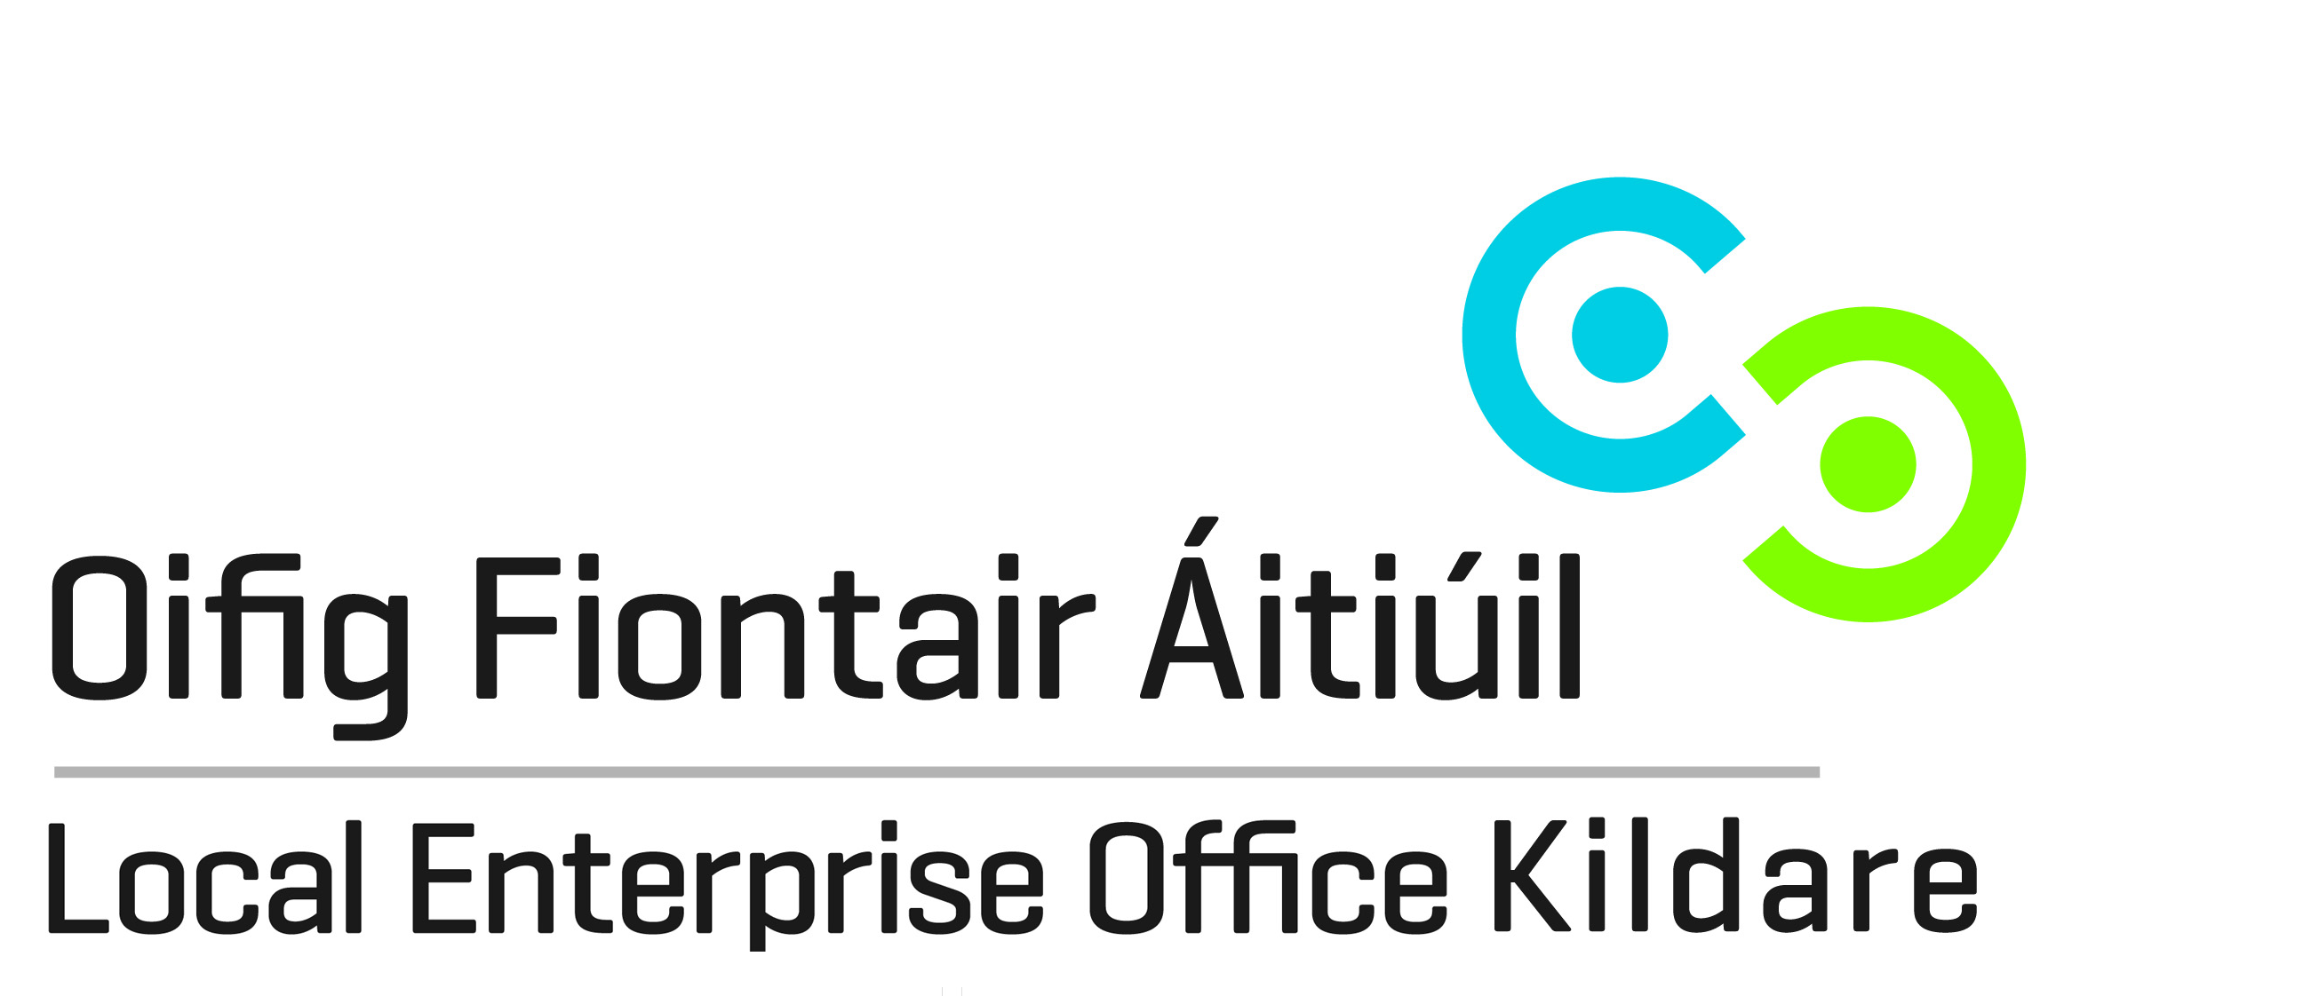
Tel: (045) 980838
Email: localenterprise@kildarecoco.ie

To establish if the business could be supported by the Local Enterprise Office, we need background information to understand more about the business opportunity, the proposed management and their experience in this market / technology and the development plans/needs of the company. The following list of questions should be answered as best as possible and submitted to the Local Enterprise Office before setting up an initial one-to-one meeting. Note:- We do not require business plans at this early stage if a business plan has not yet been developed. This template allows you to present your business proposal and for the Local Enterprise Office to provide an opinion on eligibility for financial support.
Eligibility Criteria: https://www.localenterprise.ie/Kildare/Financial-Supports/Eligibility-Criteria/

Name
Business Address (Kildare)
Mobile and Telephone
Email
Website

Status (Sole Trader / Partnership / Limited Company)
Date business Established?
Previous grant /funding history (both LEO and Non-LEO)
Which sector does your business operate in – manufacturing, internationally traded services, or other?
How many are employed full-time and part-time in the business? Are you the promoter, or another working full-time in the business?

Project and Promoter Questions
1. Describe your business / business idea?

2. Describe the product / service it will offer? How is this different to what is currently available on the market? (i.e. what is innovative about your proposal and what is your competitive advantage?)

3. Does the Irish company have or intend to secure Intellectual Property protection?

4. Who are the main entrepreneurs (founders) in this business? What is the background and experience of promoters in this technology / market? You should outline the professional experience and the names of companies that the founders worked in.

5. What market(s) / sector(s) will you be targeting? Why do you believe that your start-up is capable of trading internationally? What is the scale of this market, who are the main competitors in Ireland and internationally?

6. From a timing perspective – how advanced is the project idea / business? And what do you need to do to move the business to the next stage of development? Is the company at the idea stage, is there a company registered, is there any investment raised to date, is there any full-time employees, is the company selling?

7. What is the funding requirement? How do you plan to service this requirement?

8. What supports are you seeking from the Kildare Local Enterprise Office?

9. What is the potential for employment in Kildare in this company in the next 12 months?

Consent to Contact about Future Business Support Services: Kildare Local Enterprise Office provides a service to inform clients about future business support services. If you would like to be kept informed of available business supports and opportunities, and consent to our office contacting you about these services, please tick any of the following boxes to indicate your preferred means of communication.
Your consent can be withdrawn at any time and we do not share personal data with third parties.

As a regular provider of business courses and a supplier of business support services, Kildare Local Enterprise Office may from time to time, need to contact clients to notify them of details related to their enquiry or business support service. Please tick the consent box below to confirm acceptance. Your consent may be withdrawn at any time by contacting us at localenterprise@kildarecoco.ie. The information you provide will be held in accordance with the Data Protection Acts 1988-2018. The full terms of our privacy, data protection and GDPR policies protecting your personal data can be found at www.kildare.ie/CountyCouncil/DataProtection

I consent to Kildare Local Enterprise Office contacting me in relation to general matters related to this enquiry.

I do not consent to Kildare Local Enterprise Office contacting me in relation to general matters related to this enquiry.

Signed: |  | Date:

