SHOP FRONT IMPROVEMENT SCHEME

GUIDELINES

Applying for a Grant

Kildare County Council
Comhairle Contae Chill Dara

Eligible works under the scheme may include:
Eligible Works *
- Repair and reinstatement of all or any part of a shop front fixture that is visible from the street, including the first and second floors of premises. We wish to encourage the reinstatement of architectural or historic features that have formed part of the buildings’ design and character but may have been lost or damaged over time.
- Retention of original shop front and reinstatement of original features will be encouraged. New shop fronts in a traditional style should be based on the guidance below and
Kildare County Council
Comhairle Contae Chill Dara

Business Support Unit

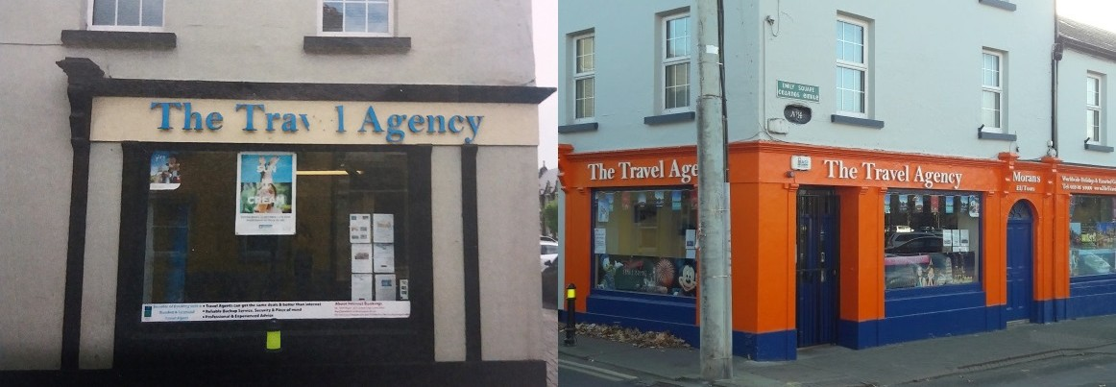
- Details of proposed works including all drawings (even any minor details) of improvements to the façade should be included with the completed grant application form.
- Retrospective applications for works already undertaken will not be accepted.
- Should applicants wish to undertake work themselves: a grant will be paid towards material costs only.
- An itemised list of proposed woks must be submitted with each application.
- An estimate for the cost of works must be submitted with each application. The Council reserves the right to request further quotes if it is deemed appropriate.
Eligibility
- Grants will only be offered to independently owned businesses.
- Grants will not be offered in respect of works already completed prior to application being received.
- Grants will not be paid in respect of properties included on the Derelict Sites Register.
- Grant – Up to €5,000 or:
Up to 50% of eligible costs for Painting, Woodwork, Signage etc (however if you also include an element of Accessibility/Age Friendly this can be increased up to 75% of costs) or
Up to 75% of eligible costs for Accessibility Improvements or
Up to 75% of eligible costs for Age Friendly Improvements Each application will be considered on it’s own merits
nearby examples. Modern designs will also be supported: however, these must use high
quality materials and be sympathetic to the immediate area.
- Repainting of shop fronts in suitable colours.
- Repair and reinstatement of guttering and down-pipes to match historic materials.
- Repainting and/or re-rendering of prominent elevations of the building.
- Installation of Exterior Lighting.
- Appropriate Seasonal Exterior Displays
- Pedestrian access improvements, which in particular support the Age Friendly Initiative.

- Signage. Removal and replacement of neon signs, banners or other inappropriate signage affixed to front elevations (or side elevations visible from the street) and replacement with signage more appropriate to the Shop Front Design.

Retail Improvements:

Shop Front Improvement,
Accessibility and Age Friendly Grant Scheme
The purpose of this scheme is to foster good design practices which respect the character of streetscape in terms of detailing, materials and finishes. The encouragement of high quality commercial frontages which use a variety of architectural styles which need not duplicate established architectural approaches but should conform to the scale, massing, height and urban grain of the subject building and also contribute to the overall aesthetic, appearance, character and heritage of the urban environment.

Supporting
Local Business

Ineligible Expenditure
Shop Front Improvement Scheme Application Form
General Provisions

The scheme will not support:
  - Improvements to residential property.
  - Retrospective applications i.e. work already completed or underway before receipt of application.
  - Structural repairs including re-roofing.
  - Structural Internal repairs and alterations.
  - External security features, such as CCTV systems.

Grant Scheme will open from the 1st of February
Application Procedure
- Applicants should assess their own eligibility (including need for planning) and return the application Form along with estimate for works (details on how to return your application are below).
- Applications should clearly identify each element of the works proposed.
- Application should be accompanied by:
  - Photograph of existing shop front
  - Sketch of proposed changes
  - Indication of material type and colour scheme to be used
  - A written quotation for the works proposed
  - Details of Accessibility / Age Friendly element of improvements must also be included i.e. hand rails, bell at entrance, seating
  - Written Proof of Ownership if owner of premises
  - Written permission from Landlord/Owner for the work to be carried out if leasing the premises
- A site visit/s may take place throughout the process to ensure work is appropriate and is
Name: Address:

Contact Name: Contact No. Contact Email: Description and Location of Project:

Planning Application Reference (if applicable) Estimated start date: Est. completion date: What is the estimated cost of this project:

Grant will be up to a max of €5000 or:
Up to 50% of eligible costs for Painting, Woodwork, Signage etc (however if you also include an element of Accessibility/Age Friendly this can be increased up to 75% of costs) or
Up to 75% of eligible costs for Accessibility Improvements or
Up to 75% of eligible costs for Age Friendly Improvements

Description of proposed works:

- Planning Permission is required for works to shop fronts that include significant works, such as the construction of new or replacements shop fronts, the erection of security grilles and shutters and the installation of canopies. Please refer to Shop Front Guidelines: http://kildare.ie/countycouncil/planning/ShopfrontGuidelines2013/

- Grants are awarded entirely at the discretion of the Council.

- Applications may be made by the owner of premises or by the lessee with the owner’s written consent.

- Applications may not be considered where there are local taxes or charges due to the Council by the applicant or the lessee of the property.

- The grant must be used for the purpose intended, as outlined in the Grant Offer Letter.

- Project must be completed within 3 months of date of Grant Offer and Claim for payment must then be made 30 days after completion date.

- Where planning permission is required, the grant will only be paid to the planning requests which have been granted planning permission. Nothing in the agreement or
negotiation of the grant will affect the Council’s decision in relation to planning permission.
An offer of agreement in principle will be made until planning permission has been granted. Only then may a Grant Offer Letter be issued and works commence.

- The applicant must inform Kildare County Council of any changes to the business or changes of business address and telephone number.

carried out to specification in application. Payment of grant will be dependent on work being
carried out to specification in approved application .
5. A Selection Board will be set up to select suitable applications and to place them in order of

9. Any grant must be taken up within the period stated in the grant offer letter, unless a prior arrangement is made.

priority. The decision of the Selection Board is final in relation to all applications under this scheme.
- If the application is successful, Kildare County Council will send a Grant Offer Letter, confirming the grant offered in accordance with the guidelines.
- Any alterations to design and/or materials must be agreed in advance and recorded
on the work schedule. No grant will be paid to any project where changes are made that have not been agreed with Kildare County Council.
- Once works are complete the applicant should submit evidence of paid contractor invoices to Kildare County Council.
- Kildare County Council will then pay the applicant the sum agreed as per the Grant Offer
Note: Please provide a detailed breakdown and a written quotation for the total estimated cost of the project and ensure that all the necessary documentation is included with this application:

DECLARATION
I/WE declare that the information provided is true and correct
Name (Block Capitals): Position Held: Signed: Date:
Competed forms should be returned to:
Business Support Unit, LEO Office, Áras Chill Dara, Devoy Park, Naas,
Co Kildare W91 X77F, Áras Chill Dara, Devoy Park, Naas, Co Kildare W91 X77F Or Email to: localenterprise@kildarecoco.ie

- Once Project has been Pre Approved, Payment will be made in arrears upon production of the grant claim form, along with supporting documentation (e.g. copies of paid invoices).

- Completed application forms should be returned to:

Business Support Unit, LEO Office, Áras Chill Dara, Devoy Park, Naas, Co Kildare W91 X77F

Telephone: (045) 980200

Letter.
10. Closing Date for Applications : 31st of August
Email: localenterprise@kildarecoco.ie

www.kildare.ie
Kildare County Council
Comhairle Contae Chill Dara

