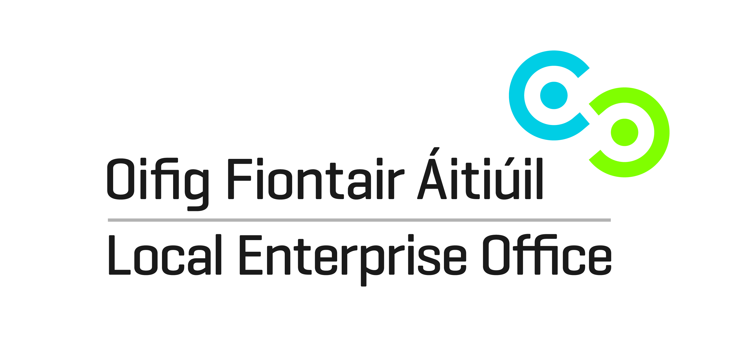
SHOWCASE 2017
22nd – 25th January 2017
RDS, Dublin

EXPRESSION OF INTEREST

Look Up Zone at Showcase 2017
Showcase – Ireland’s International Creative Expo is one of the country’s largest international trade shows. The annual event is attended by over 5,000 buyers from Ireland and up to 26 countries around the world, generating sales orders of up to €20 million over the four days of the show. Showcase is a partnership between the Design & Crafts Council of Ireland and Showcase Ireland Events Ltd, with support from Enterprise Ireland in promoting the show internationally through their network of offices overseas. www.showcaseireland.com

The Lookup Zone was developed by the LEO Network in association with the Design & Crafts Council of Ireland. The zone contains approximately 100 stands which will be allocated to LEO clients from around the country who represent the best of design and craft supported by the LEO Network. Sales and marketing training will be provided to the selected LEO clients in advance of Showcase.

The cost of each stand has not yet been determined but it will be heavily subsidized by the LEO.

If you are interested in taking a stand, please complete the details below and return to us by 31st August 2016.

Applicant Details
Name of Applicant
Address
Telephone
E-Mail
Tax Reference Number

Business Details
Business Name
Business Status  (please tick opposite) | Sole Trader  Limited Company  Partnership
Number of Employees
Brief Description of Business

Please outline the benefits to your business of participating in the show

Priority will be given to businesses that have not been previously supported by the LEO to attend the show.

Completed forms to be returned by post to
Local Enterprise Office Kildare, Aras Chill Dara, Devoy Park, Naas, Co. Kildare
or by email to localenterprise@kildarecoco.ie
Closing date for receipt of completed forms is Wednesday 31st August 2016

