START-UP WITH GLOBAL AMBITION
EXPRESSION OF INTEREST
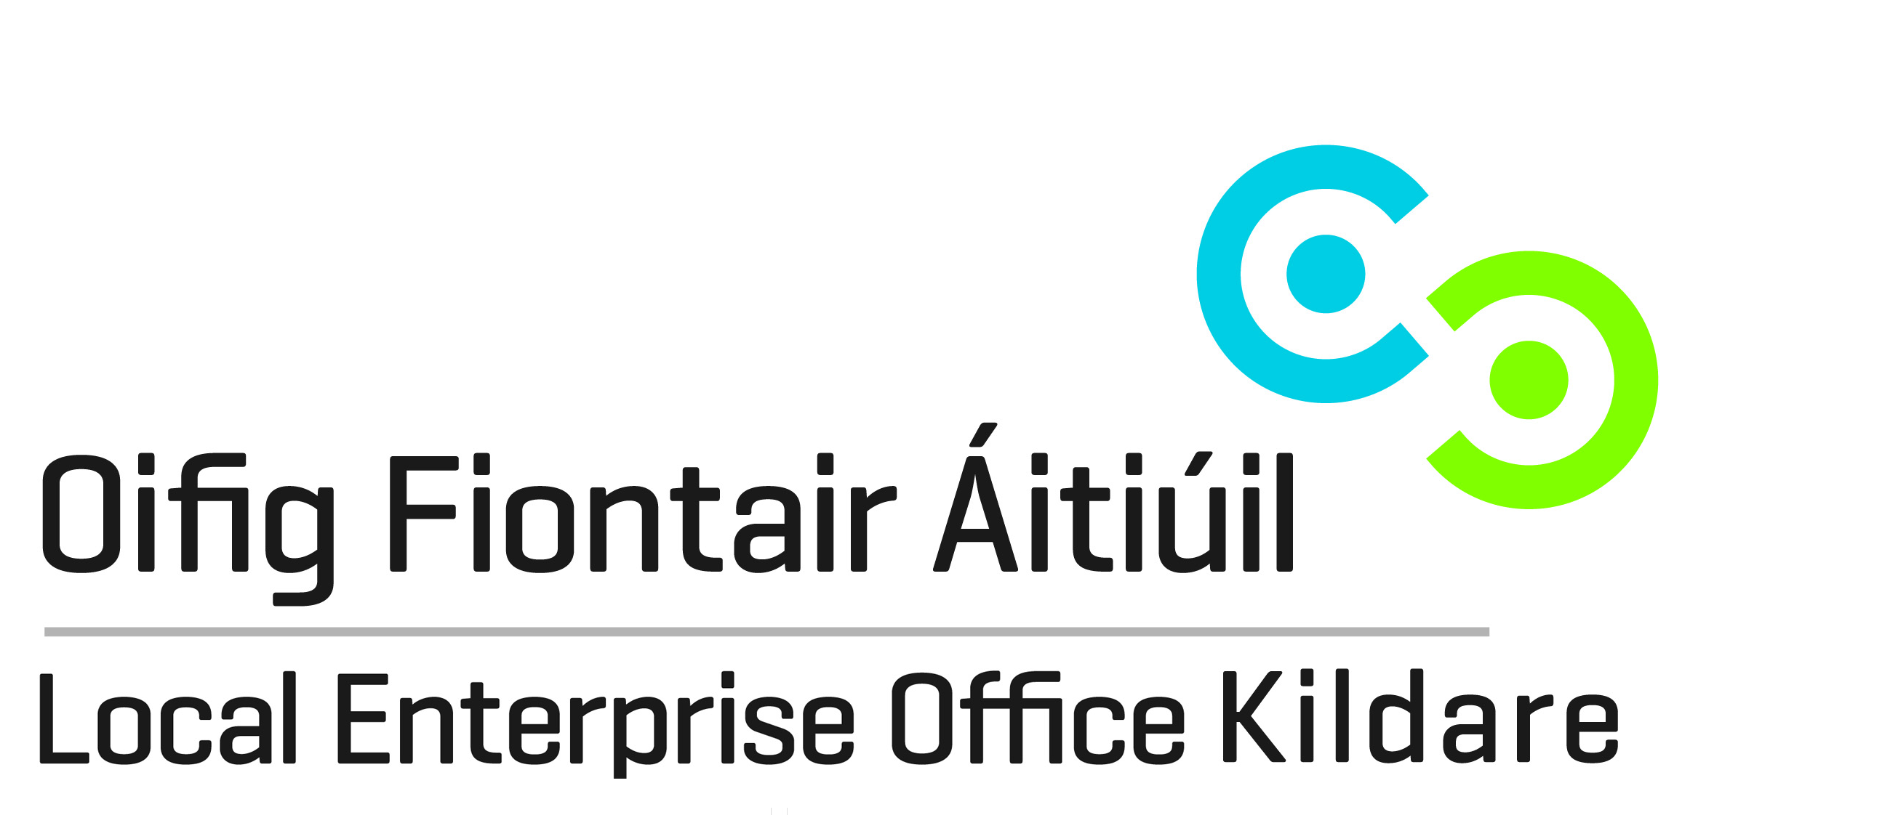
Tel: (045) 980838
Email: localenterprise@kildarecoco.ie

Name
Address
County

Telephone
Email
Website

Status | Sole Trader Partnership Limited Company Pre Start-Up
Date trading commenced (If applicable)

Project and Promoter Questions
1. Briefly describe your business idea.

2. Who are the main entrepreneurs (founders) in this business? What is the background and experience of promoters in this technology / market? You should outline the professional experience, the names of companies that the founders worked in and the current employment status.

3. What market(s) / sector(s) will you be targeting? What is your global ambition for your business? Why do you believe that your start-up is capable of trading internationally? What is the scale of this market, who are the main competitors in Ireland and internationally.

4. From a timing perspective – how advanced is the project idea / business? And what do you need to do to move the business to the next stage of development? Is the company at the idea stage, is there a company registered, is there any investment raised to date, is there any full-time employees, is the company selling?

5. What are your immediate challenges?

Consent to Contact about Future Business Support Services: Kildare Local Enterprise Office provides a service to inform clients about future business support services. If you would like to be kept informed of available business supports and opportunities, and consent to our office contacting you about these services, please tick any of the following boxes to indicate your preferred means of communication.
Your consent can be withdrawn at any time and we do not share personal data with third parties.

As a regular provider of business courses and a supplier of business support services, Kildare Local Enterprise Office may from time to time, need to contact clients to notify them of details related to their enquiry or business support service. Please tick the consent box below to confirm acceptance. Your consent may be withdrawn at any time by contacting us at localenterprise@kildarecoco.ie. The information you provide will be held in accordance with the Data Protection Acts 1988-2018. The full terms of our privacy, data protection and GDPR policies protecting your personal data can be found at www.kildare.ie/CountyCouncil/DataProtection

I consent to Kildare Local Enterprise Office contacting me in relation to general matters related to this enquiry.

I do not consent to Kildare Local Enterprise Office contacting me in relation to general matters related to this enquiry.

Signed: |  | Date:

