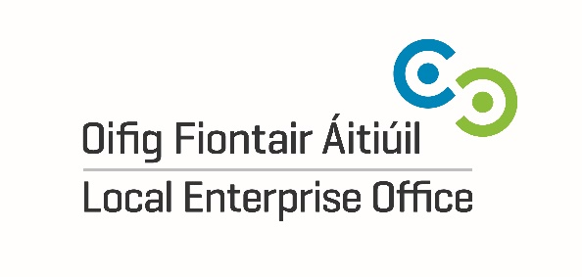
Press Release Monday, April 19th 2021
Kilkenny food and drink producers invited to join Food Academy
Local Enterprise Office Kilkenny is inviting food and drink producers from the county to join the hugely successful Food Academy programme and follow in the footsteps of local companies, such as Goatsbridge Trout, Mooncoin Beetroot, Highbank Orchards, the Little Mill Company, Bob and Joan’s Juicy Jams and The Fig Tree which have previously taken part.

Now in its eighth-year, Food Academy is a unique food business development programme between the 31 Local Enterprise Offices, including Local Enterprise Office Kilkenny, SuperValu and Bord Bia. Participants in the programme receive training in food safety, market research and branding, marketing, finance, sustainability and business development.

The Food Academy programme currently supports 290 Irish food and drink producers including 140 female entrepreneurs, generating €170m in sales. In 2020, there was a 15% growth in SuperValu Food Academy sales with participants earning €28m. The Food Academy programme supports 1,500 jobs in local communities nationwide and local producers are now being encouraged to apply for the 2021 programme before Monday April 26th.

Welcoming the increase in Food Academy sales through SuperValu in 2020, Fiona Deegan, Head of Enterprise with Local Enterprise Office Kilkenny said: “Since it was started up eight years ago by the Local Enterprise Offices, SuperValu and Bord Bia, the Food Academy programme has been hugely successful, going from strength to strength. It has helped hundreds of food and drink producers, like Mooncoin Beetroot, Goatsbridge Trout & Bob & Joan’s Juicy Jams in Thomastown, Highbank Orchards in Cuffesgrange and the Little Mill Company in Bennettsbridge, that have graduated through Food Academy to get their products market-ready, giving them an opportunity to sell to a nationwide audience.”
She added: “The Food Academy is part of a suite of Local Enterprise Office supports designed for food and drink entrepreneurs in Ireland, such as the Digital School of Food and Food Starter programmes, both aimed at getting those with food ideas off the ground. As local food and drink producers grow their sales through these programmes, Local Enterprise Office Kilkenny is on hand to support their expansion plans through further training, mentoring and financial assistance.”
Commenting on the Food Academy programme, Carmel Biggane, Food Academy Manager, SuperValu said: “At SuperValu we believe in local business and are proud to continue to support local producers across the country. In collaboration with the Local Enterprise Office Network and Bord Bia, the Food Academy is a great way for us to help new businesses to grow and get the support they need.

“The programme allows us to use our experience to help small businesses through their journey from start up to getting their products on our shelves all year round. We’ve had great success with the Food Academy in recent years, we look forward to welcoming new producers this year and continuing to support local communities. I would call on local food producers across Ireland to get involved and see how Food Academy can help you grow.”

The Food Academy Programme is now open for applications until Monday 26th April. To apply, interested food and drink producers from County Kilkenny are encouraged to contact Local Enterprise Office Kilkenny for an application form by e-mailing info@leo.kilkennycoco.ie or by visiting localenterprise.ie/kilkenny

Further information about the Food Academy is also available at https://supervalu.ie/real-people/food-academy-programme.

ENDS

For further information, please contact:
Catherine Hennessy
Local Enterprise Office Kilkenny
086-3886580
catherine.hennessy@leo.kilkennycoco.ie
Notes to Editor:

About the Local Enterprise Offices
The Local Enterprise Offices, located in local authorities and funded through Enterprise Ireland, support over 7,000 small Irish businesses and entrepreneurs nationwide. Since their establishment in 2014, they have helped create over 20,000 jobs and provide a range of supports to small businesses including financial assistance, mentoring and training. For the food and drink sector, Local Enterprise Offices offer a suite of programmes including the Food Academy Programme (in partnership with SuperValu and Bord Bia), The Food Starter Programme and the Digital School of Food. For more information on the Local Enterprise Offices, go to www.LocalEnterprise.ie

About SuperValu
SuperValu serves over 2.6 million customers every week and has 223 stores nationwide. Together with its retail partners, SuperValu employs approximately 14,500 colleagues, making it one of the State’s largest private-sector employers. SuperValu continues to source locally wherever possible which helps to sustain 30,000 jobs in the Irish economy.

