Local Enterprise Office Kilkenny  National Enterprise Awards 2017 | 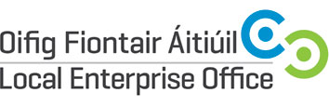

Guidelines for judging criteria and marking system

LEO Name

Promoter

Address
Region

Date Business Established

Telephone

Email

Website

Social Media Details

Business Plan | 20 | Total Marks
- Management capability / staff structure
- Competitiveness
- Growth potential
- Employment potential
- Business strategy
Marketing | 20
- Marketing strategy
- Company’s success in national and export markets
- Growth in sales revenue this year over previous years
- Responsiveness to market trends
Finance | 20
- Financial commitment of the owner
- Profitability of the company
- Strength of the balance sheet
- Net assets of the company
Technology & Innovation | 20
- Use of technology
- Innovation in business e.g. finance, production, marketing, HR etc.
Entrepreneurial Skills of Promoter | 20
- Leadership qualities
- Vision and drive
- Commitment
- Entrepreneurial capability (risk taking etc)

TOTAL (out of 100) ________

