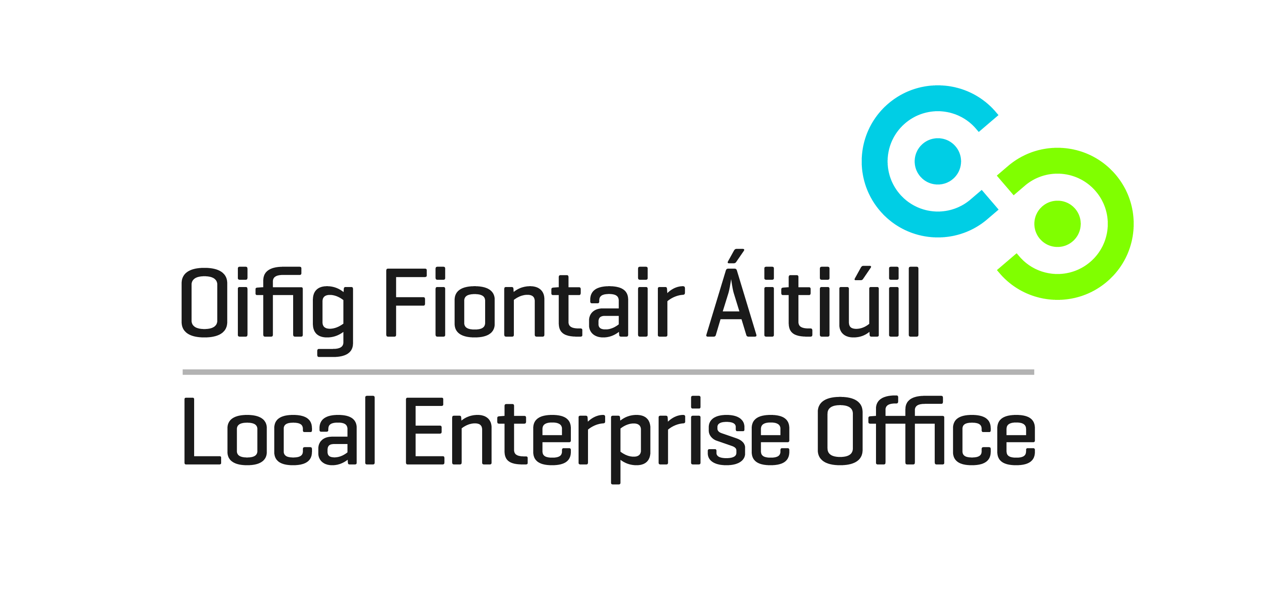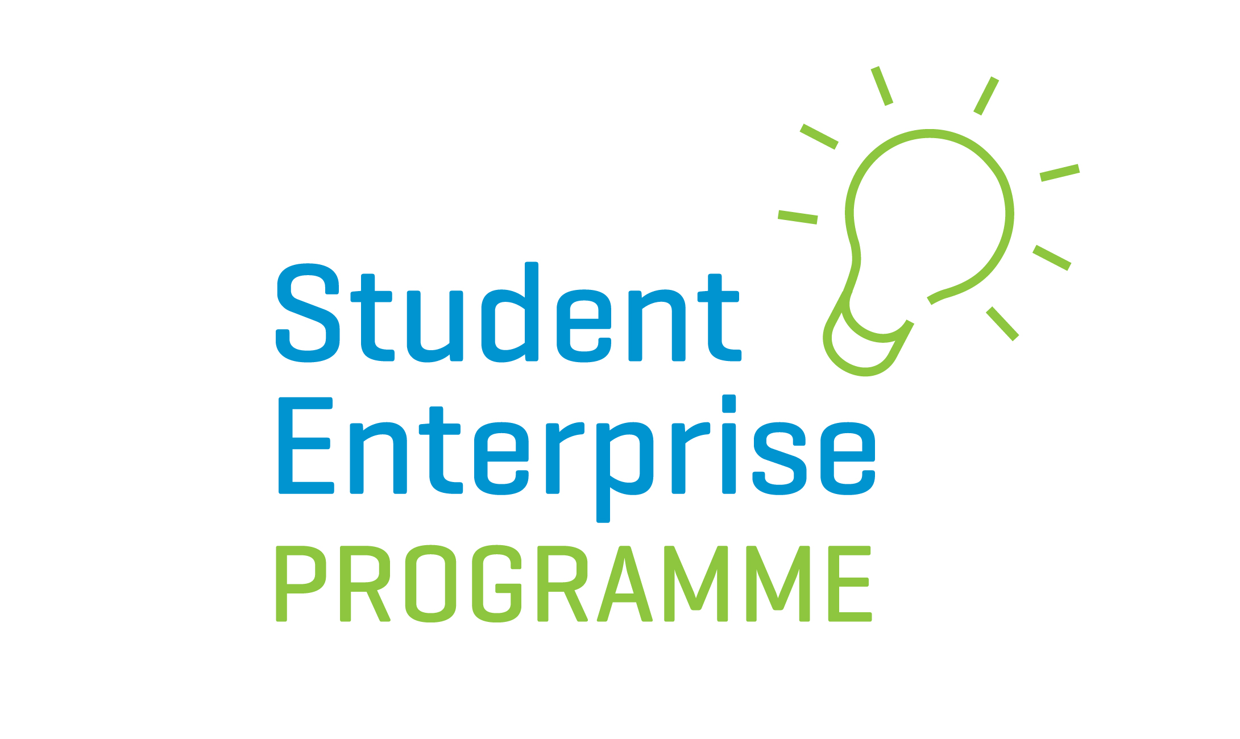

REQUEST FOR QUOTATION

FOR THE CO-ORDINATION OF THE

STUDENT ENTERPRISE PROGRAMME

2018-2020

Request for Quotation Guidelines

1. Introduction
The Student Enterprise Programme (hereafter referred to as SEP) is a flagship national enterprise education programme for secondary school students aimed at fostering an entrepreneurial spirit. The SEP brings the world of business into the classroom, helping students develop enterprise and management skills. With the support of their schools and the Local Enterprise Offices in the Local Authorities Network, students research, set-up and run their own real-life businesses. Further information and details about the SEP can be accessed on www.studententerprise.ie

The Local Enterprise Office Kilkenny is currently inviting request for quotations for the delivery and co-ordination of the SEP in second level schools within County Kilkenny for the next 2 academic years i.e. 2018-2019 Programme and also 2019-2020 Programme subject to budget allocations.

2. Student Enterprise
The SEP is a primary vehicle for exposing young people to enterprise and giving them a better understanding and appreciation of what is involved in running a business. It is aimed at encouraging students to think about entrepreneurship and self-employment as a viable career choice and also to enhance the teaching of entrepreneurship in schools by combining learning with real life experiences.
This programme provides students aged 12 to 18 with the experience of ‘the entrepreneurial journey’ through entrepreneurship education in school and the opportunity to compete at county and national level and showcase the business projects developed during the academic school terms.

While recognising that participation in the Programme is on an entirely voluntary basis, the following are key targets that the Local Enterprise Office Kilkenny aims to achieve:
- At least 80% participation rate per annum in the Senior Category of the Awards among second level schools in the county offering transition year. There are currently 16 second level schools in County Kilkenny;
- At least 400 students participating at the Senior Category Level per annum;
- At least 2 schools participating at the Junior and Intermediate Categories of the Awards

3. Closing Date for Submission of Quotations
The closing date for receipt of completed proposals is 5.00pm, Thursday 19th July 2018. Proposals received after the closing deadline will not under any circumstances be considered.

Submissions should be sent in writing, marked ‘Request for Quotation for Co-ordination of SEP’ for the attention of Ms. Catherine Hennessy, Business Advisor, Local Enterprise Office Kilkenny, 42 Parliament Street, Kilkenny or email to catherine.hennessy@leo.kilkennycoco.ie with ‘Request for Quotation for Co-ordination of SEP’ in the subject line.

4. Costs and Proposal
To date the Local Enterprise Office Kilkenny has dedicated a budget of circa €10,000 per academic year towards this contract. The price and proposal should be inclusive of all costs; a fixed sum to include the costs of all travel and other expenses, overheads, insurance's, etc to be incurred in the delivery of the contract. No additional costs will be incurred by the sub-contractor without the prior approval of Local Enterprise Office Kilkenny. Please note that all necessary arrangements in connection with the promotion of the SEP, and the organising of associated workshops and of the County Final (including the cost of venue hire, etc.) will be arranged in agreement with and covered by Local Enterprise Office Kilkenny.

5. General conditions of engagement
(i) This is a contract for the delivery of the SEP from 20th August 2018 to May 20th 2019 & the period 19th August 2019 to 19th May 2020. Payments for all goods and services supplied will be made on the submission of appropriate invoices, in accordance with the Prompt Payment of Accounts Act 1997, as amended by the European Communities (late Payment in Commercial Transactions) Regulations 2002 (SI 388/2002). The payment schedule and invoicing arrangements will be agreed with the successful sub-contractor following their selection. The Local Enterprise Office Kilkenny retains the right to withhold payment, where a sub-contractor has failed to meet his/her contractual obligations in relation to the delivery of goods/services to an acceptable level of quality.

(ii) The sub-contractor shall be required to fully comply with the tax clearance procedures for public service contracts and produce for inspection either a valid tax clearance certificate, Revenue Access Code to confirm tax compliance or other certification from the Revenue Commissioners as to their suitability on tax grounds for appointment;

(iii) The Local Enterprise Office Kilkenny will provide full administrative back-up and support to the sub-contractor at all stages in and throughout the delivery of the SEP;

(iv) If in the opinion of Local Enterprise office Kilkenny, the sub-contractor is not achieving the pre-set objectives or is deviating from the brief and terms of reference for delivery of the contract, their engagement will be terminated without the full cost being incurred;

(v) The Company / Consultant to be engaged shall be required to work within the remit and comply with the Health Safety & Welfare at Work Act 2005.

(vi) The Sub-contractor shall be required to fully comply with the vetting legislation and Children First National Guidance and Children First Act.

(vii) The Sub-contractor shall be required to fully comply with Data Protection 1998-2018. The Local Enterprise Office is committed to its transparency obligations under the Data Protection Acts 1998-2018. Our data protection notice for personal data that is supplied to us by our clients is available www.localenterprise.ie/legal This notice tells you about your privacy rights and sets out how we, as a Controller, collect, use, process and disclose your personal data relating to your interactions with us. We request that you read the notice carefully and that you ensure that it is made available to any data subjects (e.g. your employees) whose personal data you provide to us.

6. Required Programme Activities

(i) The sub-contractor shall undertake to promote the SEA in all 16 second level schools in the County and to secure maximum participation in same, having due regard to the targets set out under 2 above;

(ii) The sub-contractor will be expected, as a minimum, to undertake at least 3 (three) visits to each second level school participating in the school during delivery of the contract, and to assist in all stages/aspects of the SEP from idea generation through to preparation of final submissions to the Finals (at County & National level);
(iii) The sub-contractor will arrange regular liaison meetings with school representatives, Local Enterprise Office Kilkenny staff and other stakeholders.
(iv) The sub-contractor will keep records of the number of students participating in each school and category, the gender ratio involved and final entrants in both county and national finals.
(v) The sub-contractor with the agreement of Local Enterprise Office Kilkenny will arrange the provision of additional support/resources for students participating in SEP, including workshops and presentations on various elements of the SEP (e.g. sales & marketing; writing business plans; etc.);

(vi) The sub-contractor will submit a short written progress report to Local Enterprise Office Kilkenny before payment of each instalment of the agreed contract price, and a comprehensive final report will be submitted to Local Enterprise Office Kilkenny before payment of the final instalment;
(vii) The sub-contractor will promote the SEP website www.studententerpriseawards.ie to schools, teachers and students and encourage the use of the website for registration and information requirements;
(viii) The sub-contractor will organise the County Final with the agreement of and in association with Local Enterprise Office Kilkenny staff and the participating schools;
(ix) The sub-contractor will prepare promotional/publicity material and related PR for local media at various stages throughout the SEA programme; and
(x) The sub-contractor will liaise and communicate formally on behalf of the Local Enterprise Office Kilkenny with the National Co-ordinator of the SEP.

(xi) The sub-contractor will co-ordinate Kilkenny entries to the National Finals in terms of assisting students with final entry in terms of presentation of business plan and display stand, ensuring they are aware of deadlines and arrangements for the National Final event.

7. Submissions
In submitting a quotation proposal, you should detail your proposal, approach, methodology and capacity to successfully address the Required Programme Activities. You should demonstrate that you possess the necessary technical and other expertise and experience to successfully undertake and complete the contract.
As per submission document, your proposal should clearly indicate the following:
- A clear overview of your approach/methodology to promote the SEP to gain maximum participation among second level schools;
- A clear overview of how you would deliver the SEP in participating schools;
- A clear outline of your specific experience, skills, profiles and qualifications;
- Details of your costs;
- Any further information that you wish to submit in support of your proposal.

Note: Proposals/submissions should not normally exceed ten (10) pages.

8. Evaluation of Quotations
The Local Enterprise Office Kilkenny will not be bound to accept the lowest or any quotation. Prospective bidders should note that the award criteria to be applied in deciding on the successful proposal will involve scoring on the following:
- Methodology to achieving all of the programme objectives (40%);
- Relevant experience of the bidder in delivering similar programmes, in particular working with young people in youth enterprise initiatives (30%);
- Quality of approach (20%) in terms of administrative ability, communication skills and capacity to deliver the programme and
- Value for money (10%); Lowest Quoted price divided by tendered price multiplied by total marks available for fixed budget price. (Prospective bidders are reminded that the budget is fixed at €10,000 and is expected that the tender sum will not exceed this amount; marks will be deducted from submissions which contain pricing in excess of the fixed budget).

Please note the following:
- The Local Enterprise Office Kilkenny may shortlist for interview on the basis of the written documentation before making a final decision on the Co-ordinator position.
- Late applications will not be accepted.
- Only fully completed applications that have all the necessary supporting documentation enclosed will be considered for inclusion.
- The Student Enterprise Programme is a national programme delivered by the national network of Local Enterprise Offices and is subject to annual budget allocation.

