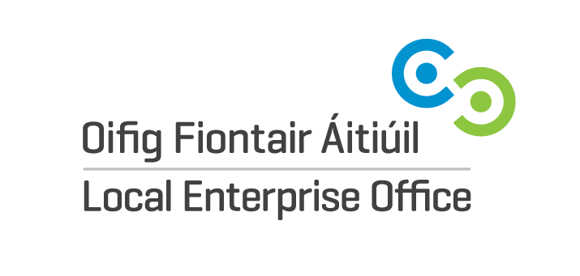
DIGITAL MARKETING BEGINNERS PROGRAMME SPRING 2021
EXPRESSION OF INTEREST FORM
This Digital Marketing Beginners Programme has been developed to provide businesses with limited knowledge and experience the tools they need to manage these digital platforms with confidence. To take part in the programme please confirm you have the following already in place.
Name of Participant:

Business Name:

Business Address:

Email Address:

Website Address:

Do you currently have a digital marketing plan for your business? | Yes  No
Are you currently using at least one social media channel to communicate your business products/services? | Yes  No  If you have answered yes, please provide the following details:  Facebook Account Name:  Instagram Account Name:  Other Social Media Platform:
Do you post content to your digital channels (web, blogs, newsletter, social media) on a relatively frequent basis? | Yes  No
Do you (or a team member) dedicate a certain amount of time every week to communicating digitally? | Yes  No

Please submit this Expression of Interest to catherine.myers@leo.kilkennycoco.ie
Please note:
A completed Expression of interest Form does not guarantee a space on this programme.
All Forms will be reviewed and we will revert back to you to advise if you have been successful in obtaining a space on this programme.
If you have any been successful, we will forward you a payment link. The cost to participate in this programme is €50.

