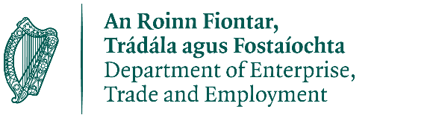

Increased Cost of Business

Customer Declaration

Local Authority:
Customer Number:

Property Details

Property Id / Rate Number:
Tax Reference Number:
Business Legal Name:
Business Address 1:
Business Type:
Total Employees:

Note: Business Type and Total Employees are for statistical purposes only and will not be used to determine the grant eligibility.

Please confirm following:
□ | The property for which I am registering the grant is not vacant.
□ | The business seeking this grant complies with all tax obligations.
□ | The business has been trading at this property since February 1, 2024.
□ | The business intends to trade for at least 3 months following registration and submission of self-declaration.

Contact Information

Your Name:
Phone Number: |  | Mobile Number:

Bank Account Details

Bank Name:
Account Owner Name:
Sort Code: |  | Account Number:
BIC / SWIFT Code:
IBAN Number:

Note: Include a copy of your bank header

NOTE: As part of the Increased Cost of Business Grant Scheme all grant recipients will be published on the local authority website in November 2024.

- Please be aware that your local authority reserves the right to reclaim any grant payment found to be incorrect later. This includes cases of error by the recipient business or the local authority making the payment, or where a business provides false eligibility declarations.

- The ICOB grant is provided under the European Commission Regulation on 'De Minimis' aid (De Minimis Regulation (EU) 2023/2831 of 13 December 2023) and your business has obligations in relation to de minimis state aid.

□ | I consent to the supplied data being used for the purpose of the grant, including for verification of tax compliance with the Revenue Commissioners.

Name: _______________________________

Signature: _______________________________ Date: _______________________

Property Details (copy this page to add more properties)

Property Id / Rate Number:
Tax Reference Number:
Business Legal Name:
Business Address 1:
Business Type:
Total Employees:

□ | The property for which I am registering the grant is not vacant.
□ | The business seeking this grant complies with all tax obligations.
□ | The business has been trading at this property since February 1, 2024.
□ | The business intends to trade for at least 3 months following registration and submission of self-declaration.

