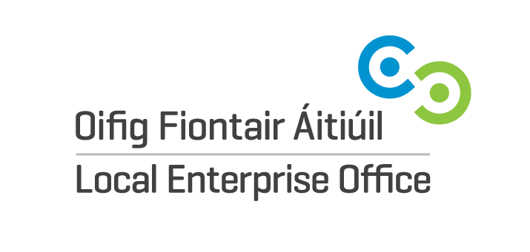
VISUAL STORYTELLING WORKSHOP SPRING 2021
EXPRESSION OF INTEREST FORM
If you wish to be considered for a place on this workshop, please complete the following:
Name of Participant:

Business Name:

Email:

Business Address:

Website Address:

Is your Website Active? | Yes  No
Has your Business a presence on any Social Media Platforms? | Yes  No  If you have answered yes, please provide the following details:  Facebook Account Name:  Instagram Account Name:  Other Social Media Platforms:
Do you have a basic understanding of how social media & website content works but want to refresh and then move up to the next level? | Yes  No
Have you created and uploaded a Video on your Website or one of your Social Media Accounts? | Yes  No

Please submit this Expression of Interest to catherine.myers@leo.kilkennycoco.ie

Please note:
A completed Expression of interest Form does not guarantee a space on this programme.
All Forms will be reviewed and we will revert back to you to advise if you have been successful in obtaining a space on this programme.
If you have any been successful, we will forward you a payment link. The cost to participate in this programme is €10.

