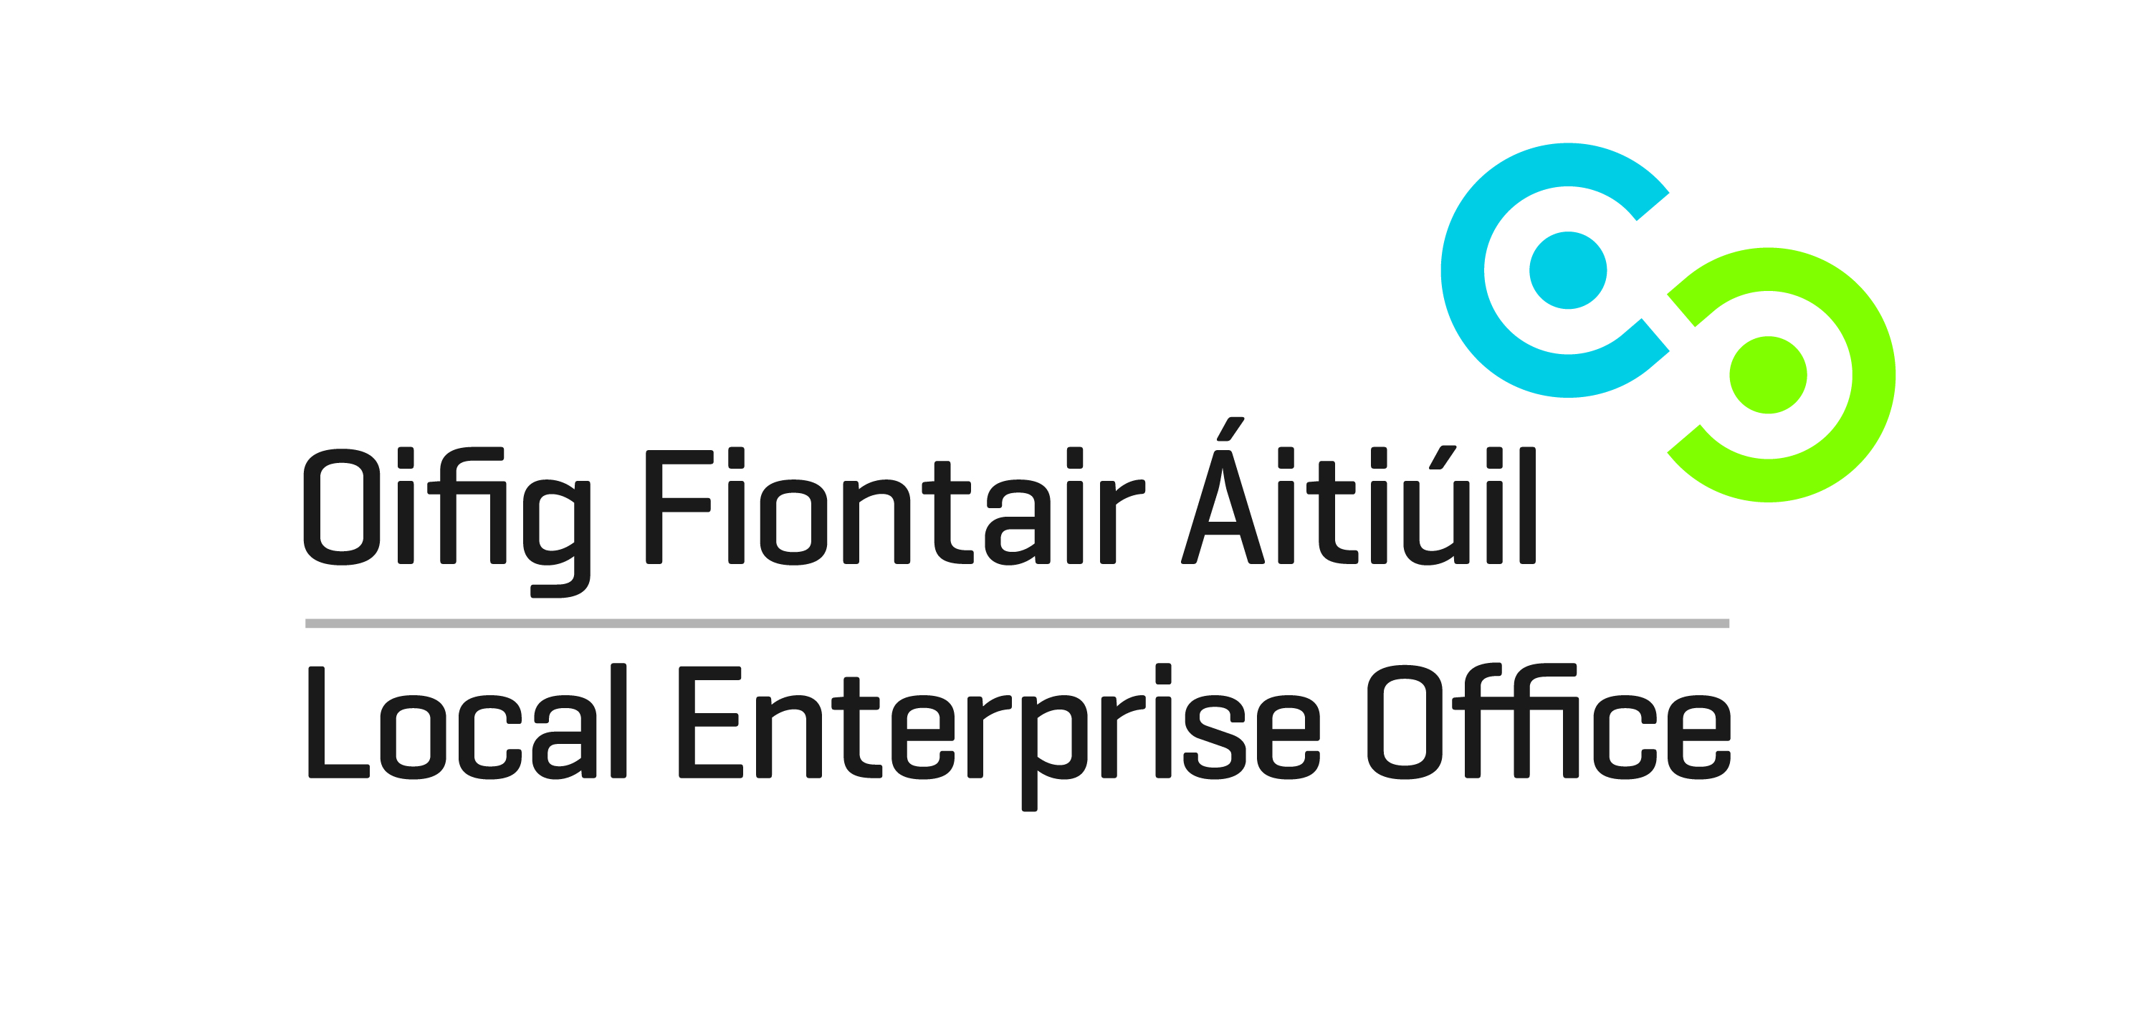

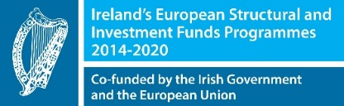
Lean tools and techniques are helping companies across the globe to address competitiveness issues within their businesses, building the capability of their people to identify issues and improve their operations.
Lean for Micro is designed to encourage clients to adopt Lean business principles in their organisations to increase competitiveness.
The key to becoming and remaining competitive is Lean: the relentless pursuit of value to the customer.
What is Lean?
Lean is about being effective and efficient - doing things quicker, better, cheaper…together. Lean strives to stamp out waste and to continually improve.
Lean requires that individuals, teams and the entire organisation remain continuously focussed on the customer, adopting a practical approach to increasing value to the customer by the relentless elimination of every form of unnecessary waste.
Lean is a way of thinking and acting that enables people to drive the organisation forward. It increases capability and capacity, and is the catalyst for innovation.
Lean helps ensure flexibility, responsiveness, efficiency, innovation and by continuously listening to the customer allows companies to compete and win on merit.
Why Lean? Benefits
The LEO Lean for Micro business programme helps to:
- Identify issues and potential improvement areas
- Provide support to implement
- Achieve savings and improvements in capability and capacity to deliver
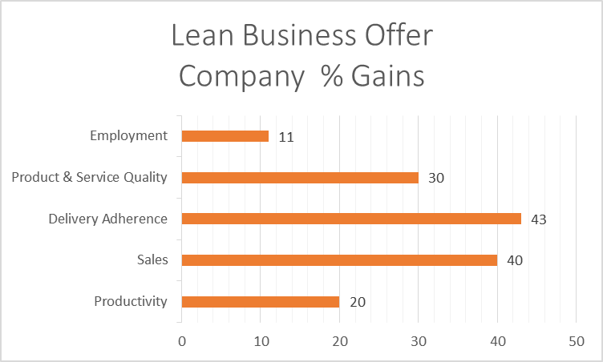
In 2014, Forfas carried out an independent review of Enterprise Ireland’s Lean Business offer and found that companies engaged in the programme recorded significant gains:
- Productivity up 20%
- Sales up 40%
- Delivery adherence up 43%
- Product & Service quality up 30%
- Employment up 11%

Implementation
The programme involves a short in-company assignment by an external ‘Lean’ consultant who will introduce Lean principles and complete a specific cost reduction project.
The programme will commence with a diagnosis of current practice and performance. Key performance indicators will be established to achieve targeted business improvement measures based on a set of Lean tools and methodologies tailored to suit each client’s situation.
The programme will be available to a limited number of LEO clients on a pilot programme. Lean for Micro is available to Measure 1 LEO eligible companies who employ up to 10 employees in eligible LEO sectors who have the potential to export / internationally trade.
Participating clients will be selected subject to eligibility as determined by LEOs and depending on the client’s existing capability in using Lean business principles, the current size, and their particular business development needs.
The cost of the programme to the company will be €1,000 with LEOs support of an additional €4,000.

How to Apply
All applications for Lean for Micro should be discussed with Laois Local Enterprise Office, Portlaoise Enterprise Centre, Clonminam Enterprise Park, Portlaoise, Co. Laois R32 D611; 057-8661800; localenterprise@laoiscoco.ie https://www.localenterprise.ie/laois
Shortlisted businesses who can demonstrate a capability for a lean project will be invited to complete an application form for Lean for Micro.

Further Information
Local Enterprise Office
http://www.localenterprise.ie
Enterprise Ireland
Becoming LEAN Practical Steps to Build Competitiveness
http://bit.ly/1Lk7CVN
BECOMING a LEAN Service Business Practical steps to build competitiveness, capacity & capability
http://bit.ly/1DbPcjV
NSAI
SWiFT 11: Driving Competitiveness Using Lean.
http://bit.ly/18xyNgE

