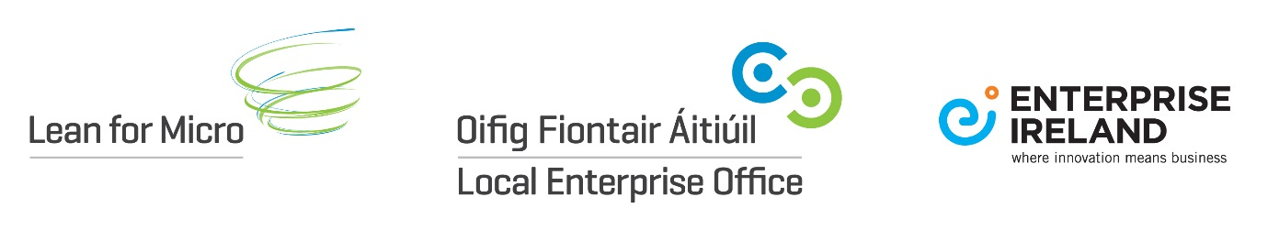

Frequently Asked Questions on
LEO Lean for Micro Pilot Programme
- What is Lean for Micro?
- Am I eligible?
- What costs are eligible and what is the maximum funding available?
- How do I apply?
- Where can I find a suitable consultant/trainer?
- Key contact/more information
- Disclaimer to note
Lean for Micro:
Lean for Micro provides an introduction to Lean concepts and allows you to gain an understanding of what the tools and techniques can do for you and your company in a short, focused engagement. The initiative is designed for companies that are unfamiliar with and lacking capability in business process improvement methodologies such as Lean and/or other best practice methods specific to particular business sectors.
Lean for Micro is not just for manufacturing companies. Software and internationally traded services companies can avail of funding to learn about and implement improvements to their business.
Companies can apply for grant support towards the cost of hiring a Lean consultant/trainer to undertake a short in-company assignment which will
- introduce Lean principles and Agile processes
- achieve immediate cost reduction targets
- lay a foundation for future Lean or productivity improvement projects
- incorporate First Steps to Green Competitiveness Guidebook
Assignments will typically be carried out over 6 to 8 weeks. Companies will be eligible to receive support for a maximum of 5.5 consultancy days to a limit of €5,000.
Am I Eligible?
Lean for Micro will be available to a limited number of LEO clients on a pilot basis during 2017. It will typically be available to Measure 1 LEO eligible companies who employ up to 10 employees in eligible LEO sectors who have the potential to export / internationally trade.
Participating clients will be selected subject to eligibility as determined by LEOs and depending on the client’s existing capability in using Lean business principles, the current size, and their particular business development needs.
What costs are eligible and what is the maximum funding available?
The typical cost of undertaking a Lean for Micro assignment is €5,000. The company must pay the first €1,000 and the Local Enterprise Office will provide grant funding for the outstanding costs to a maximum of €4,000.
Eligible Expenditure is limited to the cost of hiring a Lean consultant/trainer for a maximum of 5.5 days. Consultants must be approved by the Enterprise Ireland Lean Team.
The maximum daily fee payable to a consultant/trainer is €900 inclusive of travel and subsistence and all out-of-pocket expenses.
Note: Receipt of other grants may impact on your eligibility for support under this initiative.
How do I apply?
All applications for Lean for Micro should be discussed with the Local Enterprise Office.
Shortlisted businesses who can demonstrate a capability for a lean project will be invited to complete an application form for Lean for Micro.
If the company has already initiated a Lean for Micro assignment before submitting an application to the Local Enterprise Office, the application and associated expenditure will not be accepted.
Where can I find a suitable consultant/trainer?
A directory of consultants/trainers interested in undertaking assignments under this initiative is maintained by Enterprise Ireland. The directory holds a profile provided by each consultant/trainer on their expertise and experience with Lean projects. A company may select a consultant/trainer from this directory, or it may select a consultant/trainer who is not. In either case, before the company applies for funding, sufficient information must be provided to Enterprise Ireland to demonstrate that the proposed consultant/trainer is qualified to carry out the proposed work and has previously carried out similar assignments satisfactorily.
Please ensure you carefully read the Directory and the Guidelines for Use of Directory [excel format] prior to selecting from the list of consultants/trainers.
Enterprise Ireland does not give any warranty, either express or implied, as to the qualifications or suitability of any of the persons on the list of consultants/trainers and Enterprise Ireland will not be liable for any loss and/or damage caused by a company’s decision to retain the services of such a consultant/trainer.
Key contact/more information
Local Enterprise Office Laois
http://www.localenterprise.ie/laois
057-8661800

Disclaimer to Note:
Disclaimer – For the avoidance of doubt it is understood and accepted that it is the applicant companies who are selecting and entering into a contract with third parties. The State and its agents (including Local Enterprise Office(s), Enterprise Ireland or any Government Department) does not accept any liability whatsoever in respect of any deficit in or consequences arising from products or services procured by or provided to companies under this scheme. In submitting your application under this scheme you are confirming that you understand and accept this disclaimer.

